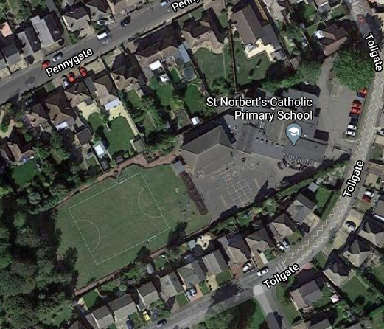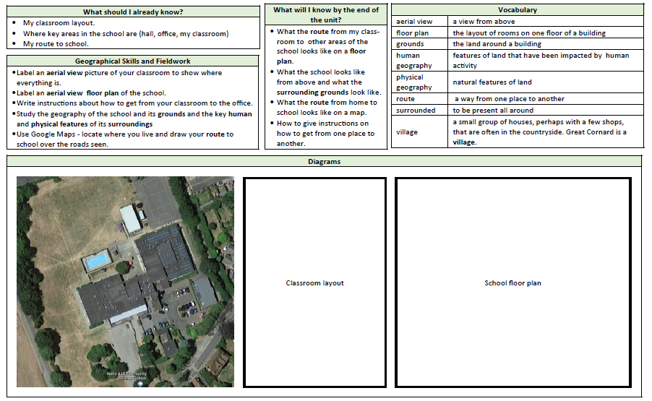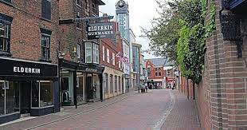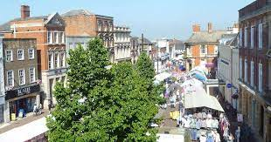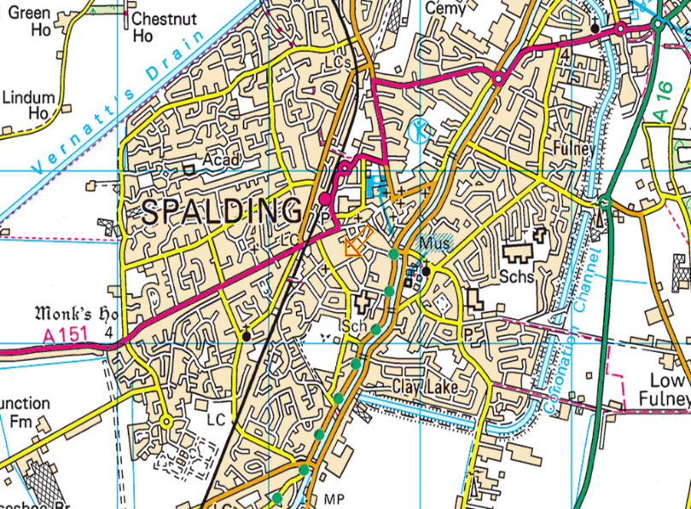

**A built-up area with a name and many shops, larger than a village and smaller than a city. The name of our town is Spalding.**

**Label an aerial view picture of your classroom to show where everything is.**

**Label an aerial view of the school grounds.**

**Study the geography of the school and its grounds and the key human and physical geographical features of its surroundings.**

**Use Google maps – locate our school and draw a route between school and church.**

**Begin to draw own maps**

**town**

Maps and photos

**What the route from my classroom looks like on a floor plan**

**What the school looks like from the air (aerial view)**

**What the route from school to church looks like on a map.**

**Compass direction names- North, South, East, West**