# Dear Parents/Carers,

## Home Learning

Weekly spellings and homework will be printed and handed out to children every Friday, please hand in homework on a Wednesday.

Please remember when your child is swimming, they need to come to school in uniform and not PE kit, you may want to put your child’s swimming costume/trunks on in a morning under the uniform. This is fine and saves time for the children getting into the pool please remember to pack underwear, I would recommend spare, along with their towel.

**Article 28: You have the right to education.**

**Year 3 newsletter**

Welcome back, I hope you all enjoyed the summer holidays, Knowledge Organisers and Year 3 Recommended Reads have been put in this pack for you to look at with your children. They will also give you an idea of the things they will be learning this term 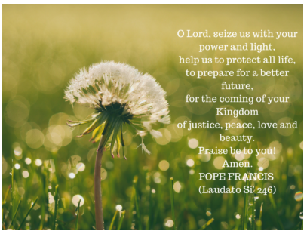

This term we will be Homes in RE we will be thinking about what makes a house a home and we will be exploring Jesus’ home and family and how they showed love for Jesus. We will think about how Christians show love for Jesus. We will be exploring Animals including Humans in Science; we will be identifying the food groups, the types of food we should have in our diet and the children will create a balanced meal. In Geography we will be learning about the United Kingdom we will look at cities, counties and how the UK has changed over time, In Art we will be exploring the artist Henri Rosseau the children will be exploring his painting techniques and recreating their own.

PE will still take place every **Tuesday and Friday** – **Tuesday 11th September- 12th December will be swimming** please ensure your child brings a towel and spare underwear. On Friday, please make sure your child is wearing the correct, labelled PE kit and Earrings should be removed. Please don’t hesitate to contact the school office if you have any queries.