“A communion of high achieving Catholic Schools where every person meets Jesus and grows uniquely in God’s love.”

St. Norbert’s Catholic Voluntary Academy

Striving to nurture the whole child through:
‘Love of God’
Love of one another’
‘Love of life itself’

Curriculum Guidance

“Students learn by doing – smelling, seeing, hearing, touching and tasting as well as thinking either creatively or logically. All their senses are utilised in all sorts of manners so that learning is meaningful and practical- not something so alien that they have to be forced upon to do. When children find learning meaningful, they will naturally want to learn more and hence, they will be self-motivated and do not need to be pushed by adults to learn.”
(Burke and Grosvenor, 2003)

Article 28: Children have a right to an education.

St. Norbert’s Catholic Voluntary Academy

Mission Statement

St. Norbert’s education first and foremost is rooted in the Catholic teaching of the church supported by our chosen School’s Mission and Christian Virtues and Values. We strive for a curriculum that is accessible to all and develops the whole child. It nurtures spirituality, curiosity, creativity and enjoyment.

Our golden threads of equality, excellence and ambition weave through all areas of our curriculum and enable children to secure knowledge and skills and deepen their conceptual understanding.

Equality: accessible for all, to support children to develop as successful learners, confident individuals and responsible citizens
Excellence: through support and challenge, children will overcome barriers to pursue excellence in all they do.
Ambition: takes into account the context of our school within a local, national and global perspective

To enable everyone to flourish and achieve their ambition at our school, our knowledge rich, rounded and coherent curriculum, aims to equip our children with the information, skills, vocabulary, and personal characteristics which will help to ensure they can become lifelong learners and make a positive contribution to the communities they belong to.

Therefore, we:
Challenge and support children through high quality teaching and learning to enable them to be the best that they can be. A wide range of learning opportunities foster children’s love of learning and intrinsically motivates them to succeed. Our lessons challenge, support and enable children to overcome barriers and encourages a lifelong love of learning.

Ensure our children are responsible citizens who take a keen interest in current affairs. They take action when faced with inequalities and injustice and are valued for who they are as aspirational and ambitious individuals.

Provide a framework that allows children to encounter opportunities with resilience, perseverance, and self-determination to grow and become responsible independent learners. We will work closely with families who are the primary educators to foster local and Parish community to the benefit of all.

We strive to provide practice in which our pupils develop that capacity to assess and improve work, sustain effort over time, exceed what they thought was possible and work well with others to combine ideas and approaches.
St. Norbert’s Catholic Voluntary Academy

Aims
Our key aims are based upon A.C.H.I.E.V.E.R.S:

A-achieve an understanding of who God wants me to be

C-caring citizens grow in and leave our school

H-high standards in learning and achievement

I- inspire one another to do our collective best

E-engage in a strong and trusting home, school and Parish partnership

V-value the power of prayer and develop our Catholic Faith

E-everyone to grow closer to God and follow Church teachings

R-respect and understand other cultures and faiths

S-school environment that is safe, caring and nurturing

- To aim for every child to reach their potential in all areas of the curriculum.
- To prepare children well for Key Stage and Secondary transition.
- To provide a curriculum that is designed to excite and motivate children with varied topics, projects and immersive learning to interest them and to which they contribute.
- To ensure learning is a knowledge and skills balanced approach that is engaging, interactive and challenging.
- To create a positive, safe learning environment that nourishes the ‘whole child’ meeting all needs.
- To develop responsible British Citizens for the future that can contribute positively to our richly diverse society.
- To support emotional well-being so children can talk openly about feelings.
- To equip children with the skills to evaluate and assess to take risks, making positive choices.
- To promote lifelong learning to all children and staff alike ensuring a whole school learning and development culture.
- To be a truly inclusive community in which we not only seek to develop children but in which all stakeholders are involved in developing the school itself.

“See a child differently see a different child.”

Article 4: Governments must do all they can to make sure every child can enjoy their rights.

St. Norbert’s Catholic Voluntary Academy
Our School Virtues
Faith
Is to trust. Faith helps us grow in friendship with Jesus and his friendship helps us become the best we can be by becoming more like him.
Hope
You know that when life gets hard you don’t give up but carry on hoping that things will get better. You trust that God is at work moving the world towards what is good.
Love
You accept someone as they are, you care for them, and care what happens to them. You love people you do not know by simple acts of kindness and by wanting the best for them.
Compassion
You notice that a person is sad, in distress or in trouble, you care about how they are feeling and you want to help them.
Patience
You are able to wait without complaining because you know that most things take time. You are calm and trusting.
Knowledge
You decide, based on what you know, what is the best thing to do. You take time to think about what you must do and ask other people about it.
Honesty
You are truthful with yourself and with others. You tell the truth without exaggerating what you say or without sometimes saying less than you know to be true even when admitting the truth may be hard to do.
Kindness
You think about other people, how they feel, and with tenderness you perform an act of care that brings happiness, relief or comfort.
Friendship
You love your friend for the person they are not for what you can get from your friend. You always want the best for your friend and do not treat them badly but as a person whom you love.

St. Norbert’s Catholic Voluntary Academy

School Values

To achieve our full Christian potential we all need to live out the Gospel Values:-
Love: A Christ-like love respects the talent of each person in our school.
Faith: Faith helps us to do God’s will in this world.
Hope: Hope helps us to see a new life beyond our present one.
Truth: We should show God’s truth in all we do.
Joy: We show we are joyful and happy and that we are friends with God.
Prayer: Through prayer we stay close to God.
Mission: Our mission is to live as Christ lived.
Justice: We always live a life that works against injustice and wrong.
Peace: We know that if we love one another, peace will be all around us.
Mercy: We believe that mercy will be shown by the way we forgive others.
Community: We believe our community here unites us all as a follower of Jesus.

This forms part of our Value of the month and Faith Journey Projects that we focus on through worship and general daily provision.

Month | Value
September | Respect
October | Friendliness
November | Diversity
December | Honesty
January | Self-Discipline
February | Trust
March | Co-operation
April | Patience
May | Self-Belief
June | Courtesy
July | Aspiration

Article 13: Every child must be free to say what they think and to seek and receive all kinds of information, as long as it is within the law.

St. Norbert’s Catholic Voluntary Academy

Curriculum Leadership

Mrs J Withers | Safeguarding/Lead DSL  SENCO/Inclusion-EAL  Attendance
Mrs S Hibbert | RE  Deputy DSL  English  Curriculum  Assessment  Pupil Premium/LAC Lead
Mr S Morton | PE/Sports Premium  Computing  DSL Deputy  Key Stage 1 Lead
Miss S Bools | PHSCE  Eco Ambassadors  Outdoor Learning
Miss I Whyles | RRSA  The Arts  Collective Worship
Mrs C Bradley | EYFS  DT
Mrs C Simons | History/Geography
Mrs K Franklin | Key Stage 2 Lead  Maths  Science  MFL
Mrs Fairbanks | ECT

Article 14: Children have the right to think and believe what they want and to practice their religion, as long as they are not stopping other people from enjoying their rights. Parents should guide their children on these matters.

St. Norbert’s Catholic Voluntary Academy

Whole School Curriculum Plan

Contents Navigation – Click on links to access subjects directly
Aims | Art and Design | Languages
Curriculum Map | Computing | Physical Education
School Values | Science | Religious Education
Curriculum Planning Process | Design Technology | English Writing
Curriculum Leadership | Geography | English Reading
 | PSHCE | Music
 | History | Maths
 |  | Curriculum Maps

Article 1: All children under 18 have all the rights in the convention.

Curriculum in EYFS
Reception progression
‘Know hows…’

ost pertinent to the following Subject Leaders – Music, PSHCE, Science, Math’s, English.

Communication and Language
Intent - Communication and language involves igniting enthusiastic communicators. Genuine interactions encouraging children to express themselves as confident speakers and listeners. Building a rich vocabulary to draw from as children grow. Developing understanding through hearing and focus.
Listening, Attention and Understanding
ELG: Listen attentively and respond to what they hear with relevant questions, comments and actions hen being read to and during whole class discussions and small group interaction, make comments about what they have heard and ask questions to clarify their understanding, hold conversation when engaged in back and forth exchanges with their teacher and peers.
Reception
Advent | Lent | Pentecost
- To know how to listen carefully and why listening is important.  - To know how to be follow an instruction/request, including following prepositions.  - To know how to join in with rhymes and stories I like.  - To Know how to ask and respond to ‘why’ questions.  - To Know how to engage in story times and  - follow a story with props and pictures.  - To Know how to operate a digital device and show understanding of the remote controls.  - To Know how to be able to show interest in other technological items.  - To Know how to engage in non-fiction books. | - To know how to listen to and comment on a whole story, including ones without props or pictures.  - To know how to ask questions about my favourite books.  - To know how to ask questions to find out more and check understanding.  - To know how to choose and comment on a book or game that might be different from my friends.  - To know how to play and listen to my friends at the same time.  - To know how to recite rhymes, poems and songs, paying attention to how they sound.  - To know how to listen to and talk about selected non-fiction (new knowledge and vocabulary.)  - To know how to be able to respond quickly to a series of instructions.  - To know how to have a ‘back and forth’ conversation.  - To know how to understand and complete a simple program on a computer. | - ELG -Listening, Attention and Understanding  - To know how to listen attentively and respond to what they hear with relevant questions, comments and actions when being read to and during whole class discussions and small group interactions;  - To know how to make comments about what they have heard and ask questions to clarify their understanding;  - To know how to hold a conversation when engaged in back-and-forth exchanges with their teacher and peers.  - To Know how to listen to a longer story

Communication and Language
Communication and language involves igniting enthusiastic communicators. Genuine interactions encouraging children to express themselves as confident speakers and listeners. Building a rich vocabulary to draw from as children grow. Developing understanding through hearing and focus.
Speaking
ELG: Participates in small group, class and one to one discussions, offering their own ideas, using recently introduced vocabulary, offering explanations for why things might happen, making use of recently introduced vocabulary from stories, non- fiction, rhymes and poems when appropriate, express their ideas and feeling about their experiences using full sentences including use of past, present and future tenses and making use of conjunctions, with modelling and support from their teacher.
Reception
Advent | Lent | Pentecost
- To know how to start to link simple sentences, using connectives.  - To know how to explain using simple sentences, including ordering, stating what happened and what might happen.  - To know how to use tense, intonation and rhythm to enhance meaning.  - To know how to use vocabulary to express imaginary events in play.  - To know how to engage in imaginary role play, sometimes building stories around toys and objects.  - To know and learn new vocabulary. | - To know how to explore new vocabulary, sounds and intonation and use them throughout the day and in different contexts.  - To Know how to use language to create imaginary events, storylines and themes,  and sustaining imaginary play situations.  - To Know how to use sentences that are well formed (May still have some difficulties with grammar- 'sheeps' instead of 'sheep' or 'goed' instead of 'went‘)  - To Know and ask questions to find out more and to clarify understanding.  - To know how to describe events in some detail.  - To know how to use talk to work out problems, organise thinking and explain how and why things work.  - To know how to develop social phrases.  - To know how to retell the story, some as exact repetition and some in their own words.  - To know how to use a range of connectives to link ideas. | ELG -Speaking  - To know how to participate in small group, class and one-to-one discussions, offering their own ideas, using recently introduced vocabulary.  - To know how to offer explanations for why things might happen, making use of recently introduced vocabulary from stories, non-fiction, rhymes and poems when appropriate.  - To know how to express their ideas and feelings about their experiences using full sentences, including use of past, present and future tenses and making use of conjunctions, with modelling and support from their teacher.

Most pertinent to the following Subject Leaders – Computing, PE, PSHCE, RE, Science, English.
Personal, Social and Emotional Development
Personal, social and emotional development involves: helping children to develop caring and trusting relationships based on our Catholic values. Showing kindness and respect through solving disagreements together. Nurturing and forming positive relationships so children with the skills they need to regulate themselves. Encouraging children to cultivate a good self-image, having confidence to be risk takers and independent learners.
Managing Self
ELG: Be confident to try new activities and show independence, resilience and perseverance in the face of challenge, explain reasons for rules, know right from wrong and try to behave accordingly, manage their own basic hygiene and personal needs, including dressing, going to the toilet and understanding the importance of healthy food choices
Reception
Advent | Lent | Pentecost
- To know how to select and use activities and resources with help.  - To know how to enjoy the responsibility of carrying out small tasks.  - To know how to be confident to talk to other children when playing, and communicate freely about home and community.  - To know how to be outgoing towards unfamiliar people and more confident in new social situations.  - To know how to show confidence in asking adults for help. | - To know how to welcome and value praise and recognising themselves as a valuable individual.  - To know how to willingly participate in a wide range of activities with enthusiasm.  - To know how to be confident to speak to others about own needs, wants, interests and opinions.  - To know how to be confident in speaking in front of a small group.  - To know how to describe themselves in positive terms and talk about own abilities.  - To know how to be resilient and persevere in the face of challenge.  - To know how to manage their own needs- toileting, eating with a knife and fork, zipping up own coat. | ELG: Managing Self  - To know how to be confident to try new activities and show independence, resilience and perseverance in the face of challenge;  - To know how to explain the reasons for rules, know right from wrong and try to behave accordingly;  - To know how to manage their own basic hygiene and personal needs, including dressing, going to the toilet and understanding the importance of healthy food choices

Personal, Social and Emotional Development
Personal, social and emotional development involves: helping children to develop caring and trusting relationships based on our Catholic values. Showing kindness and respect through solving disagreements together. Nurturing and forming positive relationships so children with the skills they need to regulate themselves. Encouraging children to cultivate a good self-image, having confidence to be risk takers and independent learners.
Building Relationships
ELG: Work and play cooperatively and take turns with others, form positive attachments to adults and friendships with peers, show sensitivity to their own and others’ needs.
Reception
Advent | Lent | Pentecost
- To know how to initiate play, offering cues to their friends to join them.  - To know how to demonstrate friendly behaviour, initiating conversations and forming good relationships with friends and familiar adults.  - To know how to build constructive and respectful relationships. | - To know how to start conversations, attend to and take account of what others say.  - To know how to explain their own knowledge and understanding, and ask appropriate questions of others.  - To know how to take steps to resolve conflicts with other children, e.g. finding a compromise.  - To know how to think about the perspectives of others.  - To know how to play in a group, extending and elaborating play ideas, e.g. building up a role-play activity with other children. | ELG: Building Relationships  - To know how to work and play cooperatively and take turns with others;  - To know how to form positive attachments to adults and friendships with peers;  - To know how to show sensitivity to their own and to others’ needs.

Most pertinent to the following Subject Leaders – Art, Computing, DT, Music, PE, English.

Physical Development
Physical development involves being active which allows children to develop an understanding of the importance of exercise and healthy choices. Ensuring good brain development as a pathway to learning and emotional wellbeing. The development of agility, balance and co-ordination as a fundamental life skill.

Gross Motor Skills
ELG: Negotiate space and obstacles safely, with consideration for themselves and others, demonstrate strength, balance and coordination when playing, move energetically, such as running, jumping, dancing, hopping, skipping, and climbing.
Reception
Advent | Lent | Pentecost
- To know how to stand momentarily on one foot when shown.  - To know how to catch a large ball.  - To know how to move freely in a range of ways, such as slithering, shuffling, rolling, crawling, walking, running, jumping, skipping, sliding and hopping.  - To know how to run skilfully and negotiate space, adjusting speed or direction to avoid obstacles.  - To know how to show increasing control over an object in pushing, patting, throwing, catching or kicking it.  - Know the skills they need to manage the school day successfully: Lining up,  - Mealtimes and personal hygiene | - To know how to negotiate space successfully and travel around, under, over and through balancing and climbing equipment.  - To Know how to revise and refine the fundamental movement skills: -rolling -crawling -walking -jumping -running -hopping -skipping -climbing  - To Know how to move with developing control grace, strength, balance and co-ordination.  - To Know how to use their core muscle strength to achieve a good posture.  - To know how to combine different movements with ease and fluency.  - To know how to confidently and safely use a range of large and small apparatus indoors and outside, alone and in a group.  - To know how to throw, catch and kick a ball with increasing confidence and accuracy. | ELG: Gross Motor Skills  - To know how to negotiate space and obstacles safely, with consideration for themselves and others.  - To know how to demonstrate strength, balance and coordination when playing.  - To know how to move energetically, such as running, jumping, dancing, hopping, skipping and climbing.

Fine Motor Skills
ELG: Hold a pencil effectively in preparation for fluent writing (using the tripod grip in almost all cases. Use a range of small tools, including scissors, paintbrushes, and cutlery, begin to show accuracy and care when drawing.
Reception
Advent | Lent | Pentecost
- To know how to use a pincer grasp.  - To know how to show a preference for a dominant hand. | - To know how to use a tripod/modified tripod grasp.  - To know how to develop their small motor skills so that they can use a range of tools competently, safely and confidently. Suggested tools: pencils for drawing and writing, paintbrushes, scissors, knives, forks and spoons.  - To know how to develop the foundations of a handwriting style which is fast, accurate and efficient. | - ELG: Fine Motor Skills  - To know how to hold a pencil effectively in preparation for fluent writing –using the tripod grip in almost all cases.  - To know how to use a range of small tools, including scissors, paint brushes and cutlery.  - To know how to show accuracy and care when drawing (beginning).

Pertinent to the following Subject Leaders – English.

Literacy
It is crucial for children to develop a life-long love of reading. Reading consists of two dimensions: language comprehension and word reading. Language comprehension (necessary for both reading and writing) starts from birth. It only develops when adults talk with children about the world around them and the books (stories and non-fiction) they read with them, and enjoy rhymes, poems and songs together. Skilled word reading, taught later, involves both the speedy working out of the pronunciation of unfamiliar printed words (decoding) and the speedy recognition of familiar printed words. Writing involves transcription (spelling and handwriting) and composition (articulating ideas and structuring them in speech, before writing).
Writing
ELG: Children will write recognisable letters, most of which are correctly formed. Spell words by identifying sounds in them and representing the sounds with a letter or letters. Write simple phrases and sentences that can be read by others.
Reception
Advent | Lent | Pentecost
- To know how to form recognisable letters, some of them correctly.  - To orally segment words.  - To know how to spell some cvc words by identifying the sounds on a phonic sound mat.  - To know how to rehearse what I write orally before writing. | - To know how to form most lower-case and some capital letters correctly.  - To know how to spell words by identifying all the sounds and then writing the sound with letter/s. (Applying Phase 2 and some Phase 3)  - To know how to read back own writing.  - To know how to write simple phrases and captions.  - To know how to write ‘tricky words’ from Little Wandle progression.  - To know how to use finger spaces to separate words.  - To know that a full stop is at the end of a sentence. | - ELG: Writing  - To know how to write recognisable letters, most of which are correctly formed.  - To know how to spell words by identifying sounds in them and representing the sounds with a letter/letters.  - To know how to write simple phrases and sentences that can be read by others.

Comprehension and Word Reading
ELG: Demonstrate understanding of what has been read to them by retelling stories and narratives using their own words and recently introduced vocabulary. Anticipate – where appropriate – key events in stories. Use and understand recently introduced vocabulary during discussions about stories, non-fiction, rhymes and poems and during role-play.
ELG: Say a sound for each letter in the alphabet and at least 10 digraphs. Read words consistent with their phonic knowledge by sound-blending. Read aloud simple sentences and books that are consistent with their phonic knowledge, including some common exception words.
Reception
Advent | Lent | Pentecost
- To know how to talk about events and characters in books.  - To know how to tell a story to friends.  - To know how to talk about my favourite book.  - To know how to read individual letters by saying the sounds for them and some digraphs (Phase 2 Little Wandle).  - To know how to segment and blend simple words demonstrating my knowledge of sounds independently.(Phase 2)  - To know how to read the common exception words matched to Little Wandle phonic programme for phase 2 (is I the as and has his her go no to into she he we of we me be). | - To know how to use vocabulary and events from stories in my play.  - To know how to make suggestions about what might happen next in a story.  - To know how to blend sounds into words, so that I can read short words made up of known letter-sound correspondences.  - To know how to read the common exception words matched to Little Wandle phonic programme for phase 3 and secure in Phase 2  - (was you they my by all are sure pure) | ELG: Comprehension and Reading  - To know how to demonstrate understanding of what has been read to them by retelling stories and narratives using own words and recently introduced vocabulary.  - To know how to anticipate (where appropriate) key events in stories.  - To know how to use and understand recently introduced vocabulary during discussions about stories, nonfiction, rhymes and poems and during role play.  - To know how to say a sound for each letter in the alphabet and at least 10 digraphs.  - To know how to read words consistent with my phonic knowledge by sound-blending.  - To know how to read aloud simple sentences and books that are consistent with my phonic knowledge, including some common exception words.

Most pertinent to the following Subject Leaders – Geography, Math’s.

Mathematics
Mathematics involves developing good number sense to solve problems in practical situations and everyday life. Practising visualisation to support understanding and problem solving. The opportunity to explore and experience shapes, space and measures in everyday context. The aim for each learner is to become a confident mathematician.
Number
ELG: Have a deep understanding of number to 10, including the compositions of each numbers, subitise up to 5, Automatically recall number bonds up to 5 and some number bonds to 10 including double facts
Numerical Patterns
Verbally count beyond 20, recognising the patterns of the counting system, compare quantities up to 10 in different contexts, recognising when one quantity is greater than, less than or the dame as the other quantity, explore and represent patterns within numbers up to 10, including evens and odds , double facts and how quantities can be distribute equally.
Reception
Advent | Lent | Pentecost
Comparison  Compares two small groups of up to five objects  Counting  Recites some numbers  Begin to recognise numerals 0 to 10  Cardinality  Engages in subitising numbers to five  Counts up to five items1:1  Composition  Recognise that numbers are composed of smaller numbers  Recognise that each counting number is one more than the one before  Separates a group of up to 5 objects in different ways, beginning to recognise that the total is still the same | Comparison  Uses number names/symbols when comparing numbers  Counting  Recites numbers 0 to 10 or beyond  Puts numerals in order to 5 or beyond  Cardinality  Developing in subitising numbers to five  Links numerals with amounts up to 5 or more  Composition  Can say 1 more/1 less than numbers to 10  Knows that numbers are composed of smaller numbers  Explores partitioning in different ways with a wide range of objects  Number patterns  Automatically recalls Number bonds to 5  Beginning to understand doubles (up to 5) | ELG: Number  - To know numbers to 10 and have a deep understanding, including the composition of each number;  - To know how to Subitise (recognise quantities without counting) up to 5;  - To know number bonds up to 5 by automatic recall (without reference to rhymes, counting or other aids), including subtraction facts and some number bonds to 10, including double facts.  - ELG: Numerical Patterns  - To know how to verbally count beyond 20, recognising the pattern of the counting system;  - To know how to compare quantities up to 10 in different contexts, recognising when one quantity is greater than, less than or the same as the other quantity;  - To know patterns within numbers up to 10, including evens and odds, double facts and how quantities can be distributed equally.
Shape Space and Measure
Reception
Advent | Lent | Pentecost
Spatial awareness  Responds to and uses language of position and direction  Shape  Chooses items based on their shape for a purpose  Responds to informal language and common shape names  Shows awareness of similarities and differences between objects/shapes  Pattern  Creates own spatial patterns  Follows and creates simple AB pattern  Joins in with simple patterns in sounds, objects, games stories and movement predicting what comes next  Measures  Finds the longer or shorter, biggest or smallest, heavier or lighter and more/less full of two items  Recalls a sequence of events in everyday life and stories | Spatial awareness  Predicts, moves and rotates objects to fit the space or create the shape they would like  Shape  Enjoys partitioning and combining2D and 3D shapes to make  new shapes  Attempts to create arches and enclosures when building  Pattern  Follows and creates ABC pattern  Measures  Becomes familiar with measuring tools in everyday play  Able to order and sequence events using everyday language related to time | Spatial awareness  Uses spatial language, including following and giving directions  Investigates turning and flipping objects and shapes  Shape  Uses informal language and mathematical terms to describe shapes  Enjoys composing and decomposing shapes  Pattern  Begins to identify the pattern “rule”  Creates patterns beyond AB/ABC and begins to identify the unit of repeat  Measures  Problem solve involving length, weight or capacity  Experience measuring time with timers and calendars

Most pertinent to the following Subject Leaders – Computing, Geography, History, PSHCE, RE, Science, English.

Understanding the World
Understanding the world involves experiencing and valuing culture, community and environment. Developing positive interactions which show care and concern for all aspects of God’s world. Exploring and observing the world through people, places and technology.
Understanding the World: Past and Present
ELG: Talk about the lives around them and their roles in society, know some similarities and difference between things in the past and now, drawing on their experiences and what they have read in class, understand the past through settings, characters and events encountered in books read in class and storytelling.
Reception
Advent | Lent | Pentecost
- To Know how to talk and remember about significant events in own experience.  - To know that some places are special to members of their community.  - To know how to compare and contrast characters from stories, including figures from the past.  - To know how to comment on images of familiar situations in the past. | - To Know how to recognises and describe special times or events for family or friends. | ELG Past and Present  - To know how to talk about the lives of the people around them and their roles in society  - To Know some similarities and differences between things in the past and now, drawing on their experiences and what has been read in class;  - To know how to understand the past through settings, characters and events encountered in books read in class and storytelling.

Understanding the world: People, Culture, and communities
Describe the immediate environment using knowledge from observation, discussion, stories, nonfiction texts and maps, know some similarities and differences between different religious and cultural communicates in this country, drawing on their experiences and what has been read in class, explain some similarities and difference between life in this country and life in other countries, drawing on knowledge from stories, nonfiction texts and (when appropriate ) maps.
Reception
Advent | Lent | Pentecost
- To know how to show interest in the lives of people who are familiar to them.  - To know how to talk about members of their immediate family and community.  - To Know how to name and describe people who are familiar to them  - To know how to show an interest in different occupations and ways of life. (starting to)  - To know how to draw information from a simple map. | - To know how to recognise that people have different beliefs and celebrate special times in different ways.  - To know how to recognise some similarities and differences between life in this country and life in other countries.  - To know how to show an interest in different occupations and ways of life.  - To know how to create and draw information from a map of the Nursery Garden. | ELG: People, Culture and Communities  - To know how to describe their immediate environment using knowledge from observation, discussion, stories, non-fiction texts and maps;  - To Know some similarities and differences between different religious and cultural communities in this country, drawing on their experiences and what has been read in class;  - To know how to explain some similarities and differences between life in this country and life in other countries, drawing on knowledge from stories, non-fiction texts and –when appropriate –maps.

Understanding the world: The natural world
Explore the natural world around them, making observations and drawing pictures of animals and plants, know some similarities and differences between the natural world around them and contrasting environments, drawings on their experiences and what has been read in class, understand some important processes and changes in the natural world around them, including the seasons and changing states of matter.
Reception
Advent | Lent | Pentecost
- To know how to ask questions about aspects of my familiar world such as the place where I live or the natural world.  - To know how to talk about some of the things I have observed such as plants, animals, natural and found objects.  - To know about growth, decay and changes over time (developing understanding).  - To Know how to show care and concern for living things and the environment  - To know how to explore the natural world around them. | - To know how to talk about why things happen and how things work.  - To Know how to describe what they see, hear and feel whilst outside.  - To know how to recognise some environments that are different to the one in which they live.  - To Know and understand the effect of changing seasons on the natural world around them.  - To Know how to explore the natural world around them, making observations | ELG: The Natural World  - To know how to explore the natural world around them, making observations and drawing pictures of animals and plants;  - To Know some similarities and differences between the natural world around them and contrasting environments, drawing on their experiences and what has been read in class;  - To know how to understand some important processes and changes in the natural world around them, including the seasons and changing states of matter.

Most pertinent to the following Subject Leaders – Art, Computing, DT, Music, PE, PSHCE, English.

Expressive Arts and Design
Expressive Arts and Design involves an individual expression of creativity through a variety of media. Innovation and process are highly valued as children exercise freedom of choice and develop critical thinking. Creative expression promotes the articulation of feelings and thoughts in an enjoyable and physically active manner.
Expressive arts and design: Creating with materials
ELG: Safely use and explore a variety of materials, tools and techniques, experimenting with colour, design, texture, form and function, share their creation , explaining the process they have used, make use of props and materials when role playing character in narratives and stories.
Reception
Advent | Lent | Pentecost
- To know how to show interest in and describe the texture of things.  - To know how to explore colour and how colours can be changed.  - To know how to use lines to enclose a space, and then begin to use these shapes to represent objects.  - To know how to use various construction materials.  - To know how to begin to construct, stacking blocks vertically and horizontally, making enclosures and creating spaces. | - To know how to explore, use and refine a variety of artistic effects to express their ideas and feelings.  - To know how to return to and build on their previous learning, refining ideas and developing their ability to represent them.  - To know how to create collaboratively sharing ideas, resources and skills.  - To know how to join construction pieces together to build and balance | ELG: Creating with Materials  - To know how to safely use and explore a variety of materials, tools and techniques, experimenting with colour, design, texture, form and function;  - To know how to share their creations, explaining the process they have used;  - To know how to make use of props and materials when role playing characters in narratives and stories.

Expressive arts and design: Being imaginative and expressive
ELG: Invent, adapt and recount narratives and stories with peers and their teacher, sing a range of well know nursery rhymes and songs, perform songs, rhymes poems and stories with others and (when appropriate) try to move in time with music.
Reception
Advent | Lent | Pentecost
- To know how to sing to themselves and make up simple songs.  - To know how to sing a few familiar songs.  - To know how to join in with ring games.  - To begin to move in time with music.  - To know how to tap out simple repeated rhythms  - To Know how to engage in imaginative role-play based on own first-hand experiences.  - To know how to notice what adults do, imitating what is observed and then doing it spontaneously when the adult is not there. To know how to develop storylines in their pretend play and how to build stories around toys.  - To know how to use available resources to create props to support role-play.  - To know how to explore and learn how sounds can be changed. | - To know how to develop preferences for forms of expression, including dance and performance arts.  - To know how to use movement and music to express feelings.  - To know how to create movement in response to music, moving more confidently in time with the music.  - To know how to explore and engage in music making, singing and dancing, performing solo or in groups.  - To Know how to play pitch-matching games, humming or singing short songs  - To know how to explore and learn how sounds can be changed.  - To know how to recount a simple narrative through role play.  - To know how to develop and maintain a story line when playing with friends. | ELG: Being Imaginative and Expressive  - To know how to Invent, adapt and recount narratives and stories with peers and their teacher;  - To know how to sing a range of well-known nursery rhymes and songs;  - To know how to perform songs, rhymes, poems and stories with others, and –when appropriate –try to move in time with music.

Art and Design
Art and Design at St Norbert’s allows children to creatively express themselves by harnessing ideas that they themselves may already have whilst taking inspiration from some of the great artists, designers and architects that have lived. Children are engaged and inspired from this balance of freedom of expression and artwork that is already in the public domain.
Art and Design objectives and outcomes, like all subjects, form part of meaningful and relevant learning journeys. Teaching the
statutory knowledge, skills and understanding of Art and Design results in St Norbert’s children being equipped with:

Knowledge | of a range of materials of colours, patterns, textures, lines, shapes, forms and space of a range of artists, craft makers, architects and designers
Skills | Creativity and imagination within completed artwork  Developing ideas and communicating them visually  Experimenting with ideas  Working with others to gain insight and give/receive feedback Improving own learning – acting upon advice and feedback  Mastering techniques of painting, collage, sculpture, drawing, print, textiles, digital media
Understanding | Critical thinking, including:  - sharing / development of ideas  - evaluation  - comparison

Art and Design Curriculum Overview – Objectives

KS1 National Curriculum
Pupils should be taught:
- to use a range of materials creatively to design and make products
- to use drawing, painting and sculpture to develop and share their ideas, experiences and imagination
- to develop a wide range of art and design techniques in using colour, pattern, texture, line, shape, form and space
- about the work of a range of artists, craft makers and designers, describing the differences and similarities between different practices and disciplines, and making links to their own work.

Progression

Year 1 | To develop ideas | Respond to ideas and starting points Explore different methods as ideas develop.
 | To master techniques:
 | Painting | Use thick and thin brushes. Mix primary colours to make secondary.
 | Collage | Use a combination of materials that are cut, torn and glued.
 | Sculpture | Use a combination of shapes.  Include lines and texture.  Use techniques such as rolling and moulding.
 | Drawing | Draw lines of different sizes and thickness. Colour neatly following the lines.
 | Print | Use repeating or overlapping shapes.  Use objects to create prints  Press, roll, rub and stamp to make prints  Investigate the possibilities of a range of materials
 | Textiles | Use weaving to create a pattern. Join materials using glue and/or a stitch.
 | Digital media | Use a wide range of tools to create different textures and lines.
 | Evaluate | Reflect on, analyse and critically evaluate their own work and that of others.
 | To take inspiration from the greats | Describe the work of notable artists, artisans and designers.
Year 2 | To develop ideas | Explore ideas and collect visual information.  Explore different methods and materials as ideas develop.
 | To master techniques:
 | Painting | Add white to colours to make tints and black to make tones.  Create colour wheels.
 | Collage | Sort and arrange own materials.  Mix materials to create texture.
 | Sculpture | Use rolled up paper, straws, paper, card and clay as materials.  Use techniques such as cutting and carving.
 | Drawing | Show pattern and texture by adding dots and lines. Use charcoal to shade and contrast.  Show different tones by using coloured pencils.
 | Print | Use objects to create prints (e.g. fruits, vegetables, string or sponges).  Press, roll, rub and stamp to make prints.
 | Textiles | Use plaiting.  Use dip dye techniques.
 | Digital media | Use a wide range of tools to create tones, colours and shapes.
 | Evaluate | Reflect on, analyse and critically evaluate their own work and that of others.
 | To take inspiration from the greats | Use some of the ideas of artists studied to create own pieces.

KS2 National Curriculum

Pupils should be taught:

- to create sketch books to record their observations and use them to review and revisit ideas
- to improve their mastery of art and design techniques, including drawing, painting and sculpture with a range of materials [for example, pencil, charcoal, paint, clay]
- about great artists, architects and designers in history.

Year 3 | To develop ideas | To develop ideas from starting points throughout the curriculum. Adapt and refine ideas as they progress.  Comment on artworks using visual language.
 | To master techniques:
 | Painting | Use a number of brush techniques using thick and thin brushes to produce shapes, textures, patterns and lines.  Mix colours effectively.
 | Collage | Select and arrange materials for a striking effect.  Ensure work is precise.  Use mosaics.
 | Sculpture | Create and combine shapes to create recognisable forms (e.g. shapes made from nets or solid material)
 | Drawing | Use different grades of pencils to show line, tone and texture.  Annotate sketches to explain and elaborate ideas.
 | Print | Use layers of two or more colours. Replicate patterns observed in natural or built environments.
 | Textiles | Shape and stitch materials.  Use basic cross stitch and backstitch.
 | Digital media | Create images and explain why they were created.
 | Evaluate | Reflect on, analyse and critically evaluate their own work and that of others.
 | To take inspiration from the greats | Replicate some of the techniques used by notable artists, artisans and designers.

Year 4 | To develop ideas | Collect information, sketches and resources to enhance own ideas. Explore ideas in a variety of ways. Comment on artwork with a developing grasp of visual language.
 | To master techniques:
 | Painting | Use watercolour paint to produce washes for backgrounds then add detail. Experiment with creating mood with colour.
 | Collage | Ensure work is precise.  Use coiling and overlapping.
 | Sculpture | Use clay and other mouldable materials. Add materials to provide interesting detail.
 | Drawing | Sketch lightly (no need to use a rubber to correct mistakes)  Use shading to show light and shadow. Use hatching and cross hatching to show tone and texture.
 | Print | Make printing blocks (e.g. from coiled glued string glued to a block)  Make precise repeating patterns.
 | Textiles | Colour fabric.  Create weavings.
 | Digital media | Create videos and sound recordings and explain why they were created.
 | Evaluate | Reflect on, analyse and critically evaluate their own work and that of others.
 | To take inspiration from the greats | Create original pieces that are influenced by studies of others.

Year 5 | To develop ideas | Develop and imaginatively extend ideas from starting points throughout the curriculum.  Collect information, sketches and resources to inspire.  Use the qualities of materials to enhance ideas.  Comment on artwork with a grasp of visual language.
 | To master techniques:
 | Painting | Sketch (lightly) before painting to combine line and colour.  Create a colour palette based upon colours observed in the natural or built world.  Use the qualities of watercolour and acrylic paints to create interesting pieces.
 | Collage | Mix textures (rough and smooth, plain and patterned.  Use tessellation and montage.
 | Sculpture | Use tools to carve and add shapes, texture and pattern
 | Drawing | Use a variety of techniques to add interesting effects (e.g. reflections, shadows, direction of sunlight) Use a choice of techniques to depict movement, perspective, shadows and reflection.
 | Print | Build up layers of colours.  Create an accurate pattern showing fine detail.
 | Textiles | Quilt, pad and gather fabric.  Show precision in techniques. Choose from a range of stitching techniques.
 | Digital media | Enhance digital media by editing  (including sound and video)
 | Evaluate | Reflect on, analyse and critically evaluate their own work and that of others.
 | To take inspiration from the greats | Give details (including own sketches) about the style of some artists, artisans and designers.  Show how the work of those studied was influential in both society and to other artists.
Year 6 | To develop ideas | Collect information, sketches and resources and present ideas imaginatively in a sketchbook. Spot the potential in unexpected results as work progresses. Comment on artworks with a fluent grasp of visual language.
 | To master techniques:
 | Painting | Combine colours, tones and tints to enhance the mood of a piece.  Use brush techniques and the qualities of paint to create texture.  Develop a personal style of painting, drawing upon ideas from other artists.
 | Collage | Combine visual and tactile qualities. Use ceramic mosaic materials and techniques.
 | Sculpture | Combine visual and tactile qualities. Use frameworks (such as wire moulds) to provide stability and form with Modroc.
 | Drawing | Choose a style of drawing suitable for the work (e.g. realistic, or impressionistic) Use lines to represent movement.  Add 3D representations
 | Print | Use a range of visual elements to reflect the purpose of the work.
 | Textiles | Combine previously learned techniques to create pieces.
 | Digital media | Enhance digital media by editing (including animation, still images and installations)
 | Evaluate | Reflect on, analyse and critically evaluate their own work and that of others.
 | To take inspiration from the greats | Create original pieces that show a range of influences and styles. Apply knowledge and ideas from great artists, designers and architects from ancient to modernist periods.

Purpose of Art
Art should engage, inspire and challenge pupils, equipping them with the knowledge and skills to experiment, invent and create their own works of art, craft and design. As pupils progress, they should be able to think critically and develop a more rigorous understanding of art and design.
National Curriculum Programme of Study
https://www.gov.uk/government/publications/national-curriculum-in-england-art-and-design-programmes-of-study/national-curriculum-in-england-art-and-design-programmes-of-study
By the end of Year 1
- Pupils will respond to ideas
- Mix secondary colours and use thick and thin brushes
- Combine materials by cutting, tearing and gluing to make collage
- Roll and mould, combine shapes, add lines and texture in sculpture
- Draw lines and colour in neatly
- Print with repeating shapes
- Create patterns with textiles
- Use ICT tools to make pictures
- Describe the work of notable artists, artisans. Craftspeople
- Reflect on, analyse and critically evaluate their own work and that of others

By the end of Year 2
- Pupils will explore ideas
- Make tints and tones and create colour wheels
- Sort and arrange materials to make collage (including texture)
- Sculpt using different materials, cut and carve
- Draw with pencil and charcoal showing different shades
- Create prints with objects
- Plait and dye material
- Use ICT tools to make pictures with different tones, colours and shapes
- Use some of the ideas of artists studied to create own pieces
- Reflect on, analyse and critically evaluate their own work and that of others

By the end of Year 3
- Pupils will develop ideas
- Mix colours and use different paint strokes
- Create collage for effect
- Create and combine shapes to create recognisable sculpted forms
- Use different grades of pencils to show line, tone and texture
- Print using layers of two or more colours and replicate patterns
- Shape and stitch materials
- Create digital images and explain why they were created
- Replicate some of the techniques used by notable artists, artisans and designers.
- Reflect on, analyse and critically evaluate their own work and that of others

By the end of Year 4
- Collect information, sketches and resources to enhance own ideas. Explore ideas in a variety of ways
- Use paint to create washes and detail. Experiment with colour.
- Create precise collage
- Use clay and other mouldable materials, adding materials for detail.
- Sketch lightly and use different techniques for shading and texture
- Print precise patterns and make own block prints
- Colour fabrics and create patterns with them
- Develop visual arts of video and sound
- Create original pieces that are influenced by studies of others.
- Reflect on, analyse and critically evaluate their own work and that of others

By the end of Year 5
- Pupils will develop and imaginatively extend ideas
- Combine sketch, line and colour and create colour palettes
- Use collage to mix textures, create tessellations and montages
- Draw using a choice of techniques to depict movement, perspective, shadows and reflection.
- Print building up colours and showing detail
- Quilt, pad and gather fabric.
- Enhance digital media by editing
- Give details (including own sketches) about the style of some artists, artisans and designers
- Reflect on, analyse and critically evaluate their own work and that of others.

By the end of Year 6
- Collect information, sketches and resources and present ideas imaginatively
- Combine colours, tones and tints to enhance the mood of a piece.
- Use brush techniques and the qualities of paint to create texture.
- Use ceramic mosaic materials and techniques.
- Sculpt combining visual and tactile qualities. Use frameworks.
- Choose a style of drawing suitable for the work
- Enhance digital media by editing
- Create original pieces that show a range of influences and styles
- Reflect on, analyse and critically evaluate
- their own work and that of others

Computing

Computing at St Norbert’s allows children to safely and responsibly work with a range of technology-based software and hardware to see the impact that this spectrum of technology has on our lives and the wider society. Children take part in learning with safe, real-life application processes so that they understand the artificial and digital systems that ease of our lives, expressing their digital literacy through the use of ICT. Ultimately, children of St Norbert’s leave KS2 with knowledge of how to be safe participants of the digital world.
Computing objectives and outcomes, like all subjects, form part of meaningful and relevant learning journeys. Teaching the statutory knowledge, skills and understanding of computing results in St Norbert’s children being equipped with:

Knowledge | of programming of abstraction of networks of hardware and software of e-safety*
Skills | Creativity  Developing, progressing and debugging programs (solving problems) Computer/digital literacy  Safe, digital communication i.e. email, encouraging safe, secure collaboration.
Understanding | Critical thinking, including:  - analysis  - problem-solving  - evaluation  - application  - prediction  - reasoning

*E-safety or Online Safety

E-safety is concerned with a computer user’s safety on the internet; it is the knowledge of how to maximise the user's personal safety whilst minimising security risks; in other words, e-safety is the self-protection from computer/online crime and danger in general. E-safety is taught and embedded throughout our Computing Curriculum at St Norbert’s at an age appropriate level – see following pages for overview of objectives and how it is part of the year groups’ contents.

For further support and guidance, visit the E-safety area of our website

Computing Curriculum Overview – Progression

Year 1
Use logical reasoning to predict the behaviour of simple programs ( eg: Use of beebots and map to control and follow simple instructions)

Use technology purposefully to create, organise, store, manipulate and retrieve digital content (eg: Use of Microsoft Word. Font,
colour etc?)

Use technology safely and respectfully, keeping personal information private; identify where to go for help and support when they have concerns about content or contact on the internet
or other online technologies (LINK
TO PSHE ONLINE SAFETY

Use of e-safety messages and searching on google. ‘What should I click on? What should I report to the teacher?)

ARE:

- Children to confidently talk about and refer to the idea of an algorithm being an ‘instruction.’
- Children to be able to log on, open Microsoft Word and independently change their font style, font colour, font size, use of bold, italics and underlining.
- Children to have a basic understanding of what e-safety is and why it is important to stay safe online.

Year 2
Understand what algorithms are; how they are implemented as programs on digital devices; and that programs execute by following precise and unambiguous instructions (eg: Use of beebots and programming them to follow a path. ‘That algorithm was
incorrect, how could you change it?’)

Create and debug simple programs

Use technology safely and respectfully, keeping personal information private; identify where to go for help and support when they have concerns about content or contact on the internet or other online technologies. (LINK TO PSHE- Use of e-safety messages and searching on google. ‘Who should I be speaking to? What should I say? Who can I
turn to if I’m unsure?)

Recognise common uses of information technology beyond school (eg: How are programs used to control things in society? Traffic lights, factory lines, drones? BT Tower?)

ARE:
Children to be able to confidently talk about what an algorithm is and the idea that the instructions need to be precise (Need to be accurate) and what will happen if they go wrong.
- The idea of trial and error with their algorithms. ‘
- Children to confidently discuss e-safety scenario cards and discuss/debate what should be done if they face this scenario.
- Children to name at least 2 uses of information technology beyond the school environment and how this helps society,

Year 3
Use technology safely, respectfully and responsibly; recognise acceptable/unacceptable behaviour; identify a range of ways to report concerns about content and contact. (Online bullying and the idea that someone on the other side of the screen may not be who you think they are. Online bullying videos at age appropriate level)

Writing programs that accomplish given goals.
Use logical reasoning to explain how some simple algorithms work and to detect and correct errors in algorithms and programs. Understand computer networks including the internet; how they can provide multiple services, such as the world wide web; and the opportunities they offer for communication and collaboration.

ARE:
- Children to confidently talk about what they should do if they are being bullied online or if they know someone who is being bullied.
- Children should be confidently using beebots and understanding how their algorithms are going wrong and how to fix them.
- Children will be able to visually represent their algorithms using arrows
- Children should be able to use scratch and manipulate the pen and draw shapes (forwards, backwards, pen up etc.)

Year 4
Use technology safely, respectfully and responsibly; recognise acceptable/unacceptable behaviour; identify a range of ways to report concerns about content and contact (Continued progression of Y1-Y3 online
bullying content.)

Use sequence, selection, and repetition in programs; work with variables and various forms of input and output.

Use logical reasoning to explain how some simple algorithms work and to detect and correct errors in algorithms and programs.

Use search technologies effectively, appreciate how results are selected and ranked, and be discerning in evaluating digital content.

ARE:
- Children to know who specifically then can report a problem to and how to report inappropriate content.
- Children to be able to use block coding, use of repetition to create given goals such as drawing a shape.
- Children to be able to write their own programs and debug them by going back into their code to see where the problem is.
- Children to understand that all information on the internet isn’t always true and how to evaluate digital content to check its authenticity.

Year 5
Design, write and debug programs that accomplish specific goals, including controlling or simulating physical systems; solve problems by decomposing them into smaller parts.

Use technology safely, respectfully and responsibly; recognise acceptable/unacceptable behaviour; identify a range of ways to report concerns about content and contact.

Select, use and combine a variety of software (including internet services) on a range of digital devices to design and create a range of programs, systems and content that accomplish given goals, including collecting, analysing, evaluating and presenting data and information.
Year 6 | Use technology safely, respectfully and responsibly; recognise acceptable/unacceptable behaviour; identify a range of ways to report concerns about content and contact  Design, write and debug programs that accomplish specific goals, including controlling or simulating physical systems; solve problems by decomposing them into smaller parts  Select, use and combine a variety of software (including internet services) on a range of digital devices to design and create a range of programs, systems and content that accomplish given goals, including collecting, analysing, evaluating and presenting data and information

ARE
- Children to specifically know how to solve case studies into improper use of the internet (Report button, ignore button etc) and give examples
- Children to be confident in using block coding to programme physical systems and debugging them
- Children to have a basic understanding of Microsoft Excel and how to input and present data

Computing Purpose
The core of computing is computer science, in which pupils are taught the principles of information and computation, how digital systems work and how to put this knowledge to use through programming. Building on this knowledge and understanding, pupils are equipped to use information technology to create programs, systems and a range of content. Computing also ensures that pupils become digitally literate – able to use, and express themselves and develop their ideas through, information and communication technology – at a level suitable for the future workplace and as active participants in a digital world.
National Curriculum Programme of Study
https://www.gov.uk/government/publications/national-curriculum-in-england-computing-programmes-of-study/national-curriculum-in-england-computing-programmes-of-study
By the end of Year 1
- Children to confidently talk about and refer to the idea of an algorithm being an ‘instruction.’
- Children to be able to log on, open Microsoft Word and independently change their font style, font colour, font size, use of bold, italics and underlining.
- Children to have a basic understanding of what e-safety is and why it is important to stay safe online.

By the end of Year 2
- Children to be able to confidently talk about what an algorithm is and the idea that the instructions need to be precise (Need to be accurate) and what will happen if they go wrong.
- The idea of trial and error with their algorithms. ‘’
- Children to confidently discuss e-safety scenario cards and discuss/debate what should be done if they face this scenario.
- Children to name at least 2 uses of information technology beyond the school environment and how this helps society,

By the end of Year 3
- Children to confidently talk about what they should do if they are being bullied online or if they know someone who is being bullied.
- Children should be confidently using Beebots and understanding how their algorithms are going wrong and how to fix them.
- Children will be able to visually represent their algorithms using arrows
- Children should be able to use scratch and manipulate programmes

By the end of Year 4
- Children to know who specifically then can report a problem to and how to report inappropriate content.
- Children to be able to use block coding, use of repetition to create given goals such as drawing a shape
- Children to be able to write their own programs and debug them by going back into their code to see where the problem is
- Children to understand that all information on the internet isn’t always true and how to evaluate digital content to check its authenticity

By the end of Year 5 and 6
- Children to specifically know how to solve case studies into improper use of the internet (Report button, ignore button etc.) and give examples
- Children to be confident in using block coding to programme physical systems and debugging them
- Children to have a basic understanding of Microsoft Excel and how to input and present data

Science
“Tell me and I forget, teach me and I may remember, involve me and I learn.”
― Benjamin Franklin
Science Albert Einstein said, “The important thing is not to stop questioning; curiosity has its own reason for existing.” Through our teaching and learning of Science, children develop a sense of excitement and curiosity about natural phenomena and whilst there are often answers in Science, this knowledge is only as good as the latest, accepted theory and so children are encouraged to question evidence and discoveries from the scientific greats of the past and present.
During learning, the knowledge, methods, processes and uses of Science are taught and learnt in a variety of contexts. We apply constructivist theory to many areas of our Curriculum and especially Science, acknowledging that children are not ‘empty vessels’ that come to school to be ‘filled’ with ‘real, correct Science.’ Children question and often lead the line of scientific enquiry. Ultimately, learning is an active, not passive process, and teachers facilitate this learning, helping children to deepen their scientific understanding.
Science objectives and outcomes, like all subjects, form part of meaningful and relevant learning journeys. Teaching the statutory knowledge, skills and understanding of Science results in St Norbert’s children being equipped with:
Knowledge | of plants  of animals, including humans  of everyday materials – their properties and how they change  of seasonal changes of living things and their habitats  of rocks  of light  of forces and magnets  of states of matter  of sound  of electricity  of Earth and space  of evolution and inheritance
Skills | Working scientifically:  asking questions and problem solving  predicting  observation and working with others  testing and taking measurements through using and applying number identifying and classifying  making suggestions  gathering, recording and reporting data – communicating all of this scientific understanding
Understanding | Critical thinking, including:  enquiry  analysis  evaluation  making connections and contrasts

Science Curriculum Overview – Progression
Year
1 | Working Scientifically (throughout each unit elements shown below MUST weave throughout)  • asking simple questions and recognising that they can be answered in different ways  • observing closely, using simple equipment  • performing simple tests  • identifying and classifying  • using their observations and ideas to suggest answers to questions  • gathering and recording data to help in answering questions  Plants  • identify and name a variety of common wild and garden plants, including deciduous and evergreen trees (art – observational drawings)  • identify and describe the basic structure of a variety of common flowering plants, including trees. (measuring lengths/heights)  Animals including humans  • identify and name a variety of common animals including fish, amphibians, reptiles, birds and mammals (sorting groups linked to maths) (Links to ENG Rainbow Fish and sharks)  • identify and name a variety of common animals that are carnivores, herbivores and omnivores.  • describe and compare the structure of a variety of common animals (fish, amphibians, reptiles, birds and mammals, including pets)  • identify, name, draw and label the basic parts of the human body and say which part of the body is associated with each sense (PE links during warm up sessions)  Everyday Materials  • distinguish between an object and the material from which it is made  • identify and name a variety of everyday materials, including wood, plastic, glass, metal, water, and rock  • describe the simple physical properties of a variety of everyday materials  · compare and group together a variety of everyday materials on the basis of their simple physical properties.  Seasonal Changes  • observe changes across the four seasons  • observe and describe weather associated with the seasons and how day length varies
2 | Working Scientifically (throughout each unit elements shown below MUST weave throughout)  • asking simple questions and recognising that they can be answered in different ways  • observing closely, using simple equipment  • performing simple tests • identifying and classifying  • using their observations and ideas to suggest answers to questions  • gathering and recording data to help in answering questions  Living things and their habitats  • explore and compare the differences between things that are living, dead, and things that have never been alive  • identify that most living things live in habitats to which they are suited and describe how different habitats provide for the basic needs of different kinds of animals and plants, and how they depend on each other  • identify and name a variety of plants and animals in their habitats, including microhabitats  • describe how animals obtain their food from plants and other animals, using the idea of a simple food chain, and identify and name different sources of food. (links to PSHE and healthy eating)  Plants  • observe and describe how seeds and bulbs grow into mature plants (tables in maths to record plant growth)  • find out and describe how plants need water, light and a suitable temperature to grow and stay healthy (Eng story endings Jack and the Beanstalk for egample)  Animals including humans  • notice that animals, including humans, have offspring which grow into adults • find out about and describe the basic needs of animals, including humans, for survival (water, food and air) ( Science/Africa Topic)  • describe the importance for humans of exercise, eating the right amounts of different types of food, and hygiene. (PE links)  Everyday Materials  • identify and compare the suitability of a variety of everyday materials, including wood, metal, plastic, glass, brick, rock, paper and cardboard for particular uses  • find out how the shapes of solid objects made from some materials can be changed by squashing, bending, twisting and stretching (Tally chart suitable materials)
3 | Working Scientifically (throughout each unit elements shown below MUST weave throughout)  · asking relevant questions and using different types of scientific enquiries to answer them  • setting up simple practical enquiries, comparative and fair tests  • making systematic and careful observations and, where appropriate, taking accurate measurements using standard units, using a range of equipment, including thermometers and data loggers  • gathering, recording, classifying and presenting data in a variety of ways to help in answering questions  • recording findings using simple scientific language, drawings, labelled diagrams, keys, bar charts, and tables  • reporting on findings from enquiries, including oral and written explanations, displays or presentations of results and conclusions  • using results to draw simple conclusions, make predictions for new values, suggest improvements and raise further questions  • identifying differences, similarities or changes related to simple scientific ideas and processes  • using straightforward scientific evidence to answer questions or to support their findings  Plants  • identify and describe the functions of different parts of flowering plants: roots, stem/trunk, leaves and flowers  • explore the requirements of plants for life and growth (air, light, water, nutrients from soil, and room to grow) and how they vary from plant to plant  • investigate the way in which water is transported within plants  • explore the part that flowers play in the life cycle of flowering plants, including pollination, seed formation and seed dispersal.  Animals including humans  • identify that animals, including humans, need the right types and amount of nutrition, and that they cannot make their own food; they get nutrition from what they eat  • identify that humans and some other animals have skeletons and muscles for support, protection and movement. (links to PE)  Rocks  • compare and group together different kinds of rocks on the basis of their appearance and simple physical properties  • describe in simple terms how fossils are formed when things that have lived are trapped within rock  • recognise that soils are made from rocks and organic matter Light  • recognise that they need light in order to see things and that dark is the absence of light  • notice that light is reflected from surfaces  • recognise that light from the sun can be dangerous and that there are ways to protect their eyes  • recognise that shadows are formed when the light from a light source is blocked by an opaque object  • find patterns in the way that the size of shadows change (Maths – patterns and angles)  Forces and Magnets  • compare how things move on different surfaces  • notice that some forces need contact between two objects, but magnetic forces can act at a distance  • observe how magnets attract or repel each other and attract some materials and not others  • compare and group together a variety of everyday materials on the basis of whether they are attracted to a magnet, and identify some magnetic materials • describe magnets as having two poles  • predict whether two magnets will attract or repel each other, depending on which poles are facing.
4 | Working Scientifically (throughout each unit elements shown below MUST weave throughout)  • asking relevant questions and using different types of scientific enquiries to answer them  • setting up simple practical enquiries, comparative and fair tests  • making systematic and careful observations and, where appropriate, taking accurate measurements using standard units, using a range of equipment, including thermometers and data loggers  • gathering, recording, classifying and presenting data in a variety of ways to help in answering questions  • recording findings using simple scientific language, drawings, labelled diagrams, keys, bar charts, and tables  • reporting on findings from enquiries, including oral and written explanations, displays or presentations of results and conclusions  • using results to draw simple conclusions, make predictions for new values, suggest improvements and raise further questions  • identifying differences, similarities or changes related to simple scientific ideas and processes • using straightforward scientific evidence to answer questions or to support their findings  Living things and their habitats  • recognise that living things can be grouped in a variety of ways  • explore and use classification keys to help group, identify and name a variety of living things in their local and wider environment  • recognise that environments can change and that this can sometimes pose dangers to living things.  Animals Including Humans  • describe the simple functions of the basic parts of the digestive system in humans identify the different types of teeth in humans and their simple functions (links to PE)  • construct and interpret a variety of food chains, identifying producers, predators and prey.  States of Matter  • compare and group materials together, according to whether they are solids, liquids or gases  • observe that some materials change state when they are heated or cooled, and measure or research the temperature at which this happens in degrees Celsius (°C) identify the part played by evaporation and condensation in the water cycle and associate the rate of evaporation with temperature. (Maths – reading scales)  Sound  • identify how sounds are made, associating some of them with something vibrating recognise that vibrations from sounds travel through a medium to the ear  • find patterns between the pitch of a sound and features of the object that produced it  • find patterns between the volume of a sound and the strength of the vibrations that produced it  • recognise that sounds get fainter as the distance from the sound source increases  Electricity  • identify common appliances that run on electricity  • construct a simple series electrical circuit, identifying and naming its basic parts, including cells, wires, bulbs, switches and buzzers  • identify whether or not a lamp will light in a simple series circuit, based on whether or not the lamp is part of a complete loop with a battery  • recognise that a switch opens and closes a circuit and associate this with whether or not a lamp lights in a simple series circuit  • recognise some common conductors and insulators, and associate metals with being good conductors.
5 | Working Scientifically (throughout each unit elements shown below MUST weave throughout)  Working Scientifically  • planning different types of scientific enquiries to answer questions, including recognising and controlling variables where necessary  • taking measurements, using a range of scientific equipment, with increasing accuracy and precision, taking repeat readings when appropriate  • recording data and results of increasing complexity using scientific diagrams and labels, classification keys, tables, scatter graphs, bar and line graphs  • using test results to make predictions to set up further comparative and fair tests  • reporting and presenting findings from enquiries, including conclusions, causal relationships and explanations of and degree of trust in results, in oral and written forms such as displays and other presentations identifying scientific evidence that has been used to support or refute ideas or arguments. Living Things and their habitats  • describe the differences in the life cycles of a mammal, an amphibian, an insect and a bird  • describe the life process of reproduction in some plants and animals.  Animals including humans  • describe the changes as humans develop to old age (link to SRE) (Link to PSHE and PE)  Properties and Changes in materials  • compare and group together everyday materials on the basis of their properties, including their hardness, solubility, transparency, conductivity (electrical and thermal), and response to magnets  • know that some materials will dissolve in liquid to form a solution, and describe how to recover a substance from a solution  • use knowledge of solids, liquids and gases to decide how mixtures might be separated, including through filtering, sieving and evaporating  • give reasons, based on evidence from comparative and fair tests, for the particular uses of everyday materials, including metals, wood and plastic  • demonstrate that dissolving, mixing and changes of state are reversible changes explain that some changes result in the formation of new materials, and that this kind of change is not usually reversible, including changes associated with burning and the action of acid on bicarbonate of soda.  Earth and Space  • describe the movement of the Earth, and other planets, relative to the Sun in the solar system  • describe the movement of the Moon relative to the Earth  • describe the Sun, Earth and Moon as approximately spherical bodies  • use the idea of the Earth’s rotation to explain day and night and the apparent movement of the sun across the sky  Forces  • explain that unsupported objects fall towards the Earth because of the force of gravity acting between the Earth and the falling object  • identify the effects of air resistance, water resistance and friction, that act between moving surfaces  • recognise that some mechanisms, including levers, pulleys and gears, allow a smaller force to have a greater effect
6 | Working Scientifically (throughout each unit elements shown below MUST weave throughout)  Working Scientifically  • planning different types of scientific enquiries to answer questions, including recognising and controlling variables where necessary  • taking measurements, using a range of scientific equipment, with increasing accuracy and precision, taking repeat readings when appropriate  • recording data and results of increasing complexity using scientific diagrams and labels, classification keys, tables, scatter graphs, bar and line graphs  • using test results to make predictions to set up further comparative and fair tests  • reporting and presenting findings from enquiries, including conclusions, causal relationships and explanations of and degree of trust in results, in oral and written forms such as displays and other presentations  • identifying scientific evidence that has been used to support or refute ideas or arguments.  Living things and their habitats  · describe how living things are classified into broad groups according to common observable characteristics and based on similarities and differences, including microorganisms, plants and animals  • give reasons for classifying plants and animals based on specific characteristics. Animals including humans  • identify and name the main parts of the human circulatory system, and describe the functions of the heart, blood vessels and blood (PE links)  • recognise the impact of diet, exercise, drugs and lifestyle on the way their bodies function (PSHE and PE links)  • describe the ways in which nutrients and water are transported within animals, including humans.  • evolution and Inheritance  • recognise that living things have changed over time and that fossils provide information about living things that inhabited the Earth millions of years ago  • recognise that living things produce offspring of the same kind, but normally offspring vary and are not identical to their parents  • identify how animals and plants are adapted to suit their environment in different ways and that adaptation may lead to evolution.  Light  • recognise that light appears to travel in straight lines  • use the idea that light travels in straight lines to explain that objects are seen because they give out or reflect light into the eye  • explain that we see things because light travels from light sources to our eyes or from light sources to objects and then to our eyes  • use the idea that light travels in straight lines to explain why shadows have the same shape as the objects that cast them.  Electricity  • associate the brightness of a lamp or the volume of a b buzzer with the number and voltage of cells used in the circuit  • compare and give reasons for variations in how components function, including the brightness of bulbs, the loudness of buzzers and the on/off position of switches  • use recognised symbols when representing a simple circuit in a diagram.

Science is the study of the world around us. Scientists learn about their subject by observing, describing, and experimenting. There are many subjects and branches of science. Some study outer space like astronomy. Other sciences study life (biology) or the earth (geology) or even matter and energy (physics).
By the end of year 1 pupils should be able to: identify common plants and trees and be able to comment on basic structures of plants and trees. Pupils should be able to name common animals including fish, understand the term carnivore, herbivores and omnivores and be able to draw and label basic body parts associated with each of the senses. Children should be able to identify everyday materials and describe simple properties of materials being able to group and compare based on simple properties. Children should be able to describe seasonal changes and weather associated with the seasons.
By the end of year 2 pupils should be able to: should be able to explore and compare the differences between things that are living, dead, and things that have never been alive. They should be able to recognise habitats and microhabitats of living things and describe them; they should also be able to say how animals and plants rely on each other through food chains and sources of food. Year 2 children know how plants and seeds grow and what they need to keep them healthy. Pupils should understand how offspring grow into adults and what they need to survive, including the importance of exercise, hygiene and a balanced diet. Year 2 children should be able to compare materials and say why they are good for a particular purpose and describe properties using language such as squashing, bending, twisting and stretching.
By the end of year 3 pupils should be able to: identify and describe the functions of different parts of flowering plants e.g. roots, stem, leaves and flowers and be able to explore how air, light, water, nutrients from soil, and room to grow affect growth. Pupils should be able to say which parts of the plant are involved in pollination, seed formation and seed dispersal and investigate the way in which water is transported within plants. Children should be able to identify that animals, including humans, the right types and amount of nutrition they need, and the fact that that they cannot make their own food. They should have knowledge of the fact that humans and some other animals have skeletons and muscles for support, protection and movement. Year 3 pupils should be able to compare and group together different kinds of rocks on the basis of their appearance and simple physical properties. They should be able to use simple terms to describe how fossils are formed when things that have lived are trapped within rock. Children should be able to say how soils are made from rocks and organic matter. In lower KS2 pupils should be able to recognise that they need light in order to see things and that dark is the absence of light and understand how reflective surfaces reflect light. They should recognise that light from the sun can be dangerous and that there are ways to protect their eyes. Children should understand the term opaque and how these objects block light. They should also have an understanding of how shadows are formed and the patterns that are made when the light from a light source is blocked by such an object. Year 2 pupils should be able to compare how things move on different surfaces and notice that some forces need contact between two objects, but magnetic forces can act at a distance. They should be able to describe through observation how magnets attract or repel each other and attract some materials and not others. Children should be able to compare and group a variety of everyday materials on the basis of whether they are attracted to a magnet, and identify some magnetic materials. They should be able to describe magnets as having two poles and be able to predict whether two magnets will attract or repel each other, depending on which poles are facing.

By the end of year 4 pupils should be able to: recognise that living things can be grouped in different ways and use classification keys to help group, identify and name a variety of living things in their local and wider environment. They should be able to recognise that environments can change and that this can at times pose dangers to living things. Pupils should be able to describe simple functions of basic parts of the digestive system in humans identify the different types of teeth in humans and their functions. Children should be able to construct and interpret a variety of food chains, identifying producers, predators and prey. Year 4 children should have an understanding of how to compare and group materials, according to whether they are solids, liquids or gases and should be able to describe how some materials change state when they are heated or cooled. They should acquire skills as to how to measure or research the temperature at which this happens in degrees Celsius (°C) and explain the processes of evaporation and condensation in the water cycle and relate this to the rate of evaporation with temperature. Pupils should be able to identify how sounds are made through vibration and those vibrations from sounds travel through a medium to the ear. Children should understand the pattern between the pitch of a sound and features of the object that produced it along with the volume of a sound and the strength of the vibrations that produced it. They should be able to describe how distance from the source decreases the volume of the sound.
Year 4 children should be able to name common appliances that run on electricity and be able to construct basic electrical circuits using cells, wires, bulbs, switches and buzzers. They should be aware of whether or not a lamp will light in a simple series circuit, based on whether or not the lamp is part of a complete loop with a battery. Children should understand that a switch opens and closes a circuit and link this with whether or not a lamp lights up or not. Year 4 pupils should have an understanding of conductors and insulators and be able to say why metals are good conductors.

By the end of year 5 pupils should be able to: talk about the differences in the life cycles mammals, amphibians, insects and birds and be able to talk about reproduction in some plants and animals and have an awareness of how old age changes humans. Pupils should be able to use properties of materials such as hardness, solubility, transparency, conductivity (electrical and thermal), and response to magnets to group materials and be able to compare materials based on these properties. Children should be able to describe how some materials are dis-solvable and how they can be made solid again. They should have an understanding of how solids, liquids and gas mixtures might be separated using filtering, sieving and evaporating. Children should be able to use knowledge and evidence for a fair test and understand that dissolving, mixing and changes of state are reversible changes. Children should also know that when this process forms a new material that this is not usually reversible. Year 5 children should be able to talk about the movement of the Earth, and other planets, relative to the Sun in the solar system, understand the movement of the Moon relative to the Earth they should be able to describe the Sun, Earth and Moon and describe how the rotation of the earth creates day and night. use the idea of the Earth’s rotation to explain day and night and the apparent movement of the sun across the sky. Pupils should be able to explain the force of gravity, have an understanding of air, water resistance and friction, and understand how the use of mechanisms enable a smaller force to have a greater effect

By the end of year 6 pupils should be able to: talk about how through observations microorganisms, plants and animals can be classified and be able to explain their reasons for classification. They should be able to name parts of the circulatory system and talk about the job of the heart, blood vessels and blood. Children should understand the need for a balanced diet and the impact of an unhealthy lifestyle. Year 6 pupils should have knowledge of how water is transported within animals, including humans. They should have an understanding of evolution and inheritance. Children should understand that over time living things change and that information about the past can be found in fossils. Children should understand that living things produce offspring of the same kind, but normally offspring vary and are not identical to their parents. They should also be able talk about how animals and plants adapt to their environment (evolution). Year 6 pupils should know that light travels in straight lines and that light is reflected and given out by objects so that they can be seen. Children should be able to say that light enters the eye through a light source enabling us to see the object. Children should also be able to describe how shadows are formed and describe how the shapes are produced. Year 6 children should be able to say how the voltage of a cell related to the brightness of a lamp or the loudness of a buzzer and be able to present diagrams of circuits using the correct symbols.

Design and Technology
If you invent something, you're doing a creative act. It's like writing a novel or composing music.
James Dyson

Design and Technology at St Norbert’s will ensure that by the time children leave at the end of KS2, they will be able to actively participate in the technological world. Our Design and Technology Curriculum allows children make products that solve real and relevant problems within a variety of contexts based on a well-thought, child-led design brief and specification. Meaningful and purposeful cross-curricular links are made with Art and Design, Maths and Science to support children’s breadth and depth of understanding, so children communicate their learning in a range of forms.
Design and Technology objectives and outcomes, like all subjects, form part of meaningful and relevant learning journeys. Teaching the statutory knowledge, skills and understanding of Design and Technology results in St Norbert children being equipped with:

Knowledge | of past/existing products, inventions and inventors, and their impact on daily life and the wider world  of technical and practical methods to construct of tools and equipment  of materials and components, including mechanisms and electrics of nutrition, diet, food sources and how to cook healthily
Skills | Creativity and imagination  Designing and communicating physical ideas  Making and constructing (technical and practical)  Application of number i.e. measurements  Evaluating Working with others to gain insight and give/receive feedback Improving own learning – acting upon advice and feedback
Understanding | Critical thinking, including: risk-taking resourcefulness innovation enterprise  critical evaluation and testing of ideas

Design and Technology Curriculum Overview – Progression
Year Group
1 | DESIGN  design purposeful, functional, appealing products for themselves generate, develop, model and communicate their ideas through talking, drawing, templates, mock-ups and, where appropriate, information and communication technology MAKE  use tools and equipment to perform practical tasks  use a wide range of materials and components, including construction materials, textiles and ingredients, according to their characteristics EVALUATE explore a range of existing products  evaluate their ideas and products  TECHNICAL KNOWLEDGE  build structures, exploring how they can be made stronger, stiffer and more stable explore and use mechanisms in their products. COOKING AND NUTRITION  use the basic principles of a healthy and varied diet to prepare dishes understand where food comes from.
2 | DESIGN  design purposeful, functional, appealing products for other users based on design criteria  generate, develop, model and communicate their ideas through talking, drawing, templates, mock-ups and, where appropriate, information and communication technology MAKE  select from and use a range of tools and equipment to perform practical tasks select from and use a wide range of materials and components, including  construction materials, textiles and ingredients, according to their characteristics EVALUATE  explore and evaluate a range of existing products  evaluate their ideas and products against design criteria TECHNICAL KNOWLEDGE  build structures, exploring how they can be made stronger, stiffer and more stable explore and use mechanisms in their products. COOKING AND NUTRITION  use the basic principles of a healthy and varied diet to prepare dishes understand where food comes from.
3 | DESIGN  use research and develop design criteria to inform the design of innovative, functional, appealing products that are fit for purpose generate, develop, model and communicate their ideas through discussion and annotated sketches MAKE  use a wider range of tools and equipment to perform practical tasks select from and use a wider range of materials and components, including construction materials, textiles and ingredients, according to their functional properties and aesthetic qualities EVALUATE  analyse a range of existing products  evaluate their ideas and products against their own design criteria TECHNICAL KNOWLEDGE  apply their understanding of how to strengthen, stiffen and reinforce structures  understand and use mechanical systems in their products COOKING AND NUTRITION  understand and apply the principles of a healthy and varied diet prepare and cook a variety of predominantly savoury dishes know where/how a variety of ingredients are grown, reared, caught and processed.

4 | DESIGN  use research and develop design criteria to inform the design of innovative, functional, appealing products that are fit for purpose generate, develop, model and communicate their ideas through discussion, annotated sketches and crosssectional / exploded diagrams MAKE  select from and use a wider range of tools and equipment to perform practical tasks select from and use a wider range of materials and components, including construction materials, textiles and ingredients, according to their functional properties and aesthetic qualities EVALUATE  investigate and analyse a range of existing products  evaluate their ideas and products against their own design criteria and consider the views of others  TECHNICAL KNOWLEDGE  apply their understanding of how to strengthen, stiffen and reinforce structures understand and use electrical systems in their products COOKING AND NUTRITION  understand and apply the principles of a healthy and varied diet  prepare and cook a variety of predominantly savoury dishes using a range of cooking techniques understand seasonality, and know where and how a variety of ingredients are grown, reared, caught and processed.
5 | DESIGN  use research and develop design criteria to inform the design of innovative, functional, appealing products that are fit for purpose, aimed at particular individuals  generate, develop, model and communicate their ideas through discussion, annotated sketches, cross-sectional / exploded diagrams including prototypes MAKE  select from and use a wider range of tools and equipment to perform practical tasks accurately select from and use a wider range of materials and components, including construction materials, textiles and ingredients, according to their functional properties and aesthetic qualities EVALUATE  investigate and analyse a range of existing products  evaluate their ideas and products against their own design criteria and consider the views of others to improve their work  understand how key individuals in design and technology have helped shape the world  TECHNICAL KNOWLEDGE  apply their understanding of how to strengthen, stiffen and reinforce more complex structures  understand and use mechanical systems in their products COOKING AND NUTRITION  understand and apply the principles of a healthy and varied diet  prepare and cook a variety of predominantly savoury dishes using a range of cooking techniques understand seasonality, and know where and how a variety of ingredients are grown, reared, caught and processed.
6 | DESIGN  use research and develop design criteria to inform the design of innovative, functional, appealing products that are fit for purpose, aimed at particular groups generate, develop, model and communicate their ideas through discussion, annotated sketches, cross-sectional / exploded diagrams, prototypes and pattern pieces  MAKE  select from and use a wider range of tools and equipment to perform practical tasks accurately  select from and use a wider range of materials and components, including construction materials, textiles and ingredients, according to their functional
properties and aesthetic qualities EVALUATE
investigate and analyse a range of existing products
evaluate their ideas and products against their own design criteria and consider the views of others to improve their work
understand how key events and individuals in design and technology have helped shape the world
TECHNICAL KNOWLEDGE
apply their understanding of how to strengthen, stiffen and reinforce more complex structures
understand and use electrical systems in their products
apply their understanding of computing to program, monitor and control their products
COOKING AND NUTRITION
understand and apply the principles of a healthy and varied diet
prepare and cook a variety of predominantly savoury dishes using a range of cooking techniques understand seasonality, and know where and how a variety of ingredients are grown, reared, caught and processed.
Design and Technology in primary schools develops children's skills and knowledge in design, structures, mechanisms, electrical control and a range of materials, including food. It encourages children's creativity and encourages them to think about important issues.

By the end of year 1 pupils should be able to: use drawings, and mock ups to communicate their ideas. They should be able to use simple tools to perform practical tasks using a varied range of materials including textiles, ingredients and components. Children should be able to explore and evaluate existing products. They should be able to create mechanisms should also be used in these constructions. Children should understand the basic values of eating a broad and balanced diet and have an understanding of where food comes from.

By the end of year 2 pupils should be able to: use a design criterion to produce a purposeful, appealing product for other users. They should be able to use mock ups and design templates to communicate their inspiration and ideas orally and through communication technology. Pupils should be able to choose from a variety of tools to carry out practical tasks including selecting ingredients, construction materials and mechanisms. They should be able to extend their knowledge of how to make materials stiffer, stronger and more stable. Year 2 pupils should be able to evaluate their products against their original design ideas. Children should understand what it means to eat healthily, prepare a variety of dishes and understand where food comes from.

By the end of year 3 pupils should be able to: use research and develop design criteria to inform the design of innovative, functional, appealing products that are fit for purpose generate, develop, model and communicate their ideas through discussion and annotated sketches. They should be able perform practical tasks using a wide range of equipment and tools and be able to choose from a broader range of components. Pupils should be able to select materials including ingredients according to their function and aesthetic qualities. Year 3 pupils should be able to apply their existing knowledge of how to reinforce, stiffen and strengthen materials as well as using mechanical systems in their products. Pupils should have an understanding of what consists of a varied, healthy diet and be able to cook a variety of savoury dishes. They should know where food is grown, reared, caught and processed.

By the end of year 4 pupils should be able to: create a design criterion that informs the design of functional, appealing, innovative products that suits a purpose generate, develop, model and communicate their ideas through discussion, annotated sketches and cross-sectional / exploded diagrams. Pupils should be able to choose from and use a wider range of equipment and tools to undertake practical tasks. Year 4 children should be able to choose from a broad range of components, textiles and materials, using their judgement of function and aesthetic qualities. They should be able to analyse and investigate a range of existing products and consider their products and ideas against their own design criteria considering the views of others. Pupils should be able to use their existing understanding of how to reinforce, strengthen and stiffen structures and have a knowledge of electrical systems. By the end of year 4 children should be able to apply their understanding of a healthy and varied diet, be able to cook a selection of manly savoury dishes using a wide range of cooking skills. Children should have an understanding of ow to cook what is in season and know where a selection of food items are grown, reared, caught and processed.

By the end of year 5 pupils should be able to: use their research skills to develop design criteria to produce functional, appealing and innovative products that are suited for their purpose which are aimed at particular individuals. They should be able to create, develop, model and communicate their ideas through discussion, being able to annotated sketches, cross-sectional / exploded diagrams including prototypes. Pupils should be able to choose from a wider selection of equipment and tools to undertake practical tasks with accuracy. Year 5 children should be able to use their judgement to choose from a broader selection of components and material, including construction materials, ingredients, and textiles according to their aesthetic qualities and functional properties. Pupils should be able to analyse and investigate a selection of existing products, being able to evaluate their products and ideas against their individual design criteria and consider the ideas of others to improve their work. Children should understand how key individuals in design and technology have made the world what it is today. By the end of year 5 pupils should be able to apply their knowledge of how to stiffen, reinforce and strengthen more complicated structures being able to use their understanding of how to use mechanical systems in their products. Children should be able to use their knowledge of what consists of a varied and healthy diet to make a variety of predominantly savoury dishes using a range of cooking skills, understanding seasonal quality. Children should have a sound understanding of how a selection of ingredients are grown, reared, caught and processed.

By the end of year 6 pupils should be able to: use their research skills to develop design criteria to create a functional, appealing and innovative products that are fit for purpose and targeted at a particular group of society. They should be able to create, develop, model and communicate their ideas through annotated sketches, discussion, cross-sectional / exploded diagrams, prototypes and pattern pieces. Children should be able to choose from an increasingly wider range of equipment and tools and undertake tasks with precision. They should be able to choose from a wider range of components, materials, including construction materials, ingredients and textiles considering their aesthetic qualities and function. By the end of year 6 pupils should be able to consider a range of
existing products and evaluate their own ideas and design criteria with consideration to the views of others to improve their work. They should be able to acknowledge how key events and individuals in design and technology have helped shape the world we know today. Pupils should be able to develop their existing knowledge of how to stiffen, reinforce and strengthen more complex structures and be able to understand of how electrical systems can be incorporated in to their products. This should include their understanding of computing to program. Children should have a solid understanding of what makes a healthy and varied diet and be able to prepare and cook a selection of predominantly savoury dishes using a range of cooking skills. Thy should understand the importance of seasonality and know how and where a variety of ingredients are grown, reared, caught and processed.

Geography

It seems to me that the natural world is the greatest source of excitement; the greatest source of visual beauty; the greatest source of intellectual interest. It is the greatest source of so much in
life that makes life worth living.
David Attenborough
Geography at St Norbert’s fosters children’s curiosity and fascination of the world and its people. Children take part in learning about the diverse places, people, resources and natural and human environments across the world. Through Geography, children learn to care about the world around them as they study the impact of humans on the physical world and the interaction that the two have.
Geography objectives and outcomes, like all subjects, form part of meaningful and relevant learning journeys. Teaching the statutory knowledge, skills and understanding of Geography results in St Norbert children being equipped with:

knowledge | of locations including, continents, oceans, countries and capital cities of places across the world of human and physical geography
Skills | Using maps (including digital maps), atlases and globes  Using compasses  Using aerial photographs  Application of number, i.e. engaging in fieldwork  Information Technology i.e. digital mapping
Understanding | Understanding Critical thinking, including: collecting analysing communicating  interpretation

Geography Curriculum Overview – Progression

Year Group
Key Stage 1
Pupils should develop knowledge about the world, the United Kingdom and They should understand basic subject-specific vocabulary relating to human and physical geography and begin to use geographical skills, including first-hand observation, to enhance their locational awareness.
Pupils should be taught to: Locational knowledge name and locate the world’s seven continents and five oceans name, locate and identify characteristics of the four countries and capital cities of the United Kingdom and its surrounding seas
Place knowledge understand geographical similarities and differences through studying the human and physical geography of a small area of the United Kingdom, and of a small area in a contrasting non- European country Human and physical geography
identify seasonal and daily weather patterns in the United Kingdom and the location of hot and cold areas of the world in relation to the Equator and the North and South Poles use basic geographical vocabulary to refer to: key physical features, including: beach, cliff, coast, forest, hill, mountain, sea, ocean, river, soil, valley, vegetation, season and weather key human features, including: city, town,
village, factory, farm, house, office, port, harbour and shop Geographical skills and fieldwork
use world maps, atlases and globes to identify the United Kingdom and its countries, as well as the countries, continents and oceans studied at this key stage use simple compass directions (North, South, East and West) and locational and directional language [for example, near and far; left and right], to describe the location of features and routes on a map use aerial photographs and plan perspectives to recognise landmarks and basic human and physical features; devise a simple map; and use and construct basic symbols in a key use simple fieldwork and observational skills to study the geography of their school and its grounds and the key human and physical features of its surrounding environment.
1 | Locational knowledge: (Using computer skills)  - Name, locate and identify characteristics of the four countries and capital cities of the United Kingdom and its surrounding seas.  Human and physical geography:  - Identify seasonal and daily weather patterns in the United Kingdom and the location of hot and cold areas of the world in relation to the Equator and the North and South Poles.  - Use basic geographical vocabulary to refer to: season and weather. Geographical skills and fieldwork  - Use world maps, atlases and globes to identify the United Kingdom and its countries, as well as the countries, continents and oceans studied at this key stage.  Computer links using maps online.  - devise a simple map; and use and construct basic symbols in a key use simple fieldwork and observational skills to study the geography of their school and its grounds and the key human and physical features of its surrounding environment. • use simple compass directions (North, South, East and West) and locational and directional language (for example, near and far; left and right)to describe the location of features and routes on a map
2 | Locational knowledge: (Using computer skills)  - Name and locate the world’s seven continents and five oceans.  Place knowledge  - Understand geographical similarities and differences through studying the human and physical geography of a small area of the United Kingdom, and of a small area in a contrasting non-European country.  Human and physical geography  - Use basic geographical vocabulary to refer to: key physical features, including: beach, cliff, coast, forest, hill, mountain, sea, ocean, river, soil, valley, vegetation. key human features, including: city, town, village, factory, farm, house, office, port,

harbour and shop. Maths link – measuring.
Geographical skills and fieldwork
• Use aerial photographs and plan perspectives to recognise landmarks and basic human and physical features
Key Stage 2
Pupils should extend their knowledge and understanding beyond the local area to include the United Kingdom and Europe, North and South America. This will include the location and characteristics of a range of the world’s most significant human and physical features. They should develop their use of geographical knowledge, understanding and skills to enhance their locational and place knowledge. Pupils should be taught to: Locational knowledge locate the world’s countries, using maps to focus on Europe (including the location of Russia) and North and South America, concentrating on their environmental regions, key physical and human characteristics, countries, and major cities name and locate counties and cities of the United Kingdom, geographical regions and their identifying human and physical characteristics, key topographical features (including hills, mountains, coasts and rivers), and land-use patterns; and understand how some of these 49 aspects have changed over time identify the position and significance of latitude, longitude, Equator, Northern Hemisphere, Southern Hemisphere, the Tropics of Cancer and Capricorn, Arctic and Antarctic Circle, the Prime/Greenwich Meridian and time zones (including day and night) Place knowledge understand geographical similarities and differences through the study of human and physical geography of a region of the United Kingdom, a region in a European country, and a region within North or South America Human and physical geography describe and understand key aspects of: physical geography, including: climate zones, biomes and vegetation belts, rivers, mountains, volcanoes and earthquakes, and the water cycle human geography, including: types of settlement and land use, economic activity including trade links, and the distribution of natural resources including energy, food, minerals and water Geographical skills and fieldwork use maps, atlases, globes and digital/computer mapping to locate countries and describe features studied use the eight points of a compass, four and six-figure grid references, symbols and key (including the use of Ordnance Survey maps) to build their knowledge of the United Kingdom and the wider world use fieldwork to observe, measure, record and present the human and physical features in the local area using a range of methods, including sketch maps, plans and graphs, and digital technologies.
3 | Locational knowledge: (Using computer skills)  - locate the world’s countries, using maps to focus on Europe (including the location of Russia) and North and South America, concentrating on their environmental regions, key physical and human characteristics, countries, and major cities  Place knowledge:  - Understand geographical similarities and differences through the study of human and physical geography of a region of the United Kingdom, a region in a European country and a region within North or South America Human and physical geography:  - Physical geography; the water cycle. (Science link) Geographical skills and fieldwork:  - Use maps, atlases, globes and digital/computer mapping to locate countries and describe features studied.
4 | Locational knowledge: (Using computer skills)  - Name and locate counties and cities of the United Kingdom, geographical regions and their identifying human and physical characteristics, key topographical features  (including hills, mountains, coasts and rivers), and land-use patterns; and understand how some of 50 these aspects have changed over time. (Maths link – measuring)  Human and physical geography:  - Human geography, including: types of settlement and land use, economic activity including trade links, and the distribution of natural resources including energy, food, minerals and water
Geographical skills and fieldwork:
• Use fieldwork to observe, measure, record and present the human and physical features in the local area using a range of methods, including sketch maps, plans and graphs, and digital technologies
5 | Locational knowledge: (Using computer skills)  - Identify the position and significance of latitude, longitude, Equator, Northern  Hemisphere, Southern Hemisphere, the Tropics of Cancer and Capricorn, Arctic and Antarctic Circle, the Prime/Greenwich Meridian and time zones (Science link including day and night)  Human and physical geography:  - Physical geography, including: climate zones, biomes and vegetation belts, mountains, and earthquakes. (Maths link, converting mountains etc to scale and measuring)  Geographical skills and fieldwork:  - Use the eight points of a compass, four and six-figure grid references, symbols and key (including the use of Ordnance Survey maps) to build their knowledge of the United Kingdom and the wider world
6 | Locational knowledge: (Using computer skills)  - Recap objectives that are not secure.  Human and physical geography:  - Physical geography, including: rivers, mountains, volcanoes. (Maths link, converting mountains etc to scale and measuring) Geographical skills and fieldwork:  - Use maps, atlases, globes and digital/computer mapping to locate countries and describe features studied. (Computer links using maps online)

Geography
The purpose of Geography is to inspire pupils with curiosity and fascination about the world and its people that will remain with them for the rest of their lives. To equip pupils with knowledge of diverse places, people, resources, natural and human environments, together with an understanding of the Earth’s key physical and human processes.
National Curriculum Programme of Study
https://www.gov.uk/government/publications/national-curriculum-in-england-geography-programmes-of-study

By the end of Year 1
- Pupils can name, locate and identify characteristics of the four countries and capital cities of the UK. Pupils can identify seasonal and daily weather patterns in the UK and use basic language to refer to these. They can locate hot and cold areas in the world in relation to the equator and North and South Poles.
- Pupils can use world maps, atlases, globes and online maps to identify the UK and its countries, continents and oceans.
- Pupils are able to devise a simple map, pupils are able to use and construct basic symbols in a key.
- Pupils can use simple fieldwork and observation skills to study the school grounds and surrounding areas. Identifying key human and physical features.
- Pupils can use simple compass directions of North, South, East and West and locational directional language for example near and far; left and right to describe the location of features and routes on a map.

By the end of Year 2
- Pupils can name and locate the world’s seven continents and five oceans.
- Pupils understand similarities and difference through the study of a small area in the United Kingdom and a contrasting area in a non-European country.
- Pupils can use basic geographical vocabulary to refer to key physical features including: beach, cliff, coast, forest, hill mountain, sea, ocean, river, soil, valley and vegetation.
- Pupils can use basic geographical vocabulary to refer to key human features including: city, town, village, factory, farm, house, office, port, harbour and shop.
- Pupils can use aerial photographs and plan perspectives to recognise landmarks and basic human and physical geographical features.

By the end of Year 3
- Pupils can locate the world’s countries using maps to focus on Europe including Russia, North and South America. Pupils can identify key environmental regions, key physical and human characteristics, countries and major cities.
- Pupils understand geographical similarities and differences through their study of human and geographical of a region of the United Kingdom, a region of a European Country and a region within North or South America.
- Pupils understand and can explain the Water Cycle.
- Pupils can use maps, atlases, globes and digital computing maps to locate countries and describe features studied.

By the end of Year 4
- Pupils can name and locate the counties, cities and geographical regions of the United Kingdom.
- Pupils can identify human and physical characteristics, key topographical features including hills, mountains, coasts and rivers.
- Pupils can identify land-use patterns and understand how these have changed over time.
- Pupils understand types of settlements and land use.
- Pupils can identify economic activity including trade links and the distribution of natural resources including energy, food, minerals and water.
- Pupils can use fieldwork skills to observe, measure, record and present the human and physical features in their local area.
- Pupils can use a range of methods, including sketch maps, plans, graphs and digital technologies.

By the end of Year 5
- Pupils can identify the position and significance of latitude, longitude, Equator, Northern Hemisphere, Southern Hemisphere, the Tropic of cancer and Capricorn, Artic and Antarctic Circle, the Prime/ Greenwich Meridian and time zones.
- Pupils understand climate zones, biomes, vegetation belts, mountains and earthquakes.
- Pupils can identify the eight compass points.
- Pupils can identify four and six figure grid references, symbols and keys on maps including ordnance survey maps.
- Pupils continue to deepen their knowledge and understanding of the United Kingdom and the wider world.

By the end of Year 6
- Pupils should be secure all above locational knowledge.
- Pupils should be able to identify physical geographical features including rivers, mountains and volcanoes.
- Pupil can use maps, atlases, globes and digital/ computer mapping to locate countries and describe features studied.

PSHCE Curriculum
Some aspects of PSHCE are taught in a cross curricular way through subjects such as: RE, PE, RSE, and Science. As well as through the Catholic Life and Prayer Life of the school. However, it is essential that all aspects of the PSHCE curriculum are taught. Objectives have been split into topics areas and mapped out on the Long-Term Plan. Below is a guide to the topic areas on the plan and the core objectives that need to cover, appropriate to the age and stage of the children.
Key Stage 1
YEAR 1 | YEAR 2
TEAM (Together Everyone Achieves More) | TEAM (Together Everyone Achieves More)
R21. about what is kind and unkind behaviour, and how this can affect others  R22. about how to treat themselves and others with respect; how to be polite and courteous  R23. to recognise the ways in which they are the same and different to others  R24. how to listen to other people and play and work cooperatively  R25. how to talk about and share their opinions on things that matter to them | R10. that bodies and feelings can be hurt by words and actions; that people can say hurtful things online  R11. about how people may feel if they experience hurtful behaviour or bullying  R12. that hurtful behaviour (offline and online) including teasing, name-calling, bullying and deliberately excluding others is not acceptable; how to report bullying; the importance of telling a trusted adult
DENTAL CARE AND HYGIENE | MEDICINES
H7. about dental care and visiting the dentist; how to brush teeth correctly; food and drink that support dental health  H1. about what keeping healthy means; different ways to keep healthy  H2. about foods that support good health and the risks of eating too much sugar  H3. about how physical activity helps us to stay healthy; and ways to be physically active everyday | H4. about why sleep is important and different ways to rest and relax  H5. simple hygiene routines that can stop germs from spreading  H6. that medicines (including vaccinations and immunisations and those that support allergic reactions) can help people to stay healthy  H8. how to keep safe in the sun and protect skin from sun damage  H9. about different ways to learn and play; recognising the importance of knowing when to take a break from time online or TV  H10. about the people who help us to stay physically healthy  H37. about things that people can put into their body or on their skin; how these can affect how people feel
DIGITAL WELLBEING AND SAFE RELATIONSHIPS | MANAGING THOUGHTS AND FEELINGS
R13. to recognise that some things are private and the importance of respecting privacy; that parts of their body covered by underwear are private  R14. that sometimes people may behave differently online, including by  pretending to be someone they are not  R15. how to respond safely to adults they don’t know  R16. about how to respond if physical contact makes them feel uncomfortable or unsafe  R17. about knowing there are situations when they should ask for permission and also when their permission should be sought  R18. about the importance of not keeping adults’ secrets (only happy surprises that others will find out about eventually)  R19. basic techniques for resisting pressure to do something they don’t want to  do and which may make them unsafe  R20. what to do if they feel unsafe or worried for themselves or others; who to ask for help and vocabulary | H17. about things that help people feel good (e.g. playing outside, doing things  they enjoy, spending time with family, getting enough sleep)  H18. different things they can do to manage big feelings, to help calm themselves down and/or change their mood when they don’t feel good  H19. to recognise when they need help with feelings; that it is important to ask for help with feelings; and how to ask for it  H20. about change and loss (including death); to identify feelings associated with this; to recognise what helps people to feel better
MONEY MATTERS | DIGITAL WELLBEING AND SAFER RELATIONSHIPS
L10. what money is; forms that money comes in; that money comes from different  sources  L11. that people make different choices about how to save and spend money  L12. about the difference between needs and wants; that sometimes people may  not always be able to have the things they want  L13. that money needs to be looked after; different ways of doing this | R17. about knowing there are situations when they should ask for permission and also when their permission should be sought  R18. about the importance of not keeping adults’ secrets (only happy surprises that others will find out about eventually)  R19. basic techniques for resisting pressure to do something they don’t want to do and which may make them unsafe  R20. what to do if they feel unsafe or worried for themselves or others; who to ask for help and vocabulary to use when asking for help; importance of keeping trying until they are heard
DIVERSITY- BRITAIN (LOCAL) | MONEY MATTERS
L4. about the different groups they belong to  L5. about the different roles and responsibilities people have in their community  L6. to recognise the ways they are the same as, and different to, other people | L10. what money is; forms that money comes in; that money comes from different sources  L11. that people make different choices about how to save and spend money  L12. about the difference between needs and wants; that sometimes people may not always be able to have the things they want  L13. that money needs to be looked after; different ways of doing this
THINKING POSITIVE | DIVERSITY- GLOBAL
H11. about different feelings that humans can experience  H12. how to recognise and name different feelings  H13. how feelings can affect people’s bodies and how they behave  H14. how to recognise what others might be feeling  H15. to recognise that not everyone feels the same at the same time, or feels the  same about the same things  H16. about ways of sharing feelings; a range of words to describe feelings | L5. about the different roles and responsibilities people have in their community  L6. to recognise the ways they are the same as, and different to, other people
 | KEEPING SAFE
H28. about rules and age restrictions that keep us safe
H29. to recognise risk in simple everyday situations and what action to take to minimise harm
H30. about how to keep safe at home (including around electrical appliances) and fire safety (e.g. not playing with matches and lighters)
H31. that household products (including medicines) can be harmful if not used correctly
H32. ways to keep safe in familiar and unfamiliar environments (e.g. beach,
shopping centre, park, swimming pool, on the street) and how to cross the road safely
H33. about the people whose job it is to help keep us safe
H34. basic rules to keep safe online, including what is meant by personal
information and what should be kept private; the importance of telling a trusted adult if they come across something that scares them
H35. about what to do if there is an accident and someone is hurt
H36. how to get help in an emergency (how to dial 999 and what to say)

Lower Key Stage 2
YEAR 3 | YEAR 4
TEAM (Together Everyone Achieves More) | MANAGING BEHAVIOUR AND RELATIONSHIPS
R30. that personal behaviour can affect other people; to recognise and model respectful behaviour online  R31. to recognise the importance of self-respect and how this can affect their thoughts and feelings about themselves; that everyone, including them, should expect to be treated politely and with respect by others (including when online and/or anonymous) in school and in wider society; strategies to improve or  support courteous, respectful relationships  R32. about respecting the differences and similarities between people and  recognising what they have in common with others e.g. physically, in personality or background  R33. to listen and respond respectfully to a wide range of people, including those whose traditions, beliefs and lifestyle are different to their own  R34. how to discuss and debate topical issues, respect other people’s point of  view and constructively challenge those they disagree with | R1. to recognise that there are different types of relationships (e.g. friendships, family relationships, romantic relationships, online relationships)  R2. that people may be attracted to someone emotionally, romantically and  sexually; that people may be attracted to someone of the same sex or different sex to them; that gender identity and sexual orientation are different  R3. about marriage and civil partnership as a legal declaration of commitment made by two adults who love and care for each other, which is intended to be lifelong  R4. that forcing anyone to marry against their will is a crime; that help and support is available to people who are worried about this for themselves or others  R5. that people who love and care for each other can be in a committed  relationship (e.g. marriage), living together, but may also live apart  R6. that a feature of positive family life is caring relationships; about the different ways in which people care for one another  R7. to recognise and respect that there are different types of family structure (including single parents, same-sex parents, step-parents, blended families, foster parents); that families of all types can give family members love, security and stability  R8. to recognise other shared characteristics of healthy family life, including commitment, care, spending time together; being there for each other in times of difficulty  R9. how to recognise if family relationships are making them feel unhappy or unsafe, and how to seek help or advice  R19. about the impact of bullying, including offline and online, and the  consequences of hurtful behaviour  R20. strategies to respond to hurtful behaviour experienced or witnessed, offline and online (including teasing, name-calling, bullying, trolling, harassment or the deliberate excluding of others); how to report concerns and get support
SHARED RESPONSIBILITIES | KEEPING SAFE
L1. to recognise reasons for rules and laws; consequences of not adhering to rules and laws  L2. to recognise there are human rights, that are there to protect everyone  L3. about the relationship between rights and responsibilities  L4. the importance of having compassion towards others; shared responsibilities we all have for caring for other people and living things; how to show care and  concern for others  L5. ways of carrying out shared responsibilities for protecting the environment in school and at home; how everyday choices can affect the environment (e.g. reducing, reusing, recycling; food choices) | H37. reasons for following and complying with regulations and restrictions (including age restrictions); how they promote personal safety and wellbeing with  reference to social media, television programmes, films, games and online gaming  H38. how to predict, assess and manage risk in different situations  H39. about hazards (including fire risks) that may cause harm, injury or risk in the home and what they can do to reduce risks and keep safe  H40. about the importance of taking medicines correctly and using household products safely, (e.g. following instructions carefully)  H41. strategies for keeping safe in the local environment or unfamiliar places (rail, water, road) and firework safety; safe use of digital devices when out and about  H42. about the importance of keeping personal information private; strategies for keeping safe online, including how to manage requests for personal information or images of themselves and others; what to do if frightened or worried by something seen or read online and how to report concerns, inappropriate content  and contact  H43. about what is meant by first aid; basic techniques for dealing with common injuries  H44. how to respond and react in an emergency situation; how to identify  situations that may require the emergency services; know how to contact them and what to say
DIGITAL WELLBEING | HEALTHY BODIES
R22. about privacy and personal boundaries; what is appropriate in friendships and wider relationships (including online);  R23. about why someone may behave differently online, including pretending to be someone they are not; strategies for recognising risks, harmful content and contact; how to report concerns  R24. how to respond safely and appropriately to adults they may encounter (in all contexts including online) whom they do not know  R25. recognise different types of physical contact; what is acceptable and unacceptable; strategies to respond to unwanted physical contact  R26. about seeking and giving permission (consent) in different situations  R27. about keeping something confidential or secret, when this should (e.g. a birthday surprise that others will find out about) or should not be agreed to, and when it is right to break a confidence or share a secret  R28. how to recognise pressure from others to do something unsafe or that  makes them feel uncomfortable and strategies for managing this  R29. where to get advice and report concerns if worried about their own or  someone else’s personal safety (including online) | H1. how to make informed decisions about health  H2. about the elements of a balanced, healthy lifestyle  H3. about choices that support a healthy lifestyle, and recognise what might influence these  H4. how to recognise that habits can have both positive and negative effects on a healthy lifestyle  H5. about what good physical health means; how to recognise early signs of  physical illness  H6. about what constitutes a healthy diet; how to plan healthy meals; benefits to health and wellbeing of eating nutritionally rich foods; risks associated with not eating a healthy diet including obesity and tooth decay.  H7. how regular (daily/weekly) exercise benefits mental and physical health (e.g. walking or cycling to school, daily active mile); recognise opportunities to be physically active and some of the risks associated with an inactive lifestyle  H8. about how sleep contributes to a healthy lifestyle; routines that support  good quality sleep; the effects of lack of sleep on the body, feelings, behaviour and ability to learn  H9. that bacteria and viruses can affect health; how everyday hygiene routines can limit the spread of infection; the wider importance of personal hygiene and how to maintain it  H10. how medicines, when used responsibly, contribute to health; that some diseases can be prevented by vaccinations and immunisations; how allergies can be managed
POSITIVE THINKING | UNDERSTANDING MONEY
H15. that mental health, just like physical health, is part of daily life; the importance of taking care of mental health  H16. about strategies and behaviours that support mental health — including how good quality sleep, physical exercise/time outdoors, being involved in community groups, doing things for others, clubs, and activities, hobbies and spending time with family and friends can support mental health and wellbeing  H17. to recognise that feelings can change over time and range in intensity  H18. about everyday things that affect feelings and the importance of expressing feelings  H19. a varied vocabulary to use when talking about feelings; about how to express feelings in different ways;  H20. strategies to respond to feelings, including intense or conflicting feelings; how to manage and respond to feelings appropriately and proportionately in different situations  H21. to recognise warning signs about mental health and wellbeing and how to  seek support for themselves and others | L17. about the different ways to pay for things and the choices people have about this  L18. to recognise that people have different attitudes towards saving and  spending money; what influences people’s decisions; what makes something ‘good value for money’  L19. that people’s spending decisions can affect others and the environment (e.g. Fair trade, buying single-use plastics, or giving to charity)  L20. to recognise that people make spending decisions based on priorities, needs and wants  L21. different ways to keep track of money  L22. about risks associated with money (e.g. money can be won, lost or stolen)  and ways of keeping money safe
ASPIRATIONS | DIGITAL WELLBEING
L25. to recognise positive things about themselves and their achievements; set goals to help achieve personal outcomes  L26. that there is a broad range of different jobs/careers that people can have; that people often have more than one career/type of job during their life  L27. about stereotypes in the workplace and that a person’s career aspirations should not be limited by them  L28. about what might influence people’s decisions about a job or career (e.g. personal interests and values, family connections to certain trades or businesses, strengths and qualities, ways in which stereotypical assumptions can deter people from aspiring to certain jobs)  L29. that some jobs are paid more than others and money is one factor which may influence a person’s job or career choice; that people may choose to do voluntary work which is unpaid  L30. about some of the skills that will help them in their future careers e.g.  teamwork, communication and negotiation  L31. to identify the kind of job that they might like to do when they are older  L32. to recognise a variety of routes into careers (e.g. college, apprenticeship,  university) | R22. about privacy and personal boundaries; what is appropriate in friendships and wider relationships (including online);  R23. about why someone may behave differently online, including pretending to be someone they are not; strategies for recognising risks, harmful content and contact; how to report concerns  R24. how to respond safely and appropriately to adults they may encounter (in all contexts including online) whom they do not know  R25. recognise different types of physical contact; what is acceptable and unacceptable; strategies to respond to unwanted physical contact  R26. about seeking and giving permission (consent) in different situations  R27. about keeping something confidential or secret, when this should (e.g. a birthday surprise that others will find out about) or should not be agreed to, and when it is right to break a confidence or share a secret  R28. how to recognise pressure from others to do something unsafe or that  makes them feel uncomfortable and strategies for managing this  R29. where to get advice and report concerns if worried about their own or  someone else’s personal safety (including online)

Upper Key Stage 2
Year 5 | Year 6
TEAM (Together Everyone Achieves More) | MANAGING BEHAVIOUR AND RELATIONSHIPS
R30. that personal behaviour can affect other people; to recognise and model respectful behaviour online  R31. to recognise the importance of self-respect and how this can affect their thoughts and feelings about themselves; that everyone, including them, should expect to be treated politely and with respect by others (including when online and/or anonymous) in school and in wider society; strategies to improve or  support courteous, respectful relationships  R32. about respecting the differences and similarities between people and  recognising what they have in common with others e.g. physically, in personality or background  R33. to listen and respond respectfully to a wide range of people, including those whose traditions, beliefs and lifestyle are different to their own  R34. how to discuss and debate topical issues, respect other people’s point of  view and constructively challenge those they disagree with | R1. to recognise that there are different types of relationships (e.g. friendships, family relationships, romantic relationships, online relationships)  R2. that people may be attracted to someone emotionally, romantically and  sexually; that people may be attracted to someone of the same sex or different sex to them; that gender identity and sexual orientation are different  R3. about marriage and civil partnership as a legal declaration of commitment made by two adults who love and care for each other, which is intended to be lifelong  R4. that forcing anyone to marry against their will is a crime; that help and support is available to people who are worried about this for themselves or others  R5. that people who love and care for each other can be in a committed  relationship (e.g. marriage), living together, but may also live apart  R6. that a feature of positive family life is caring relationships; about the different ways in which people care for one another  R7. to recognise and respect that there are different types of family structure (including single parents, same-sex parents, step-parents, blended families, foster  parents); that families of all types can give family members love, security and  stability  R8. to recognise other shared characteristics of healthy family life, including commitment, care, spending time together; being there for each other in times of difficulty  R9. how to recognise if family relationships are making them feel unhappy or unsafe, and how to seek help or advice  R19. about the impact of bullying, including offline and online, and the  consequences of hurtful behaviour  R20. strategies to respond to hurtful behaviour experienced or witnessed, offline and online (including teasing, name-calling, bullying, trolling, harassment or the deliberate excluding of others); how to report concerns and get support  R21. about discrimination: what it means and how to challenge it
MANAGING THOUGHTS AND FEELINGS | KEEPING SAFE
H15. that mental health, just like physical health, is part of daily life; the importance of taking care of mental health  H16. about strategies and behaviours that support mental health — including how good quality sleep, physical exercise/time outdoors, being involved in community groups, doing things for others, clubs, and activities, hobbies and spending time with family and friends can support mental health and wellbeing  H17. to recognise that feelings can change over time and range in intensity  H18. about everyday things that affect feelings and the importance of expressing feelings  H19. a varied vocabulary to use when talking about feelings; about how to express feelings in different ways;  H20. strategies to respond to feelings, including intense or conflicting feelings; how to manage and respond to feelings appropriately and proportionately in different situations  H21. to recognise warning signs about mental health and wellbeing and how to  seek support for themselves and others  H22. to recognise that anyone can experience mental ill health; that most  difficulties can be resolved with help and support; and that it is important to  discuss feelings with a trusted adult  H23. about change and loss, including death, and how these can affect feelings; ways of expressing and managing grief and bereavement  H24. problem-solving strategies for dealing with emotions, challenges and change, including the transition to new schools | H37. reasons for following and complying with regulations and restrictions (including age restrictions); how they promote personal safety and wellbeing with  reference to social media, television programmes, films, games and online gaming  H38. how to predict, assess and manage risk in different situations  H39. about hazards (including fire risks) that may cause harm, injury or risk in the home and what they can do to reduce risks and keep safe  H40. about the importance of taking medicines correctly and using household products safely, (e.g. following instructions carefully)  H41. strategies for keeping safe in the local environment or unfamiliar places (rail, water, road) and firework safety; safe use of digital devices when out and about  H42. about the importance of keeping personal information private; strategies for keeping safe online, including how to manage requests for personal information or images of themselves and others; what to do if frightened or worried by  something seen or read online and how to report concerns, inappropriate content and contact  H43. about what is meant by first aid; basic techniques for dealing with common injuries  H44. how to respond and react in an emergency situation; how to identify  situations that may require the emergency services; know how to contact them and what to say  H45. that female genital mutilation (FGM) is against British law, what to do and whom to tell if they think they or someone they know might be at risk
DIGITAL WELLBEING | DIGITAL WELLBEING
L11. recognise ways in which the internet and social media can be used both positively and negatively  L12. how to assess the reliability of sources of information online; and how to make safe, reliable choices from search results  L13. about some of the different ways information and data is shared and used online, including for commercial purposes  L14. about how information on the internet is ranked, selected and targeted at specific individuals and groups; that connected devices can share information  L15. recognise things appropriate to share and things that should not be shared on social media; rules surrounding distribution of images  L16. about how text and images in the media and on social media can be  manipulated or invented; strategies to evaluate the reliability of sources and  identify misinformation | L11. recognise ways in which the internet and social media can be used both positively and negatively  L12. how to assess the reliability of sources of information online; and how to make safe, reliable choices from search results  L13. about some of the different ways information and data is shared and used online, including for commercial purposes  L14. about how information on the internet is ranked, selected and targeted at specific individuals and groups; that connected devices can share information  L15. recognise things appropriate to share and things that should not be shared on social media; rules surrounding distribution of images  L16. about how text and images in the media and on social media can be  manipulated or invented; strategies to evaluate the reliability of sources and  identify misinformation
COMMUNITIES | HEALTHY BODIES
L6. about the different groups that make up their community; what living in a community means  L7. to value the different contributions that people and groups make to the community  L8. about diversity: what it means; the benefits of living in a diverse community; about valuing diversity within communities  L9. about stereotypes; how they can negatively influence behaviours and attitudes towards others; strategies for challenging stereotypes  L10. about prejudice; how to recognise behaviours/actions which discriminate | H1. how to make informed decisions about health  H2. about the elements of a balanced, healthy lifestyle  H3. about choices that support a healthy lifestyle, and recognise what might influence these  H4. how to recognise that habits can have both positive and negative effects on a healthy lifestyle  H5. about what good physical health means; how to recognise early signs of  physical illness  H6. about what constitutes a healthy diet; how to plan healthy meals; benefits to health and wellbeing of eating nutritionally rich foods; risks associated with not eating a healthy diet including obesity and tooth decay.  H7. how regular (daily/weekly) exercise benefits mental and physical health (e.g. walking or cycling to school, daily active mile); recognise opportunities to be physically active and some of the risks associated with an inactive lifestyle  H8. about how sleep contributes to a healthy lifestyle; routines that support  good quality sleep; the effects of lack of sleep on the body, feelings, behaviour and ability to learn  H9. that bacteria and viruses can affect health; how everyday hygiene routines can limit the spread of infection; the wider importance of personal hygiene and how to maintain it  H10. how medicines, when used responsibly, contribute to health; that some diseases can be prevented by vaccinations and immunisations; how allergies can be managed  H11. how to maintain good oral hygiene (including correct brushing and flossing); why regular visits to the dentist are essential; the impact of lifestyle choices on dental care (e.g. sugar consumption/acidic drinks such as fruit juices, smoothies and fruit teas; the effects of smoking)  H12. about the benefits of sun exposure and risks of overexposure; how to keep safe from sun damage and sun/heat stroke and reduce the risk of skin cancer  H13. about the benefits of the internet; the importance of balancing time online with other activities; strategies for managing time online  H14. how and when to seek support, including which adults to speak to in and outside school, if they are worried about their health
ASPIRATIONS | UNDERSTANDING MONEY
L25. to recognise positive things about themselves and their achievements; set goals to help achieve personal outcomes  L26. that there is a broad range of different jobs/careers that people can have; that people often have more than one career/type of job during their life  L27. about stereotypes in the workplace and that a person’s career aspirations should not be limited by them  L28. about what might influence people’s decisions about a job or career (e.g. personal interests and values, family connections to certain trades or businesses,  strengths and qualities, ways in which stereotypical assumptions can deter people from aspiring to certain jobs)  L29. that some jobs are paid more than others and money is one factor which may influence a person’s job or career choice; that people may choose to do voluntary work which is unpaid  L30. about some of the skills that will help them in their future careers e.g.  teamwork, communication and negotiation  L31. to identify the kind of job that they might like to do when they are older  L32. to recognise a variety of routes into careers (e.g. college, apprenticeship,  university) | L17. about the different ways to pay for things and the choices people have about this  L18. to recognise that people have different attitudes towards saving and  spending money; what influences people’s decisions; what makes something ‘good value for money’  L19. that people’s spending decisions can affect others and the environment (e.g. Fair trade, buying single-use plastics, or giving to charity)  L20. to recognise that people make spending decisions based on priorities, needs and wants  L21. different ways to keep track of money  L22. about risks associated with money (e.g. money can be won, lost or stolen)  and ways of keeping money safe  L23. about the risks involved in gambling; different ways money can be won or lost through gambling-related activities and their impact on health, wellbeing and future aspirations  L24. to identify the ways that money can impact on people’s feelings and  emotions

History
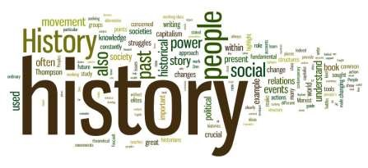
The past is the beginning of the beginning and all that is and has been is but the twilight of the
dawn.
H. G. Wells
History offers learners a wealth of opportunities to progress in their world understanding and not least from a historical stance. History inspires curiosity which allows children to gain perspective from the judgements that they make – judgments made from primary and secondary historical evidence and sources. Through the study of History across the world and different time periods, children gain a sense of personal and national identity and can see the issues that are still troubling the world today whilst avoiding an anachronistic stance on these issues.
History objectives and outcomes, like all subjects, form part of meaningful and relevant learning journeys. Teaching the statutory knowledge, skills and understanding of History results in St Norbert children being equipped with:
Knowledge | of chronology  of significant individuals of locational history  of changes in Britain from the Stone Age to the Iron Age of the Roman Empire and its impact on Britain of Britain’s settlement by Anglo-Saxons and Scots of the Viking and Anglo-Saxon struggle for England of an aspect or theme of British History beyond 1066 of the achievements of the earliest civilizations of Ancient Greece  of a non-European society that contrasts with British History
Skills | Empathy  Anachronistic  Cause and effect  Change and continuity  Written communication
Understanding | Critical thinking, including:  enquiry judgement evaluation analysis interpretation  making connections and contrasts
History Curriculum Overview – Progression
Year Group
Changes within living memory. Where appropriate, these should be used to reveal aspects of change in national life
. Travel and Transport including Significant historical events, people and places in their own locality – Raymond Mays
Events beyond living memory that are significant nationally or globally
. Guy Fawkes, James I and The Gunpowder Plot
The lives of significant individuals in the past who have contributed to national and international achievements.
. Significant Explorers
Events beyond living memory that are significant nationally or globally
. The Great Fire of London
Changes within living memory. Where appropriate, these should be used to reveal aspects of change in national life
Grace Darling RNLI, Long boats (Flag Fen), Spalding Water Taxi
The lives of significant individuals in the past who have contributed to national and international achievements.
Edith Cavell – Local link, Florence Nightingale, Mary Seacole
3 | The Roman Empire and its impact on Britain  for example:  Julius Caesar’s attempted invasion in 55-54 BC  the Roman Empire by AD 42 and the power of its army  successful invasion by Claudius and conquest, including Hadrian’s Wall  British resistance, for example, Boudica  Romanisation’ of Britain: sites such as Caerwent and the impact of technology, culture and beliefs, including early Christianity  The achievements of the earliest civilizations including an overview of where and when the first civilizations through an in depth study of Ancient Egypt.  A study of an aspect or theme in British history that extends pupils’ chronological knowledge beyond 1066  - the changing power of monarchs using case studies such as John, Anne and Victoria
4 | Saxons and Scots  - Roman withdrawal from Britain in c. AD 410 and the fall of the western Roman Empire  - Scots invasions from Ireland to north Britain (now Scotland)  - Anglo-Saxon invasions, settlements and kingdoms: place names and village life • Anglo-Saxon art and culture  - Christian conversion – Canterbury, Iona and Lindisfarne  The Viking and Anglo-Saxon struggle for the Kingdom of England to the time of Edward the Confessor for example:  - Viking raids and invasion • resistance by Alfred the Great and Athelstan, first king of England  - further Viking invasions and Danegeld  - Anglo-Saxon laws and justice • Edward the Confessor and his death in 1066  - a study of an aspect or theme in British history that extends pupils’ chronological knowledge beyond 1066  - changes in an aspect of social history, such as crime and punishment from the Anglo-Saxons to the present
5 | Stone Age to the Iron Age  for example:  - Late Neolithic hunter-gatherers and early farmers, for example, Skara Brae  - Bronze Age religion, technology and travel, for example, Stonehenge  - Iron Age hill forts: tribal kingdoms, farming, art and culture  A study of an aspect or theme in British history that extends pupils’ chronological knowledge beyond 1066  . World War II linked to local forces history  a non-European society that provides contrasts with British history  . Mayan civilization
6 | A study of an aspect or theme in British history that extends pupils’ chronological knowledge beyond 1066  . Leisure and entertainment in the 20th Century  Ancient Greece  . A study of Greek life and achievements and their influence on the western world  The achievements of the earliest civilizations – an overview of where and when the first civilizations appeared and a depth study of one of the following:  . The Shang Dynasty of Ancient China

History
The purpose of History is to gain a coherent knowledge and understanding of Britain’s past and the wider world. History inspires curiosity which allows pupils to gain further knowledge on events from the past. Through the study of History across the world and different time periods, children gain a sense of personal and national identity.
National Curriculum Programme of Study
https://www.gov.uk/government/publications/national-curriculum-in-england-history-programmes-of-study/national-curriculum-in-england-history-programmes-of-study

By the end of Year 1
- Pupils understand national and global events beyond their living memory. The Gunpowder Plot
- Pupils understand changes within living memory that reveal aspects of change in national life - Transport
- Pupils understand and can identify significant historical events, people and places in their own locality. Travel and Transport including a case study of Raymond Mays
- Pupils understand the lives of significant individuals in the past who have contributed to national and international achievements – James I and Guy Fawkes
- Pupils should be able to compare aspects of these individual’s life in different time periods. - Significant Explorers

By the end of Year 2
- Pupils understand national and global events beyond their living memory, the Great Fire of London
- Pupils understand and can identify the lives of significant individuals from the past who have contributed to national and international achievements – Grace Darling RNLI
- Pupils should be able to compare aspects of these individual’s life in different time periods. Mary Seacole and/or Florence Nightingale and Edith Cavell – Local link

By the end of Year 3
- Pupils understand the Roman Empire and the invasion of Julius Caesar.
- Pupils understand the power of the Roman Empire and the power of its army.
- Pupils understand the successful invasion by Claudius and conquest, including Hadrian’s Wall.
- Pupils understand the British resistance.
- Pupils understand the ‘Romanisation’ of Britain and can identify sites such as Caerwent and the impact of technology, culture and beliefs including Christianity.
- Pupils understand and identify where and when the first civilisations appeared.
- Pupils have an in-depth knowledge of the Egyptians.
- Pupils can study of an aspect or theme in British history that extends pupils’ chronological knowledge beyond 1066 of the changing power of monarchs using case studies such as John, Anne and Victoria

By the end of Year 4
- Pupils understand the Scots invaded from Ireland to North Britain (now Scotland).
- Pupils understand and can identify Anglo-Saxon invasions, settlements and Kingdoms.
- Pupils can identify place names and understand what village life was like in the Anglo-Saxon period.
- Pupils develop their understanding of Anglo-Saxon Art and culture.
- Pupils understand Christian conversion.
- Pupils understand the Viking and Anglo-Saxon struggle for the Kingdom of England to the time of Edward the confessor.
- Pupils understand Viking raid and invasions, Danegeld and the resistance shown by Alfred the Great and Athelstan.
- Pupils understand Anglo- Saxon laws and justice and the events leading to and including the death of Edward the Confessor in 1066.
- Pupils will be able to develop an understanding of an aspect or theme in British history that extends pupils’ chronological knowledge beyond 1066 through a study of changes to an aspect of crime and punishment from the Anglo-Saxons to the present

By the end of Year 5
- Pupils develop their understanding of British History that extends their chronological knowledge beyond 1066, through a study of local forces and World War II
- Pupils understand World War II in British History.
- Pupils understand and can identify the Mayan civilization as a society that contrast with British History.
- Pupils understand the Stone Age to the Iron Age through the study of late Neolithic hunter-gatherers and early farmers.
- Pupils understand Bronze Age technology and travel for example Stonehenge.
- Pupils can identify and understand Ion Age hill forts, tribal kingdoms, farming, art and culture

By the end of Year 6
- Pupils understand and can identify Ancient Greece, what Greek life was like, their achievements and their influence on the Western world.
- Pupils develop their understanding of British History that extends their chronological knowledge beyond 1066, through a study of Leisure and Entertainment in the 20th Century
- Pupils will understand the achievements of the earliest civilisations through an in depth study of The Shang Dynasty of Ancient China.

Languages

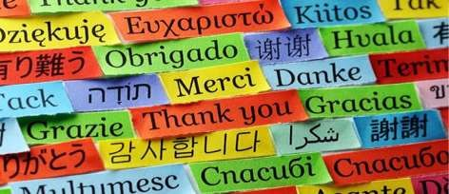
There are over forty languages that are spoken at St Norbert’s Primary School. We know that by sharing and celebrating these diverse languages, children (regardless of their cultural background) children will never feel isolated; in fact, they will feel part of a wider school community where there is an opening to many other cultures around them,
deepening world understanding.
We teach French at St Norbert’s and this Languages teaching and learning fosters further curiosity of Languages and provides children with a solid foundation for studying further Languages at KS3.
Languages objectives and outcomes, like all subjects, form part of meaningful and relevant learning journeys. Teaching the statutory knowledge, skills and understanding of Languages results in St Norbert’s children being equipped with:

Knowledge | of vocabulary of pronunciation and intonation of grammatical structures  of stories, songs, poems and rhyme
Skills | Expression of ideas and thoughts Communication – speaking and listening  Working with others to gain insight and give/receive feedback  Improving own learning – acting upon advice and feedback Applying
Understanding | of French leading to responses in speech and writing

Learning a foreign language is a liberation from insularity and provides an opening to other cultures. A high-quality languages education should foster pupils’ curiosity and deepen their understanding of the world. The teaching should enable pupils to express their ideas and thoughts in another language and to understand and respond to its speakers, both in speech and in writing. It should also provide opportunities for them to communicate for practical purposes, learn new ways of thinking and read great literature in the original language. Language teaching should provide the foundation for learning further languages, equipping pupils to study and work in other countries.
National Curriculum Overview - Progression

By the end of year 3 children should be able to: understand a few spoken words and instructions such as colours, days of the week and numbers. They should be able to say simple greetings, yes and no, name, classroom objects and comment on the weather. Pupils should be able to copy simple phrases correctly such as numbers, colours and a shopping list.

By the end of year 4 children should be able to: understand a range of short spoken phrases about themselves, the weather, their families and school. Children should be able to say where they live, if they have a pet, say when their birthday is and how old they are. They should be able to read simple phrases about the weather and a pet. They should be able to write a couple of short sentences about themselves or simple greetings on a postcard.

By the end of year 5 pupils should be able to: understand parts of a short spoken passage of made up simple sentences. They should be able to recognise short songs and rhymes, a weather report or a telephone message and they and they should be able to describe clothes. Children should be able to ask and answer simple questions about interests. They should be able to discuss a picture with a partner describing things such as colours and shapes. By the end of year 5 children should be able to understand simple text on a postcard or part of a story. They should also be able to write a few short sentences about something that interests them.

By the end of year 6 pupils should be able to: respond to both written and oral language from a variety of sources. They should be able to speak with increasing fluency through discussion and by asking questions. They should speak with increasing accuracy, pronunciation and intonation. Pupils should be able to give short presentation, give opinions. Year 6 children should be able to understand text in a postcard, short poem, part of a story or letter. They should be able to write for different purposes e.g. about themselves, about a picture or about a story using grammatical structures.

Physical Education
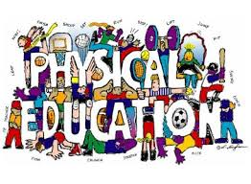
At St. Norbert’s Catholic Primary, Physical Education ensures that our pupils obtain the knowledge and understanding in order to develop and maintain a healthy lifestyle. Every class from Year 1 to Year 6 receives two PE lessons per week, usually comprising of one indoor and one outdoor lesson.

Within our PE lessons we aim to:

- Follow a sequential, developmental curriculum that progressively builds on past experiences and incorporates new experiences when children are ready.

- As Physical Education is a moving experience. We aim to find ways to actively engage all children in moderate to vigorous physical activity for the majority of every lesson, a minimum of 75%.

- In addition to being actively engaged, pupils are offered opportunities to practice the skill or concept being taught that day. Our quality programme provides practice opportunities working individually, in pairs and collaboratively in groups in order to develop knowledge and tactics in devising games and choreographing sequences of movements.

- Provide our pupils of all abilities to have high rates of success through personal challenge and an inclusive approach. When children, particularly less skilled pupils experience success, they are more likely to continue practicing and striving to improve, a positive approach to learning that we encourage in all our pupils.

- Promote successful learning experiences in a warm environment in which children are encouraged to practice new skills and improve their fitness levels without feeling embarrassed.
Knowledge | Running, jumping, catching and throwing  Balance, agility and co-ordination  Flexibility, strength, technique, control and balance  Attacking and defending games  Dance  Competitive games  Swimming and water safety
Skills | Independence  Co-operation  Application  Combination  Communication  Working with others to gain insight and give/receive feedback  Improving own learning – acting upon advice and feedback
Understanding | Critical thinking, including:  - analysis  - interpretation  - evaluation

P.E. Curriculum Overview – Progression

Year Group
Year 1 | Skills:  - To be able to perform basic movements (running, jumping, hopping etc.)  - To be able to throw and catch a ball, beanbag and quoit  - To be able to send an object by rolling it with some accuracy along a line or target, track it and pick it up as it slows down  - Say how we could warm our bodies up before exercising Gymnastics:  - To travel at different speeds and levels  - To make and hold simple shapes  - To link actions to make a sequence  - To be able to create a series of movements Dance:  - To able to perform using simple movement patterns  - To be able to develop balance and co-ordination
Year 2 | Skills:  - To be able to throw and catch a small ball  - To be able to send an object with accuracy by rolling it  - To start to develop spatial awareness within a game situation Gymnastics:  - To be able to balance confidently on a piece of apparatus with agility and co-ordination  - To roll with control and co-ordination  - To be able to make up a basic sequence linking balances and jumps Dance:  - To create and perform a dance motif inspired by a stimulus  - To use and create different movements and body shapes  - To work co-operatively and collaboratively with a partner to create a dance performance
Year 3 | Skills:  - To be able to send and receive an object with accuracy  - To be able to keep possession of an object when not under pressure  - To be able to strike a ball  - To begin to develop fielding skills

Gymnastics:
- To be able to link shapes and partner balances within a sequence
- To be able to hold and control different balances in the air
- To link movements together including, steps, jumps and leaps
- To perform movements and balances including jumps, rolls, vaults, lunges, handstands and cartwheels.
Dance:
- To create and perform an imaginative movements inspired by a stimulus
- To link actions, show awareness of others and create new movements when working in a group
- To improvise and create movements when working with a partner Swimming:
- To be able to swim 25m
Year 4 | Skills:  - To be able to send and receive an object within a game situation to keep possession of the object  - To be able to use any piece of equipment to send an object accurately  - To be able to strike a ball accurately  - To be able to field within a game situation Gymnastics:  - To be able to perform more complex sequences in a pair or small group  - To be able to use a variety of equipment within a sequence  - To perform a range of movements and balances including jumps, rolls, vaults, lunges, handstands and cartwheels.  - To link movements including jumps, leaps and pivots Dance:  - To respond to a stimulus creating and combining movement phrases and skills  - To use a range of dance techniques to create movement sequence including phrases and patterns  - To be able to perform movements within a sequence to create mood OAA:  - To take part in outdoor and adventurous activity individually Swimming:  - To be able to swim 25m using a variety of strokes

Year 5 | Skills:  - To be able to send and receive an object and use it to gain an advantage to keep possession within a competitive situation  - To be able to keep control of any object, using any piece of equipment to gain an advantage in a game situation  - To be able to strike a ball accurately in a competitive situation • To be able to field within a game situation to gain an advantage Gymnastics:  - To be able to perform weight on their hands in a controlled way  - To be able to combine travel and dynamic balances in unison or canon throughout a sequence including jumps, leaps, rolls, squats, vaults, handstands, cartwheels and round offs.  - To plan a sequence of gymnastics movements creatively in a pair and individually Dance:  - To respond to a stimulus creating and combining movement phrases and skills related to different styles of dance  - To use a range of dance techniques to create movement sequence based on a character  - To be able to perform movements within a sequence appropriate to the style and mood of the dance OAA:  - To take part in outdoor and adventurous activity within a team, developing navigation skills Swimming:  - To be able to perform and use some strokes effectively 75  - To begin to perform safe self-rescue techniques
Year 6 | Skills:  - To be able to send and receive an object within a competitive situation to outwit an opponent  - To be able to strike a ball accurately to gain an advantage in a competitive situation  - To be able to use tactics in fielding to gain an advantage Gymnastics:  - To work in a larger group to choreograph and perform a gymnastics routine to music  - To be able to combine travel and dynamic balances in unison or canon throughout a sequence including a variety of jumps, leaps, rolls, squats, vaults, handstands, cartwheels and round offs.
- To perform a series of movements in quick succession linked together to perform a sequence
- Be able to perform sequences using symmetry and asymmetry at different levels using a range of equipment Dance:
- To respond to a stimulus responding freely combining movement phrases and skills in a controlled way
- To perform a variety of dance techniques and styles with accuracy and consistency
- To represent objects and actions using a range of dance phrases
- To be able to analyse their own and their peers performance OAA:
- To take part in outdoor and adventurous activity both individually and with a team
- To be able to navigate a map and take leadership of a small group of children
Swimming:
- To be able to perform and use a range of strokes effectively
- To be able to perform safe self-rescue in different water-based situations

The purpose of physical education is to provide a high-quality curriculum that inspires all pupils to succeed and excel in competitive sport and other physically-demanding activities. It should provide opportunities for pupils to become physically confident in a way which supports their health and fitness. Opportunities to compete in sport and other activities build character and help to embed values such as fairness and respect.
National Curriculum Programme of Study
https://www.gov.uk/government/publications/national-curriculum-in-england-physical-education-programmes-of-study
By the end of Year 1
- Pupils can perform and develop basic movements including running, jumping and hopping, throw and catch basic equipment including a ball, bean bag and quoit and use some accuracy to roll a ball along a line or towards a target.
- Track objects that are rolled and be able to pick them up as they slow down.
- Pupils can say how to warm their bodies up before exercising.
- In gymnastics pupils are able to hold simple shapes, create a series of movements and link actions together in a sequence using different speeds and levels.
- In dance pupils are able to develop balance and co-ordination and perform a piece that encapsulates simple movement patterns.
By the end of Year 2
- Pupils develop skills in order to throw and catch a small ball, accurately send an object by rolling it and master basic movements including running, jumping and hopping.
- Pupils use agility and co-ordination and apply these to a range of activities including starting to develop spatial awareness within a game situation.
- In gymnastics pupils can balance confidently on a piece of apparatus with agility and co-ordination, roll with control and link a sequence of movements including balances and jumps.
- In dance pupils create different movements and body shapes to perform a dance motif inspired by a stimulus.
- Pupils are also able to work collaboratively and co-operatively with a partner or small group.

By the end of Year 3
- Pupils develop skills in order to send and receive objects with accuracy, keep possession of an object when not under pressure and develop fielding skills.
- In gymnastics pupils are able to link shapes and partner balances within a sequence, as well as hold and control different balances in the air.
- Pupils are able to link movements together including, steps, jumps and leaps and perform movements and balances including jumps, rolls, vaults, lunges, handstands and cartwheels.
- In dance pupils create and perform imaginative movements inspired by a stimulus, linking actions and showing awareness of others when working in a group.
- Pupils are also able to use improvisation to create movements when working with a partner.
By the end of Year 4
- Pupils are able to develop skills in order to keep possession of an object and send and receive an object within a game situation.
- Pupils are able to use a piece of equipment to send an object accurately including striking a ball.
- Pupils are also able to field within a game situation.
- In gymnastics pupils are able to perform a range of movements including jumps, leaps and pivots and balances including jumps, rolls, vaults, lunges, handstands and cartwheels in order to perform a more complex sequence within a pairing or small group.
- In dance pupils respond to a stimulus in order to create and combine movement phrases and skills that are performed within a sequence to create mood,
- Pupils are introduced to outdoor and adventurous activity that they can partake in individually.
- To be able to swim 25m using a variety of strokes.
By the end of Year 5
- To be able to send and receive an object and use it to gain an advantage to keep possession within a competitive situation, as well as keep control of any object, using any piece of equipment to gain an advantage in a game situation.
- In gymnastics pupils combine travel and dynamic balances holding weight on their hands in a controlled way, as well as in unison or canon throughout a sequence.
- Pupils plan a sequence of movements including jumps, leaps, rolls, squats, vaults, handstands, cartwheels and round off creatively in a pair and individually.
- In dance pupils respond to a stimulus creating and combining a range of techniques and movement phrases and skills related to different styles of dance.
- Pupils can perform movements based on a character or appropriate to the style and mood of the dance.
- Pupils take part in outdoor and adventurous activity within a team, developing navigation skills
- In swimming pupils are able to perform and use some strokes effectively and begin to perform safe self-rescue techniques.

By the end of Year 6
- Pupils to be able to send and receive an object within a competitive situation to outwit an opponent and gain advantage.
- Pupils are able to use tactics when fielding in order to gain advantage within competitive sports.
- In gymnastics pupils work in a larger group to choreograph and perform a gymnastics routine to music.
- Pupils are able to combine travel and dynamic balances in unison or canon throughout a sequence including a variety of jumps, leaps, rolls, squats, vaults, handstands, cartwheels and round offs in quick succession.
- Sequences use symmetry and asymmetry at different levels using a range of equipment.
- In dance pupils are able to respond to a stimulus responding freely combining movement phrases and skills in a controlled way with accuracy and consistency.
- Pupils are able to represent objects and actions using a range of dance phrases and analyse their own and peer’s performance.
- In outdoor and adventurous activity pupils partake both individually and with a team using a map to navigate and take leadership of a small group of children.
- In swimming pupils perform and use a range of strokes effectively and are able to perform safe self-rescue in different water-based situations.

Music

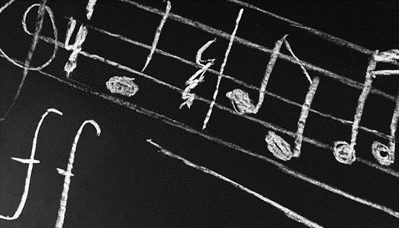
Music Purpose

Music education should engage and inspire pupils to develop a love of music and their talent as musicians, and so increase their self-confidence, creativity and sense of achievement. As pupils progress, they should develop a critical engagement with music, allowing them to compose, and to listen with discrimination.

National Curriculum Programme of Study

https://www.gov.uk/government/publications/national-curriculum-in-england-music-programmes-of-study/national-curriculum-in-england-music-programmes-of-study

Model Music Curriculum 2021(Non-Statutory Guidance)
https://www.gov.uk/government/publications/teaching-music-in-schools

Music Curriculum Overview - Progression

By the end of Year 1

Singing | Use their voices expressively and creatively by singing simple songs and speaking chants and rhymes  Try to math pitch they hear (within a limited range)
Listening | Listen with concentration and understanding to a range of high- quality live and recorded music.  Express how the music makes them feel.  Begin to respond to what they hear in different ways eg: mark-making, movement etc.
Composing | Create musical sound effects and short sequences of sounds in response to stimuli, e.g. a rainstorm or a train journey.  Understand the difference between creating a rhythm pattern and a pitch pattern.  Perform these for others, taking turns.  Recognise how graphic notation can represent created sounds. Explore and invent own symbols, for example:
Performing/Musicianship | Pulse/Beat  Walk, move or clap a steady beat with others, changing the speed of the beat as the  tempo of the music changes.  Respond to the pulse in recorded/live music through movement and dance  Rhythm  Use body percussion and classroom percussion playing repeated rhythm patterns and short, pitched patterns on tuned instruments to maintain a steady beat.  Perform short rhythm patterns accurately, led by the teacher.  Pitch  Listen to sounds in the local school environment, comparing high and low sounds.  Sing familiar songs in both low and high voices and talk about the difference in sound.  Explore percussion sounds to enhance storytelling,

By the end of Year 2

Singing | Use their voices expressively and creatively by singing simple songs and speaking chants and rhymes  Know the meaning of dynamics (loud/quiet) and tempo (fast/slow) and be able to demonstrate these when singing by responding to directions  Try to match pitch they hear (within a limited range)
Listening | Listen with concentration and understanding to a range of high- quality live and recorded music.  Express how the music makes them feel.  Begin to respond to what they hear in different ways eg: mark-making, movement etc.
Composing | Create music in response to a non-musical stimulus  Understand the difference between creating a rhythm pattern and a pitch pattern.  Perform these for others, taking turns.  Use graphic symbols, dot notation or stick notation, as appropriate, to keep a record of composed pieces.
Performing/ Musicianship | Pulse/beat  Understand that the speed of the beat can change,  Mark the beat of a listening piece by tapping/ clapping etc  Rhythm  Play copycat rhythms, copying a leader, and invent rhythms for others to copy on untuned percussion  Pitch  Respond independently to pitch changes heard in short melodic phrases, indicating with actions (e.g. stand up/sit down, hands high/hands low).  Recognise dot notation and match it to 3-note tunes played on tuned percussion, for example:

By the end of Year 3
Compose music for a range of purposes using the inter-related dimensions of music.

Singing | Sing a widening range of unison songs of varying styles and structures with an increased range of pitch.  Sing loud (forte) and soft (piano)  Perform as a choir in school assemblies/ performances
Listening | Appreciate and understand a wide range of high-quality live and recorded music drawn from different traditions and from great composers and musicians  Listen with attention to detail and recall sounds with increasing aural memory.
Composing | Improvise  Become more skilled in improvising (using voices, tuned and untuned percussion and instruments played in whole-class/group/individual/instrumental teaching), inventing short ‘on-the-spot’ responses using a limited note-range.  Pupils should compose in response to different stimuli, e.g. stories, verse, images (paintings and photographs) and musical sources.  Compose  Combine known rhythmic notation with letter names to create rising and falling phrases using just three notes (do, re and mi).  Compose song accompaniments on untuned percussion using known rhythms and note values.
Performing/ Musicianship | Pulse/beat  Understand that the speed of the beat can change,  Mark the beat of a listening piece by tapping/ clapping etc  Rhythm  Play copycat rhythms, copying a leader, and invent rhythms for others to copy on untuned percussion  Pitch  Respond independently to pitch changes heard in short melodic phrases, indicating with actions (e.g. stand up/sit down, hands high/hands low).  Recognise dot notation and match it to 3-note tunes played on tuned percussion, for example:  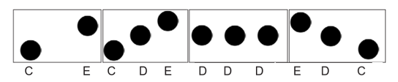  Reading Notation  Introduce the stave, lines and spaces, and clef. Use dot notation to show higher or lower pitch.  Introduce and understand the differences between crotchets and paired quavers.

By the end of Year 4

Singing | Sing a widening range of unison songs of varying styles and structures with an increased range of pitch.  Sing loud (forte) and soft (piano)  Perform as a choir in school assemblies/ performances  Continue to sing a broad range of unison songs with the range of an octave. Pitching the voice accurately and following directions for getting louder (crescendo) and quieter (decrescendo).  Begin to sing rounds and partner songs Perform a range of songs in school assemblies.
Listening | Appreciate and understand a wide range of high-quality live and recorded music drawn from different traditions and from great composers and musicians  Listen with attention to detail and recall sounds with increasing aural memory.
Composing | Improvise  Improvise on a limited range of pitches on the instrument they using, making use of musical features including smooth (legato) and detached (staccato).  Begin to make compositional decisions about the overall structure of improvisations. Continue this process in the composition tasks below.  Compose  Combine known rhythmic notation with letter names to create short pentatonic phrases using a limited range of 5 pitches suitable for the instruments being learnt. Sing and play these phrases as self-standing compositions.  Arrange individual notation cards of known note values (i.e. minim, crotchet, crotchet rest and paired quavers) to create sequences of 2-, 3- or 4-beat phrases, arranged into bars.
Performing/ Musicianship | Instrumental Performance  Play and perform melodies following staff notation using a small range (e.g. Middle C–G/do–so) as a whole-class or in small groups.  Perform in two or more parts (e.g. melody and accompaniment or a duet) from simple notation using instruments played in whole class teaching.  Copy short melodic phrases including those using the pentatonic scale (e.g. C, D, E, G, A).  Reading Notation  Introduce the stave, lines and spaces, and clef. Use dot notation to show higher or lower pitch.  Introduce and understand the differences between crotchets and paired quavers.  Introduce and understand the differences between minims, crotchets, paired quavers and rests.  Read and perform pitch notation within a defined range (e.g. C–G/do–so).  Follow and perform simple rhythmic scores to a steady beat.

By the end of Year 5

Singing | Sing a broad range of songs from an extended repertoire with a sense of ensemble and performance. This should include observing phrasing, accurate pitching and appropriate style.  Sing songs in rounds, partner songs, and songs with a verse and a chorus.  Perform a range of songs in school assemblies and in school performance opportunities.
Listening | Appreciate and understand a wide range of high-quality live and recorded music drawn from different traditions and from great composers and musicians  Listen with attention to detail and recall sounds with increasing aural memory.
Composing | Improvise  Improvise freely over a drone, developing sense of shape and character, using tuned percussion and melodic instruments (where available).  Improvise over a simple groove, responding to the beat, experiment with using a wider range of dynamics, including very loud (fortissimo), very quiet (pianissimo), moderately loud (mezzo forte), and moderately quiet (mezzo piano). Continue this process in the composition tasks below.  Compose  Compose melodies made from pairs of phrases in C major or a key suitable for the instrument chosen. These melodies can be enhanced with rhythmic or chordal accompaniment.  Working in pairs, compose a short ternary (symmetrical eg: ABA structure) piece.  Begin to explore chords to evoke a specific atmosphere, mood or environment. For example, La Mer by Debussy and The River Flows In You by Yiruma both evoke images of water. Equally, pupils might create music to accompany a silent film or to set a scene in a play or book.  Capture and record creative ideas using any of:  - graphic symbols  - rhythm notation and time signatures  - staff notation  - technology.
Performing/ Musicianship | Instrumental Performance  Play and perform melodies following staff notation using a small range (e.g. Middle C–G/do–so) as a whole-class or in small groups.  Perform in two or more parts (e.g. melody and accompaniment or a duet) from simple notation using instruments played in whole class teaching.  Copy short melodic phrases including those using the pentatonic scale (e.g. C, D, E, G, A).  Play melodies on tuned percussion, melodic instruments or keyboards, following staff notation written on one stave and using notes within the Middle C–C′/do–do range. This should initially be done as a whole class with greater independence gained each lesson through smaller group performance.  Understand how triads (3 notes together) are formed, and play them on tuned percussion, melodic instruments or keyboards. Perform simple, chordal accompaniments to familiar songs (e.g. Yellow Submarine by The Beatles).  Reading Notation  Further understand the differences between semibreves, minims, crotchets and crotchet rests, paired quavers and semiquavers.  Introduce the differences between 2/4, 3/4 and 4/4 time signatures.  Read and perform pitch notation within an octave (e.g. C–C′/do–do).  Read and play short rhythmic phrases at sight from prepared cards, using conventional symbols for known rhythms and note durations.

By the end of Year 6

Singing | Sing a broad range of songs, including those that involve syncopated rhythms, as part of a choir, with a sense of ensemble and performance. This should include observing rhythm, phrasing, accurate pitching and appropriate style.  Sing three- and four-part rounds (e.g. Calypso by Jan Holdstock) or partner songs, and experiment with positioning singers randomly within the group –  i.e. no longer in discrete parts – in order to develop greater listening skills, balance between parts and vocal independence.  Perform a range of songs as a choir in school assemblies, school performance opportunities and to a wider audience.
Listening | Appreciate and understand a wide range of high-quality live and recorded music drawn from different traditions and from great composers and musicians  Listen with attention to detail and recall sounds with increasing aural memory.
Composing | Improvise  Extend improvisation skills through working in small groups to:  Create music with multiple sections that include repetition and contrast.  Continue to explore chords and chord changes as part of an improvised sequence.  Extend improvised melodies beyond 8 beats.  Compose  Plan and compose an 8- or 16-beat melodic phrase using the pentatonic scale (e.g. C, D, E, G, A) and incorporate rhythmic variety and interest.  Play this melody on available tuned percussion and/or melodic instruments. Notate this melody.  Either of these melodies can be enhanced with rhythmic or chordal accompaniment.  Compose a ternary(symmetrical) piece; use available music software/apps to create and record it, discussing how musical contrasts are achieved.
Performing/ Musicianship | Instrumental Performance  Play a melody following staff notation written on one stave and using notes within an octave range (do–do); make decisions about dynamic range, including very loud (ff), very quiet (pp), moderately loud (mf) and moderately quiet (mp).  Begin to experiment with accompanying this same melody, and others, using block chords or a bass line. This could be done using keyboards, tuned percussion or tablets, or demonstrated at the board using an online keyboard.  Reading Notation  Further understand the differences between semibreves, minims, crotchets, quavers and semiquavers, and their equivalent rests.  Further develop the skills to read and perform pitch notation within an octave (e.g. C–C/ do–do).  Read and play confidently from rhythm notation cards and rhythmic scores in up to 4 parts that contain known rhythms and note durations.  Read and play from notation a four-bar phrase, identifying note names and durations.

Appreciation and Knowledge of Composers
 | 2019-20 | 2020-21 | 2021-22 | 2022-23 | 2023-24
Advent 1 |  | Henry Purcell (1659-1695) English | Thomas Tallis (1505-1585) English | Antonio Vivaldi  (1678-1741)  Italian | Claudio  Monteverdi  (1567-1643)  Italian
 |  |  | Black musicians:  (Black History Month) |  | Black musicians:  (Black History Month)
Advent 2 |  | Joseph Haydn (1732-1809) Austrian | George Frideric  Handel  (1685-1759)  German | Niccolò Paganini  (1782–1840)  Italian | Johann Pachelbel  (1653-1706) German
Lent 1 | Beethoven  (1770-1827) German | Frederic Chopin  (1810-1849) Polish | Mozart  (1756-1791) Austrian | Fanny  Mendelssohn  (1805-1847) German | Franz Schubert (1797-1828) Austrian
Lent 2 | Louise Farrenc (1804-1875) French | Clara Schumann  (1819-1896) German | Amy Beach  (1867-1944) American | Tchaikovsky  (1840-1893) Russian | Gustav Holst  (1874-1934) English
Pentecost 1 | Benjamin Britten  (1913-1976) English | John Williams  (b. 1932) British | Ella Fitzgerald (1917-1996) American | Sergei Prokofiev  (1891-1953) Russian | Cécile Chaminade  (1857-1944) French
Pentecost 2 | World Music Day  21/6 | World Music Day 21/6 | World Music Day  21/6 | World Music Day  21/6 | World Music Day  21/6
 | Taylor Swift  (b.1989)  American | Anna Clyne (b. 1980) British | Judd Greenstein  (b.1979)  American | Eric Whitacre  (b. 1970) American | Anne Dudley (b.1956)  English

Individual class music learning that is adapted to suit the topics, requirements and expectations detailed in the National Curriculum. In addition to this, we endeavour to foster a wide appreciation and knowledge of composers, genres, influential artists and eras of music. By using a whole school approach, children of all ages will be exposed to a wide range of music, beyond their everyday experience. Additional suggested pieces for extensive listening, appreciating and evaluating is documented within the Model Music Curriculum

Medieval | Renaissance | Baroque | Classical | Romantic | 20th Century | Current
500-1400 | 1400--1600 | 1600--1750 | 1730-1820 | 1780-1910 | 1900-2000 | 2000-present
Composer, Musician & Genre Studies
for use in class, Praise and Worship, Music appreciation and discussion opportunities

Wider Opportunities- Peripatetic Music Tuition
The school actively engages with JMP Music and offers guitar, ukulele, keyboard, piano and singing lessons for children throughout Key Stage 2. Those who play instruments are encouraged to utilise their skills in school by playing in worships or music showcases.

Year 1
 | Advent1 | Advent 2 | Lent 1 | Lent 2 | Pentecost 1 | Pentecost 2
MUSIC | Voices and Instruments | Nativity | BBC 10 Pieces- Finlandia (Sibelius) | Musical Story | Voices and Instruments | The Nutcracker-Tchaikovsky
ART | Picasso -Portraits (drawing, painting, collage) |  |  | Van Gogh (mixed media skills) | Weaving and printing

Year 2

 | Advent1 | Advent 2 | Lent 1 | Lent 2 | Pentecost 1 | Pentecost 2
MUSIC | Animals | Nativity | Djembe Drumming | Musical Story | BBC 10 Pieces- Kerry Andrew- No place like | Water (Pitch and notation-Music Express)
ART | Monet- Landscapes |  |  | Lowry |  | Sculpture

Year 3

 | Advent1 | Advent 2 | Lent 1 | Lent 2 | Pentecost 1 | Pentecost 2
MUSIC | Musical Story/Listening | Ancient Egypt | BBC 10 Pieces- Delia Derbyshire | Easter Play | Musical Story/Listening/ Notation | BBC 10 Pieces- Hans Zimmer- Earth
ART | Russo- Collage |  |  | Renoir- (Painting and drawing) | Mosaic and clay skills

Year 4

 | Advent1 | Advent 2 | Lent 1 | Lent 2 | Pentecost 1 | Pentecost 2
MUSIC | Musical story/ listening/ Notation | BBC 10 Pieces: Britten- Storm Interlude | Viking Saga Songs | Easter Play  Anglo Saxons songs | BBC 10 Pieces Brahms- Hungarian Dance No5 in G Minor | Dragon Scales (Music Express)
ART | Kahlo- drawing and painting |  | Collage and Printing |  |  | Sculpture/ Clay work

Year 5

 | Advent1 | Advent 2 | Lent 1 | Lent 2 | Pentecost 1 | Pentecost 2
MUSIC | BBC 10 Pieces Holst- Mars | BBC 10 pieces Lark Ascending | Listening /notation work/ music story | Easter Play | BBC 10 Pieces- Ravi Shankar | Listening /notation work/ music story
ART | Birds- mixed media skills | Propaganda art- Graffiti- Banksy | Hokusai |  |  | William Morris- Clay work

Year 6

 | Advent1 | Advent 2 | Lent 1 | Lent 2 | Pentecost 1 | Pentecost 2
MUSIC | Listening /notation work/ music story | BBC 10 Pieces: Vivaldi-Winter | Listening /notation work/ music story | BBC 10 Pieces- Grieg- Hall of the Mountain King | Listening /notation work/ music story | Leavers Play
ART | Collage focus |  |  | Sculpture focus | Constable- Landscapes

RE Curriculum at St Norbert’s.

“For all children Religious Education is a proper subject in its own right in the school’s curriculum. It is a rigorous academic discipline, and as such it is to be taught, developed and
resourced with the same commitment as any other subject. For those already engaged in the journey of faith Religious Education will be catechesis, and for some children Religious
Education will be evangelisation, the first opportunity to hear the good news of the gospel.”
(RE Curriculum Directory p.10)

As a Catholic School RE is one of the core subjects alongside English and Maths. In St
Norbert’s Catholic Primary School we follow the scheme recommended by the Nottingham Diocese Education Service, ‘Come and See’. This scheme works on a topic based approach under pinned by the four key constitutions of The Second Vatican Council’. These are:

- Revelation through hearing God’s word
- Christian Living
- The Church and Liturgy
- Celebration.

Each RE topic is taught over four weeks where the children explore the themes of the unit, experience the revelation of the topic in more detail through looking at scripture readings in the Bible and responding by sharing in worships and liturgies linked to the topic. Approximately two and a half hours of RE is taught each week.

Other faiths are taught through topic work as well as whole school focuses on Judaism in Autumn Term and another faith in the Summer Term.

We believe that all aspects of R.E should be woven into the fabric of school life and is also encouraged through links with home, the Parish Church, the local community. As well as other subject areas, especially PSHCE (Physical, Social, Health and Citizenship Education) and P4C (Philosophy for Children).

RSE
At St. Norbert’s we use A Journey in Love a resource created by Sister Jude Groden of BRES. It is the recommended programme of study for Catholic schools for Sex and Relationship Education and has been written as a progressive scheme of work that supports the Religious Education, PSHE and Science curricula taught within the school.

English Writing for a Purpose across the Curriculum

Guidance notes for the four writing purposes in KS1 & 2

We learn to master writing to;
- entertain
- inform
- persuade
- discuss

 | Writing to entertain | Writing to inform | Writing to persuade | Writing to discuss
Years 1 and 2  (KS1) | Story  Description  Poetry | Biography  Leaflet  Diary/journal
Years 3 and 4  (LKS2) | Playscript  Poetry | Instructions  Newspaper | Campaign  Letter
Years 5 and 6  (UKS2) | Narrative  Film | Timeline  Non-Chronological Report | Speech | Argument

Year 1 | Writing to  ENTERTAIN  Story | Writing to  ENTERTAIN  Story | Writing to  INFORM  Leaflet | Writing to  INFORM  Leaflet | Writing to  INFORM  Journal | Writing to  INFORM  Journal
Year 2 | Writing to  ENTERTAIN  Story | Writing to  ENTERTAIN  Story | Writing to  INFORM  Biography | Writing to  INFORM  Biography | Writing to  ENTERTAIN  Poetry | Writing to  ENTERTAIN  Poetry
Year 3 | Writing to  INFORM  Instructions | Writing to  INFORM  Instructions | Writing to  PERSUADE  Letter | Writing to  PERSUADE  Letter | Writing to  ENTERTAIN  Poetry | Writing to  ENTERTAIN  Poetry
Year 4 | Writing to  PERSUADE  Letter/Campaign | Writing to  PERSUADE  Letter/Campaign | Writing to  INFORM  Newspaper | Writing to  INFORM  Newspaper | Writing to  ENTERTAIN  Playscript | Writing to  ENTERTAIN  Playscript
Year 5 | Writing to  INFORM  Non-Chron | Writing to  INFORM  Non-Chron | Writing to  ENTERTAIN  Film | Writing to  ENTERTAIN  Film | Writing to  DISCUSS  Balanced Argument | Writing to  DISCUSS  Balanced Argument
Year 6 | Writing to  INFORM  Timeline | Writing to  INFORM  Timeline | Writing to  ENTERTAIN  Story | Writing to  ENTERTAIN  Story | Writing to  PERSUADE  Speech | Writing to  PERSUADE  Speech

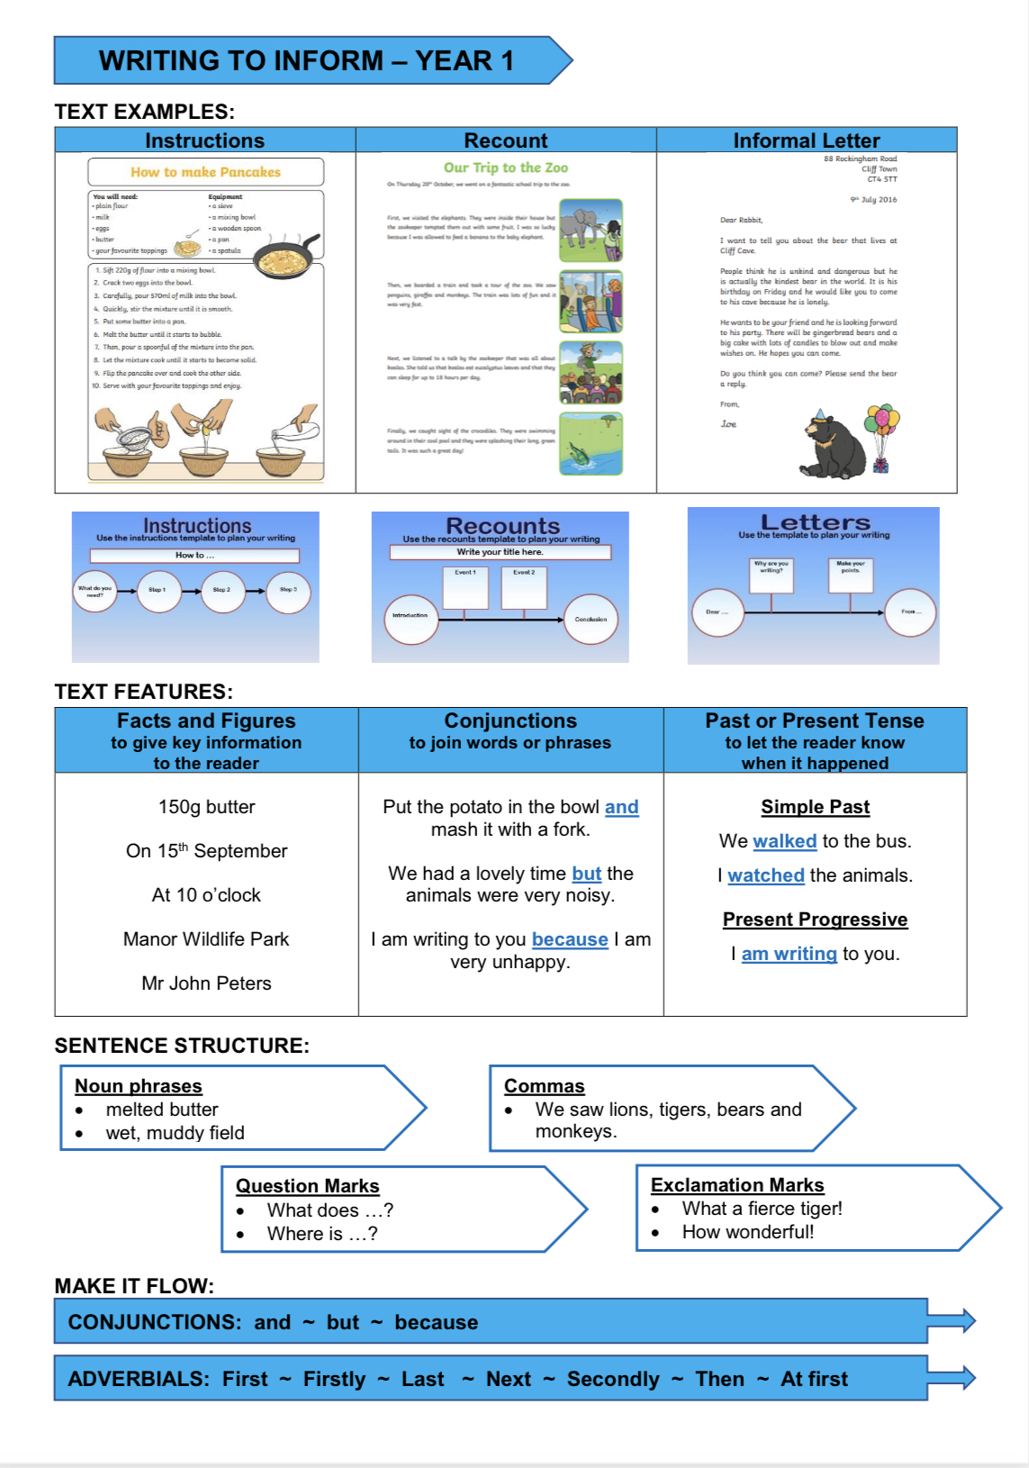

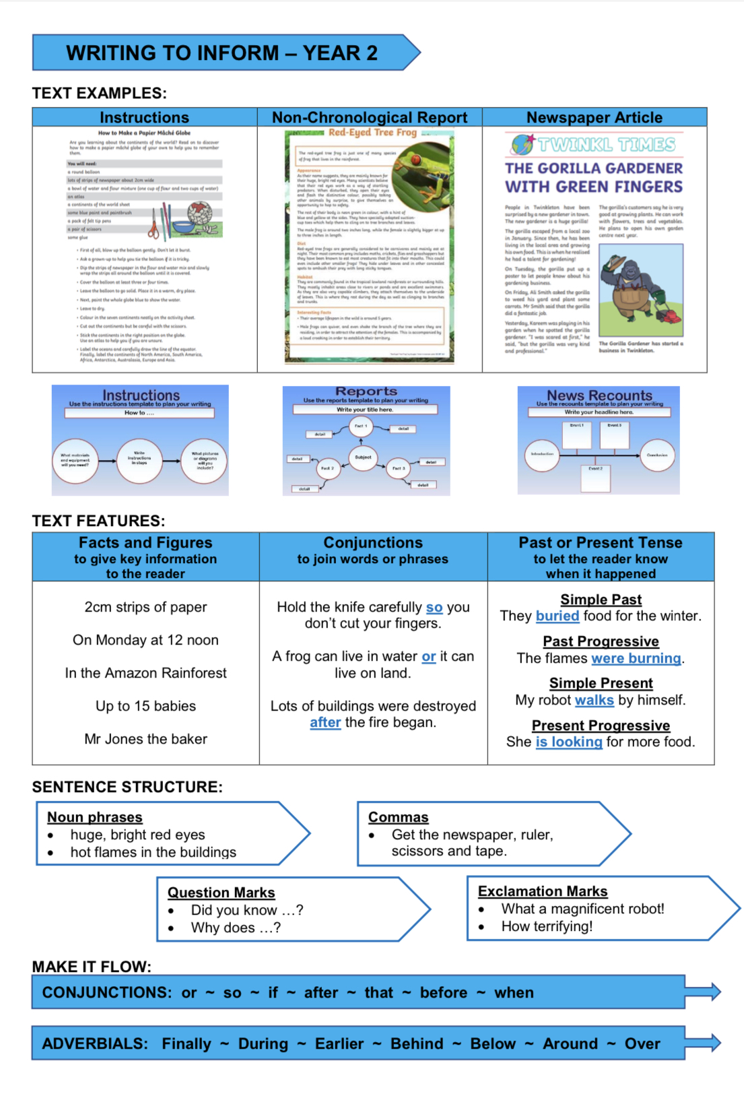

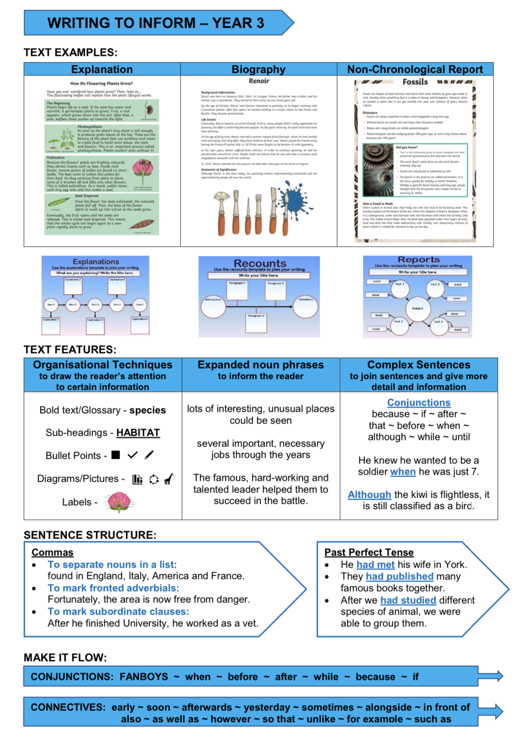
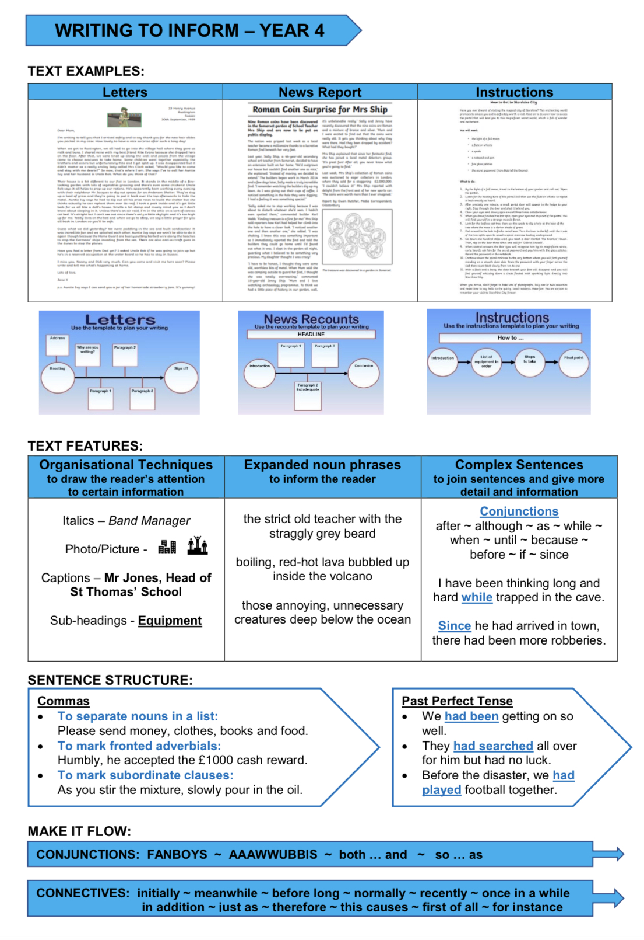

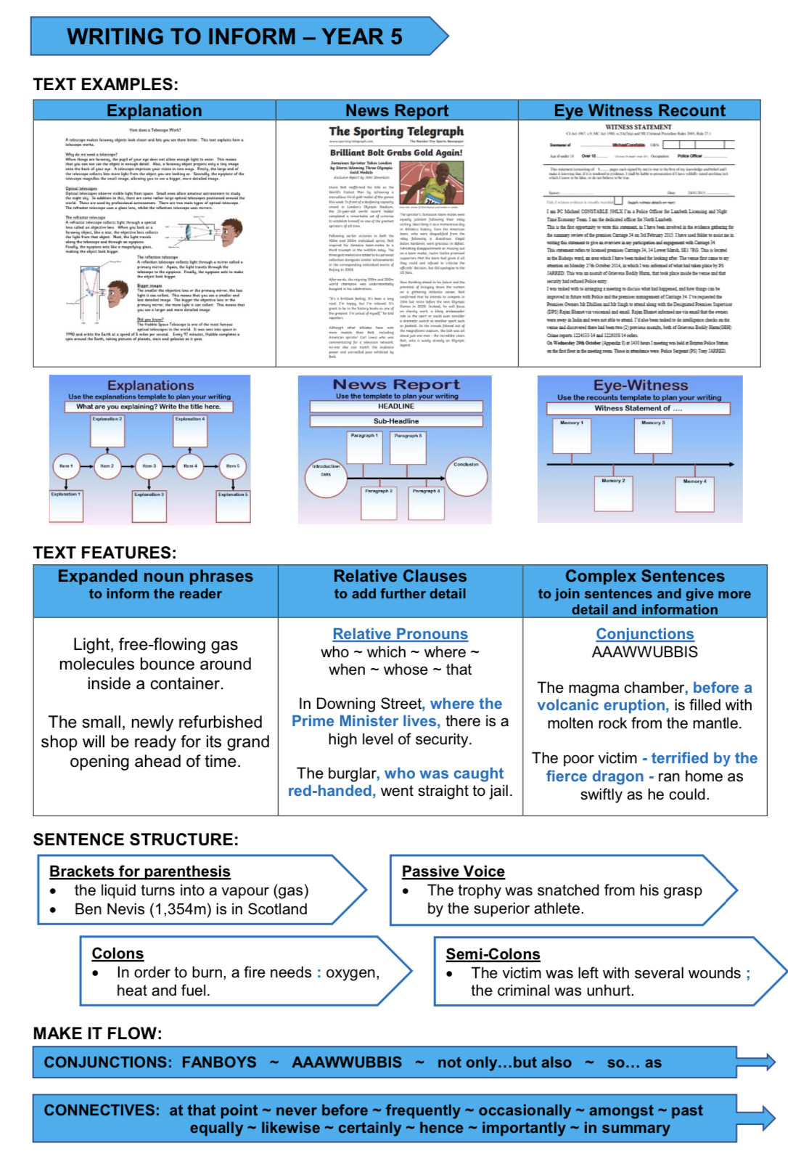

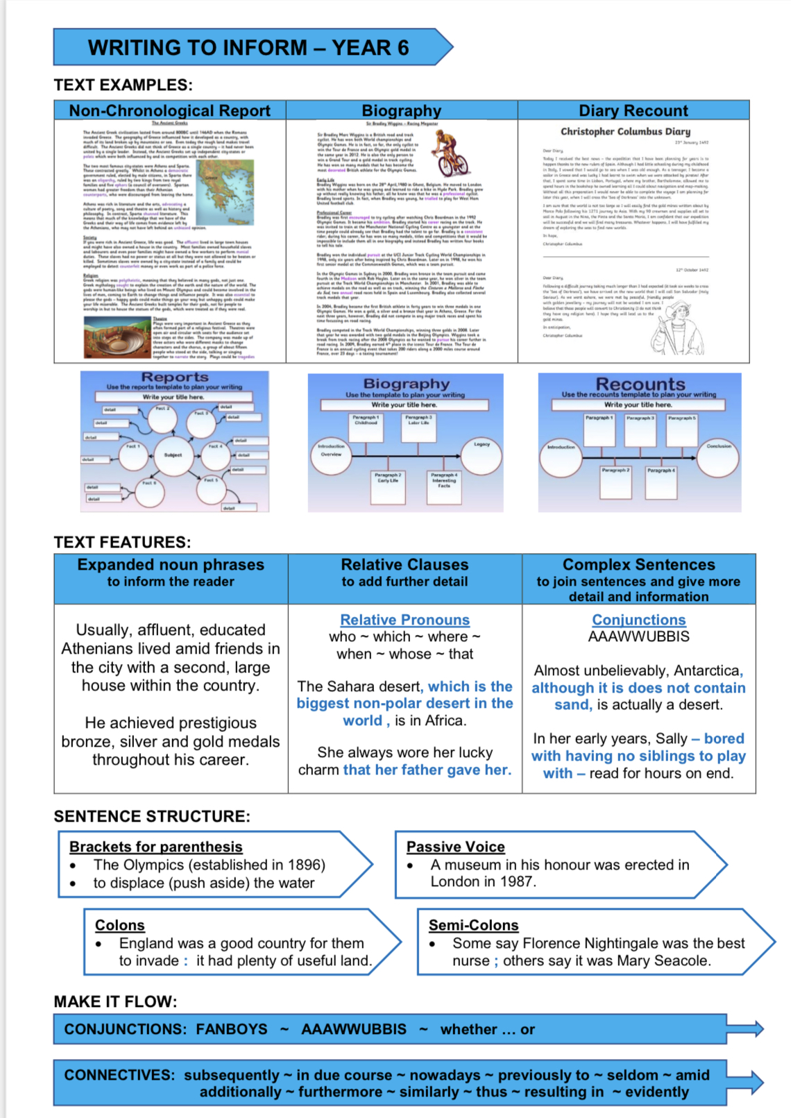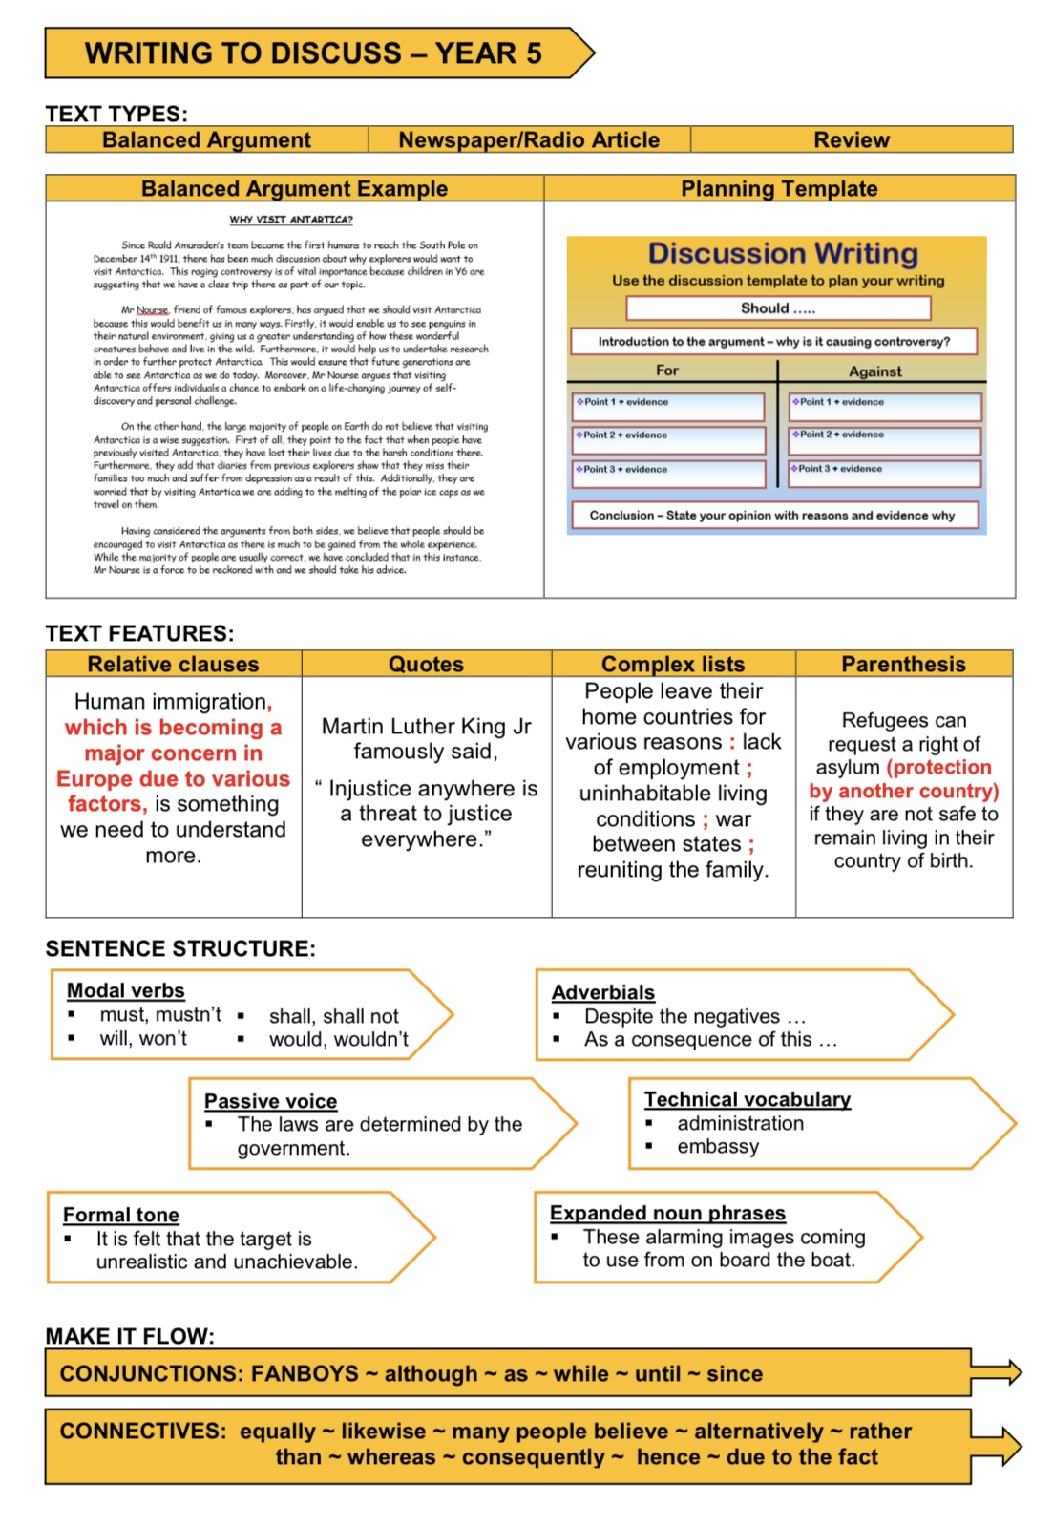

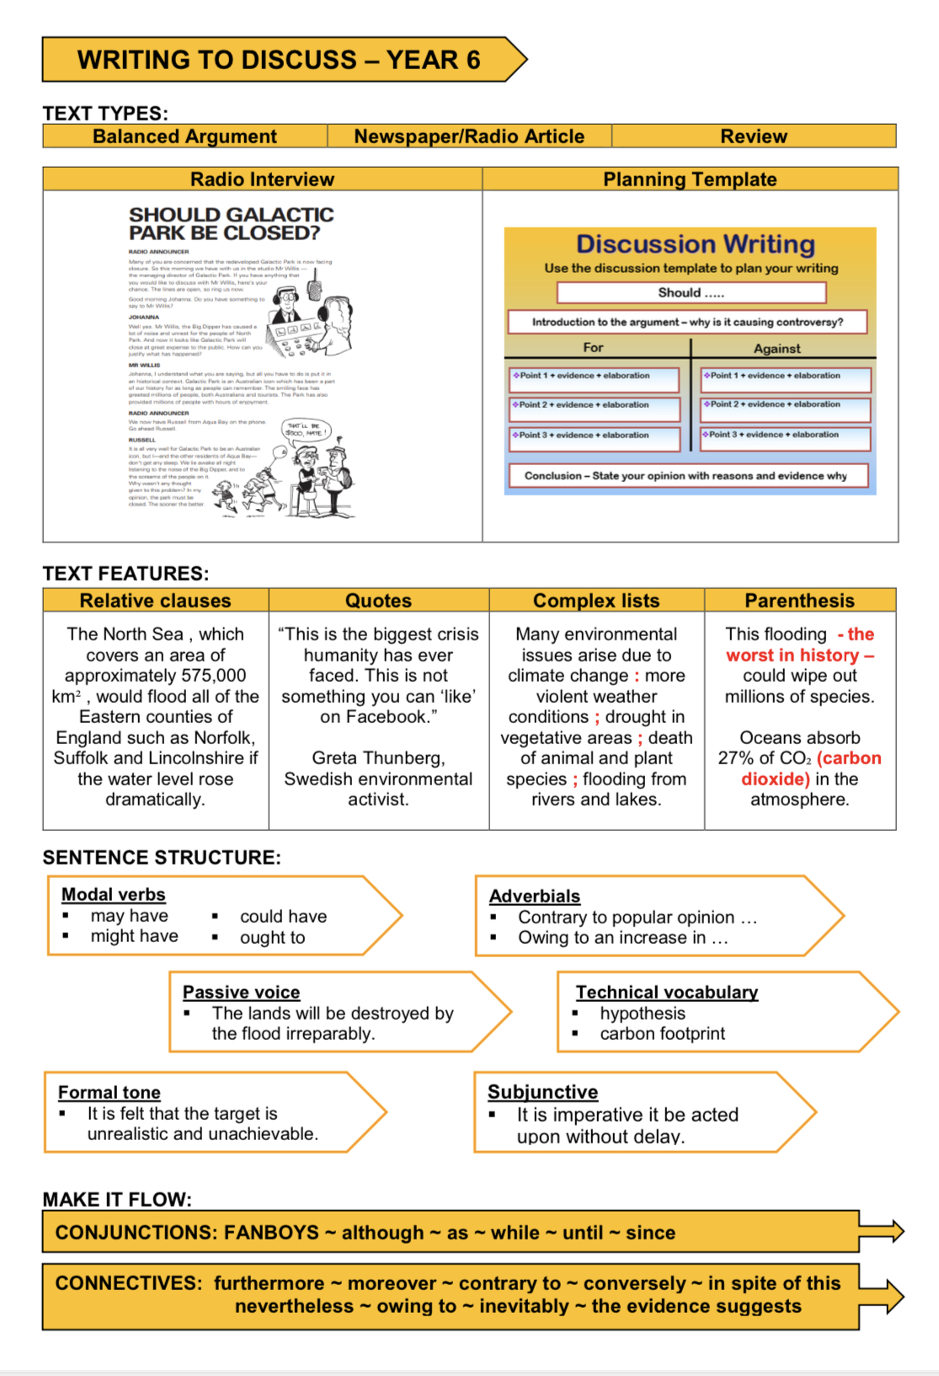

KS1 only focus on the purposes of Entertain and Inform.
Year 3 and 4 look at Inform, Entertain and Persuade.
Year 5 and 6 look at all four purposes.

Staff are welcome to move the order of purposes around as they see fit as long as the weightings remain the same. They are also able to choose which text types they wish to cover within the purpose. However, they must focus on the same purpose for writing with a half term in order for the children to master the skills which are being taught.

- When planning units of work, spend time thinking about which grammar and punctuation objectives from the National Curriculum/No Nonsense Grammar would work well with each purpose, then choose five or six key objectives to really embed within the unit.

- Focus on two main outcomes each half term. This means that in lessons leading up to writing a final piece, we are able to really embed grammar and punctuation skills; spend time investigating vocabulary appropriate to the piece; unpicking high quality examples; creating plans and writing collaboratively with peers.

- When creating writing success criteria/steps to success, ensure that children are given opportunities to embed their skills by using the grammar and punctuation in a different context.

- See below for ideas for reading themes to support teaching English.

Suggested Themes

Year | Themes
EYFS | Interest
1 | Families and Friendships  Love and care  Sharing  Change  Solving a problem
2 | Good over evil  Friendships  Lost and Found  Differences
3 | Good over evil  Relationships  Inclusion
4 | Bereavement  Aspirations  Dilemmas  Relationships
5 | Memories  Trust  Loss  Heroism
6 | Personal Reflection  Fear  Secrets  Bullying

Focused Reading and Reading Across the Curriculum

Expectations:
In terms of reading expectation we are looking to ensure reading is taking place across the curriculum and that a love of reading is encouraged and fostered by all adults. This flexibility in approach and activity is more likely to facilitate mastery reading skills.
There is no expectation to have every class split into guided groups which all have to be listened to once a week. It is expected that reading activities will take place across the curriculum and day and that your professional judgement will be used to decide what is best for your class. So for example a guided reading timetable may change to look like this;

You can also utilise TA’s as we already do, to lead reading interventions/support/boosters

Guided/Shared Reading Guidance
Shared Reading-This is the opportunity to share texts with children that they would not normally access or be able to interpret on their own. The reading skills taught in the shared reading session are usually appropriate to the age of the children rather than their reading ability. However, a skilled teacher will ensure that children of all reading abilities will be able to engage with the text.
Reading activities during the shared session:
Immersion: ‘Book Talk’
  - reading for enjoyment;
  - understanding the text;
  - questioning characters, facts, the author;
  - retrieving information and ideas;
  - interpreting what the author is saying; • responding – personal responses, art,
  - drama, journal work; writing in role.
The teacher’s role in the immersion stage is to elicit response, extend the children’s responses and encourage critique. Comprehension is developed through lots of talk and the exchange of ideas – not through text book comprehension exercises!

Analysis: identifying and commenting on:
  - the author’s style;
  - the author’s use of language;
  - the author’s view point;
  - the structure and organisation of the text;
  - the purpose and audience of the text;
  - links to other texts, times and cultures;
  - how the author’s techniques can inform the children’s writing.

The teacher’s role in the analysis stage is to teach children how to identify authors’ techniques and the intended effect upon the text and the reader. This knowledge is used to inform the children’s own writing.
Basic principles:
  - all children must be able to see the text;
  - the teacher models and then the class or groups read aloud, together; • the text is explored with a particular focus informed by the objective;
  - all children are included through good, differentiated questioning.
  - children are supported in learning how to articulate their responses, interpretation and analysis of what they read.
Guided Reading
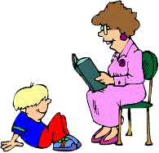
Whereas Shared Reading focuses upon teaching children how to read and respond at a level appropriate to their age, Guided Reading focuses upon teaching children how to progress from their current reading level to the next, whether this be below, at, or above a level appropriate to their age.

  - A group of about six children, who are reading at about the same level, are grouped together.
  - The teacher chooses a book or text that the children are able to read without too much difficulty, (95% accuracy).
  - There is a clear teaching focus for the session based upon the
AFs and the children’s next steps.
  - This focus is shared with the children so that they know what they are learning.
  - The children read independently and individually – not in turn.
  - Beginner readers may read in a quiet voice and the teacher tunes in to listen for reading behaviours and areas for development.
  - Confident readers may read in silence with a focus set by the teacher. They might read in advance of the session which is then devoted to a focused discussion about aspects of the text. • There is a balance of teacher and child talk – with the teacher prompting, and facilitating discussion rather than dominating.

The guided reading sequence:
  - Book introduction, recap or overview of text;
  - Phonics and reading strategies if appropriate;
  - Independent reading with a focus;
  - Returning to the text as a group for further exploration;
  - Response – personal; journals; drama; art; writing in role to inform assessment of understanding.

Reciprocal Reading: Why use reciprocal reading?
- It encourages children to think about their own thought process during reading.
- It helps children learn to be actively involved and monitor their comprehension as they read.
- It teaches children to ask questions during reading and helps make the text more comprehensible.
- It can specifically support children who:

  - Can read but struggle to understand
  - Can’t explain their understanding to others
  - Read very slowly because they are focusing on accurate decoding so never get the flow of the text nor grasp its meaning
  - Read too fast and don’t pay attention to what they are reading
  - Only read for plot events not the details within the writing
  - Lack confidence when reading new or unfamiliar texts
  - Have a limited reading repertoire- who read only very undemanding texts or only texts by the same author for example
  - Have impaired understanding through limited understanding of vocabulary
  - Read text avidly but never question the meaning of words or what they have just read
  - Find it difficult to cope with specialist texts from different curriculum areas
How to use reciprocal reading
Children need to have been taught and had time to practise the four strategies that are used in reciprocal teaching (summarising, questioning, predicting, clarifying).
- Put students in groups of four.
- Give one note card to each member of the group identifying each person’s role:
    - Summariser
    - Questioner
    - Clarifier
    - Predictor
- Ask the children to read a few paragraphs of the text. Encourage them to use notetaking strategies such as selective underlining or post-its to help them better prepare for their role in the discussion.
- At the given stopping point, the Summariser will highlight the key ideas up to this point in the reading
- The Questioner will then pose questions about the text:
  - Unclear parts
  - Puzzling information
  - Connections to other concepts already learned
- The Clarifier will address confusing parts and attempt to answer the questions that were just posed.
- The Predictor can offer predictions about what the author will tell the group next, or if it is a narrative text, the Predictor might suggest what the next events in the story will be.
- The roles in the group then switch one person to the right, and the next section of the text is read.
Children repeat the process using their new roles. This continues until the entire text is read.

- Throughout the process, the teacher’s role is to guide and nurture the children’s ability to use the four strategies successfully within the small group. The teacher’s role is lessened as children develop skill.

Reciprocal Reading

The Questioner:
Your job is to:

- Ask questions to help your group understand and discuss what has been read next time you come together.
You should think of at least 8 questions as you read the book. • Use the following question words and phrases to help:
Who, what, when, why, how, which, where, can, did, how would you feel, what might happen if….

The Clarifier:
Your job is to:
- Clear up any parts of the story you found confusing.
- Find examples of good vocabulary and explain their meaning.
- Find examples of unfamiliar words and punctuation and explain their use or meaning.

The Predictor:
Your job is to:
- Use the story clues and illustrations to predict what is going to happen next in the story or text.
- Use bullet points and the following prompts to help you:
I think……., I bet……, I wonder if…….., I imagine……, I predict…….
The Summariser:
Your job is to:
- Summarise the main things that happened in your reading/story.
- Use bullet points and as little wods as possible to do this.
- Use the following to create short summary sentences:
The main events were…..
The problem/resolutions were….
The characters involved were….
The story was set…..
The most important part to the story was….

Creative Reading Approaches

Freeze frames:
- Still images or silent tableaux to spot light a specific incident in the text;
- Opportunity to scrutinise an incident;
- Body shape and positioning used to convey ideas and emotions;
- Classmates can ‘sculpt’ body shape and language to portray emotions more clearly.

Thought tracking:
- Use in conjunction with Freeze Frame;
- The children not in the freeze frame contribute ideas as if they were speaking the thoughts of one of the characters;
- These can support or contrast with the words that character actually says.

Conscience alley:
- To explore a character’s mind at a moment of crisis or decision;
- To explore the complexity of the decision;
- Two lines of children facing each other;
- Character walks through - line of children voice thoughts for and against.
- When children are familiar with this technique, stop periodically and then challenge the child’s thoughts. Ask them to respond with further argument to extend their reasoning.

Hot seating:
- Close focus upon a character;
- Explores character’s motivation;
- Explores gaps in a character’s story;
- Class ask questions of someone in role;
- Questions can be prepared or improvised;
- Role player and questioners need to be familiar with character.

Forum theatre:
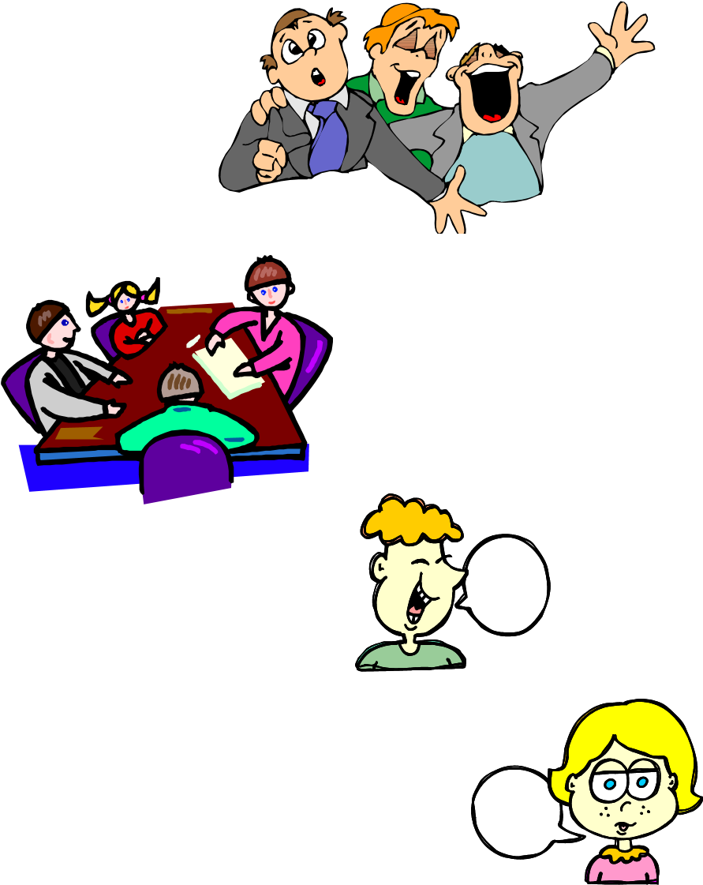
- To view an incident or event from different points of view. • Small group acts out a scene;
- The class direct the group to move, speak act differently;
- Questioning actors in role;
- Suggesting alternative interpretations of what is happening.

Meetings:
- Teacher in role calls a meeting of whole class;
- Information shared with whole group;
- Decisions made about the situation they face;

Paired improvisation:
- Encourages collective role. Children works in pairs;
- Given a role or agree them for themselves;
- Begin dialogue on a signal making the conversation up, as they go along.

Flashbacks and flash forwards:
- Children stop at a particular dramatic action;
- They refocus upon something that happened before that may have caused event;
- Focus on something that might happen later as a consequence of the action;
- Other techniques used to review situation from different perspectives; e.g. freeze-frame; • Crystal ball – what might this character be doing in 5, 10, 20, 30 years?

Visualisation
- The teacher reads a text/poem to the children;
- Whilst listening, the children sketch what they imagine onto a plain piece of paper – or scene by scene into boxes.
- They annotate their drawing with words and phrases from the text.

Role on the wall
- A large body-shape is drawn onto a large piece of paper.
- The body shape represents one of the characters in a fiction book or a character from history or popular culture.
- The children write the character’s feelings, or their own feelings about the character, onto post-it notes and stick these inside the body shape. They write facts about the character on different coloured post-its and stick these around the edge of the character.
- Vary this with different colour post-its; what you know about a character placed inside body
(direct retrieval from text), what you think you know placed immediately outside body (inference) and sometimes also what you’d like to know about the character placed around the edge of the paper.
- When reading a novel as a class or guided group, redo the role on the wall during the novel – has our knowledge or thoughts about the character changed etc.?

These techniques are supported by response stems – sentence starters to help the children to articulate (and ultimately write) answers to comprehension questions.
- The author wants me to feel/imagine;
- This makes me imagine;
- The effect of this simile is to make the reader . . . .
- The author has used this phrase to give the impression that . . .

This is also supported by the PEE prompt.
The PEE prompt can help you answer the 2 and 3 mark questions.
- P—make your Point.
- E—find Evidence in the text to support your answer.
- E—Explain or Elaborate upon your answer.
e.g. ‘I think that Jack is a stupid boy. I know this because in the text it says, ‘Jack was not bothered by intelligence. This makes Jack appear simple, but content to be the way he
was.

Novel as theme
- Writing to/from one of the characters;
- Writing an extra scene;
- Re-writing a passage from another’s point of view;
- Asking the author questions;
- Taking the setting and writing a factual report about such settings;
- Drawing the setting and annotating with words, phrases, similes and metaphors.
- Putting yourself into the book and adding your own dialogue/responses.
- All the above drama techniques to explore themes and ideas.

EYFS and KS1 READING
- Make sight words out of gingerbread dough. (get children to make a word you are trying to add to their sight vocabulary). Once cooked, they can be read and then eaten! Children have to recall who ate which word and find 'their' word on the word wall.
- Organise a word hunt - make a set of some HF Words for each child and a duplicate set that have been hidden in a variety of places. Children can work independently or in pairs to find them. The words can be tailored to their individual needs. Great for outdoor literacy!
- Make prop boxes for re-enacting stories
- Set up small world play activities for retelling e.g. We're Going on a Bear Hunt by Michael Rosen could use a (BRAND NEW, not used!) cat litter tray for each section of the story (thick oozy mud, long wavy grass) etc... Helps with sequencing, oral language etc..
- Story sacks
- Role play stories e.g. turn role play area into the 3 bears' cottage and provide relevant props
- Artwork - allow younger children to draw and paint pictures of well-loved stories and use them to talk about the 'who, where, why, what' of a story. Graduate to 'setting, characters, problem and ending' for Y1 upwards.
- Dressing up, role play and hot seating. Younger children can find it too abstract unless you provide some costumes/props.

Creating a Reading Community

Reading buddies
Decide on your focus first. What do you want to achieve? Do you want to focus on promoting simply enjoyment of reading? Or do you want to give children the opportunity to practise reading aloud? Or are you focussing on improving comprehension by giving children the opportunity to discuss books? Then decide on pairings. Will it be older children with younger children? Less confident readers paired with more confident readers? Pairing children of similar ability or with similar reading interests? Train reading buddies before they begin and consider timetabling a regular slot for children to pair up with their reading buddy.

Boys’ reading
Organise reading groups specifically for boys. Display posters and photographs of men reading eg take photographs of dads with their favourite book.

Reading is about enjoyment.
Offer and display a breadth of reading materials such as magazines, newspapers, comics, fiction and non-fiction books, poetry and websites.

Reading is something very individual.
Think about Readers’ Rights eg right to not finish a book, skip pages, dislike a book.

Parents in the library
Reserve an area of the library for parents and allow parents to borrow books from the school library.

Celebratory events
Promote reading achievement at celebratory events, especially those to which families are invited. Present children who have completed a reading challenge or become Reading Champions with a certificate.

Sports days and summer fairs
Set up a stall with relevant reading materials at events to which families are invited.

Parents' evening
At parents' evenings, encourage teachers to direct parents towards a reading for pleasure stall.

Ambassador sessions
Ask a parent who can inspire and relate to other parents to take on the role of family reading ambassador. Ask your ambassador to come in during a school event to talk to families about the importance of reading in the home.

Demystify the jargon for parents. When explaining to parents how they can help their child with reading, try to avoid using jargon.

Library visits. Plan a trip to the local library exclusively for parents. During the visit, encourage parents to join the library and inform them about all the services and different activities that take place there.

Book Swap Cupboard on Playground for families

Recipe book
Ask parents to design their own page of a recipe book, which once compiled could be distributed to all parents or sold to raise funds for the school library.

Parents in lessons
Invite parents and wider family members to come into school to take part in reading activities in class.

National Children's Book Week (first full week of October)
During National Children's Book Week, organise a tea party themed around a popular children's book about food, for example 'Mrs Wobble the Waitress'. Encourage children and adults to read the book before the event and invite families to attend the party. Visit www.booktrust.org.uk.

National Storytelling Week (end of January - beginning of February) Invite professional storytellers to school.

How to read a picture
As a precursor activity to any reading activity, engage parents and wider family members by introducing the 'How to read a picture' activity. Give them a picture and ask them to imagine what the relationship is between the people in it, what happened before the picture was taken, what will happen afterwards and what is being discussed. This is a good icebreaker activity and will help participants to understand the value of a picture book for children and how it helps develop their imagination and powers of prediction.

Storytelling workshops
Set up a 'Bedtime Story' workshop/club in school and encourage families to exchange children's bedtime stories with each other. For follow-up sessions, introduce the idea of compiling all the stories for the school or website or a book.

Storyteller visits
Consider inviting a professional storyteller to your sessions to give top tips and help with technique. A list of storytellers is available from Reading Is Fundamental, UK project zone at www.rif.org.uk.

Memory boxes
Ask families to create memory boxes at home, including family photos, books or pieces of music. Use these boxes as a starting point for sharing personal stories.

Transition (primary - secondary) -School library visits
Offer primary school pupils and their families the chance to visit the secondary school library.

Key Stage 2 Reading Progression
Year 3 | Word Reading |  | Comprehension
 |  |  | Develop positive attitudes to reading and understanding of what they read by
 | Apply their growing knowledge of root words, prefixes and suffixes (etymology and morphology) as listed in English Appendix 1, both to read aloud and to understand the meaning of new words they meet | Read exception words, noting the unusual correspondences between spelling and sound, and where these occur in the word | Listening o and discussing a wide range of fiction, poetry, plays, non-fiction and reference books or textbooks | Reading books that are structured in different ways and reading for a range of purposes | Using dictionaries to check the meaning of words that they have read | Increasing their familiarity with a wide range of books, including, fairy stories, myths and legends and retelling some of these orally | Identifying themes and conventions in and across a wide range of books | preparing poems and play scripts to read aloud and to perform, showing understanding through intonation, tone, volume and action | Discussing words and phrases that capture the reader’s interest and imagination | Recognising some different forms of poetry (for example free verse, narrative poetry)
Year 3 |  |  | Understand what they read by
 |  |  | Checking that the text makes sense to them, discussing their understanding and explaining the meaning of words in context | Asking questions to improve their understanding of a text | Drawing inferences such as inferring characters’ feelings, thoughts and motives from their actions, and justifying inferences with evidence | Predicting what might happen from details stated and implied | Identifying main ideas drawn from more than paragraph and summarising these | Identifying how language, structure, and presentation contribute to meaning
Year 3 |  |  | Further Comprehension
 |  |  | Retrieve, record and present information from non-fiction |  | Participating in discussions about books that are read to them and those they can read for themselves, taking turns and listening to what others say

Develop positive attitudes to reading and understanding of what they read by
Apply their growing knowledge of root words, prefixes and suffixes (etymology and morphology) as listed in English Appendix 1, both to read aloud and to understand the meaning of new words they meet | Read exception words, noting the unusual correspondences between spelling and sound, and where these occur in the word | Listening o and discussing a wide range of fiction, poetry, plays, non-fiction and reference books or textbooks | Reading books that are structured in different ways and reading for a range of purposes | Using dictionaries to check the meaning of words that they have read | Increasing their familiarity with a wide range of books, including, fairy stories, myths and legends and retelling some of these orally | Identifying themes and conventions in and across a wide range of books | preparing poems and play scripts to read aloud and to perform, showing understanding through intonation, tone, volume and action | Discussing words and phrases that capture the reader’s interest and imagination | Recognising some different forms of poetry (for example free verse, narrative poetry)
Year 4 |  |  | Understand what they read by
 |  |  | Checking that the text makes sense to them, discussing their understanding and explaining the meaning of words in context | Asking questions to improve their understanding of a text | Drawing inferences such as inferring characters’ feelings, thoughts and motives from their actions, and justifying inferences with evidence | Predicting what might happen from details stated and implied | Identifying main ideas drawn from more than paragraph and summarising these | Identifying how language, structure, and presentation contribute to meaning | Retrieve, record and present information from non-fiction
Year 4 |  |  | Further Comprehension
 |  |  | Participating in discussions about books that are read to them and those they can read for themselves, taking turns and listening to what others say

Year 5 | Word Reading | Comprehension
 |  | Maintain positive attitudes to reading and understanding of what they read by
 | Apply their growing knowledge of root words, prefixes and suffixes (etymology and morphology) as listed in English Appendix 1, both to read aloud and to understand the meaning of new words they meet | Continuing to read and discuss an increasingly wide range of fiction, poetry, plays non-fiction and reference books or textbooks | Reading books that are structured in different ways and reading for a range of purposes | Increasing their familiarity with a wide range of books, including, myths, legends and traditional stories, modern fiction, from literary heritage, others cultures and traditions | Recommending books that they have read to their peers, giving reasons for their choices | Identifying and discussing themes and conventions in and across a wide range of writing | Making comparisons within and across books | Learning a wider range of poetry by heart | preparing poems and play scripts to read aloud and to perform, showing understanding through intonation, tone, volume so that the meaning is clear to an audience
Year 5 |  | Understand what they read by
 |  | Checking that the text makes sense to them, discussing their understanding and explaining the meaning of words in context | Asking questions to improve their understanding of a text | Drawing inferences such as inferring characters’ feelings, thoughts and motives from their actions, and justifying inferences with evidence | Predicting what might happen from details stated and implied | Summarising the main ideas drawn from more than one paragraph identifying key details that support the main ideas | Identifying how language, structure, and presentation contribute to meaning | Participate in discussion about both books that are read to them and those they can read for themselves, taking turns and listening to what others say
Year 5 |  | Further Comprehension
 |  | Discuss and evaluate how authors use language, including figurative language, considering the impact on the reader | Distinguish between statements of fact and opinion | Retrieve, record and present information from non-fiction | Participating in discussions about books that are read to them and those they can read for themselves, building on their own and others’ ideas and challenging views courteously | Explain and discuss their understanding of what they have read, including through formal presentation and debates, maintaining a focus on the topic and using notes where necessary | Provide reasoned justifications for their views

 | Word Reading | Comprehension
 |  | Maintain positive attitudes to reading and understanding of what they read by
Year 6 | Apply their growing knowledge of root words, prefixes and suffixes (etymology and morphology) as listed in English Appendix 1, both to read aloud and to understand the meaning of new words they meet | Continuing to read and discuss an increasingly wide range of fiction, poetry, plays non-fiction and reference books or textbooks | Reading books that are structured in different ways and reading for a range of purposes | Increasing their familiarity with a wide range of books, including, myths, legends and traditional stories, modern fiction, from literary heritage, others cultures and traditions | Recommending books that they have read to their peers, giving reasons for their choices | Identifying and discussing themes and conventions in and across a wide range of writing | Making comparisons within and across books | Learning a wider range of poetry by heart | preparing poems and play scripts to read aloud and to perform, showing understanding through intonation, tone, volume so that the meaning is clear to an audience
Year 6 |  | Understand what they read by
 |  | Checking that the text makes sense to them, discussing their understanding and explaining the meaning of words in context | Asking questions to improve their understanding of a text | Drawing inferences such as inferring characters’ feelings, thoughts and motives from their actions, and justifying inferences with evidence | Predicting what might happen from details stated and implied | Summarising the main ideas drawn from more than one paragraph identifying key details that support the main ideas | Identifying how language, structure, and presentation contribute to meaning | Participate in discussion about both books that are read to them and those they can read for themselves, taking turns and listening to what others say
Year 6 |  | Further Comprehension
 |  | Discuss and evaluate how authors use language, including figurative language, considering the impact on the reader | Distinguish between statements of fact and opinion | Retrieve, record and present information from non-fiction | Participating in discussions about books that are read to them and those they can read for themselves, building on their own and others’ ideas and challenging views courteously | Explain and discuss their understanding of what they have read, including through formal presentation and debates, maintaining a focus on the topic and using notes where necessary | Provide reasoned justifications for their views

Maths Curriculum Document
Our school has adapted from the White Rose Hub’s calculation document, White Rose Scheme of Work and coupled with high quality staff training, the following Maths overview for each Year Group. We’ve adapted our practice within school altering our approach and provision. ‘Mastery’, as highlighted frequently within Mathematical documentation and resourcing relates to an expectation for all our children, creating a base for all high quality Maths provision throughout the school.

This document is a statement of the aims, principles and guidance for teaching and learning of Mathematics at St. Norbert’s Voluntary Academy. It is designed to help teachers and staff at St. Norbert’s ensure that Maths provision, is taught through a concrete, pictorial and abstract approach. Following the White Rose overview guidance and Scheme of Work, supplemented by our own understanding and school based resources, we aim to offer a high quality provision within the three areas leading towards pupils becoming Mathematically literate.
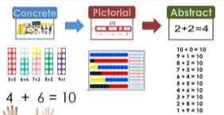
It is strongly advised that all staff read the school’s Maths Policy and Calculation Policy which sets out the subject headings of addition, subtraction, multiplication and division identifying within each specific area the progression of skills, knowledge and layout for more formal written methods. These documents identify calculation strategies your year group should adopt and provides breadth for moving from concrete to pictorial and then onto abstract recording, leading to more formal written methods. These methods include the use of mental methods, recalling all key number bonds, facts, times tables and similar as pupils progress through the school.

A variety of mental calculation methods will be taught enabling all children to access and succeed, alongside which, the recalling of facts will be taught and tested regularly through ‘Cold Maths’; drop-everything-and-count; Times tables tests. The progression of mental methods and expectations will comply with the New National Curriculum Statements from July 2014.

At St. Norbert’s it is important that staff always use correct mathematical language within their Year group and encourage this understanding of language from every pupil. This will take place in class discussions, Working Walls, Maths vocabulary posters and displays, as well as through oral and written feedback, next steps and target setting.

The basis of our Maths provision is enabling children to be competent across a range of problem solving strategies; able to use and apply visual representations; moving into abstract written methods which are complementary to mental methods enabling greater levels of success across all Year groups.
Mental methods should not be seen as separate from them but as an integral part in being mathematically literate. Children should use mental methods when appropriate, but for calculations that they cannot do in their heads they use an efficient written method accurately and with confidence, appropriate to their Year group.

What will ‘Good Quality Maths Teaching achieve?’
- A consistent and progressive approach to calculation, enabling a smooth transition between year groups.
- Pupils are able to understand the underlying ideas and they develop ways of recording to support their thinking and calculation methods, using particular methods that apply to special cases.
- Enabling children to learn to interpret and use signs, symbols and vocabulary.
- Children will acquire secure mental methods of calculation and one efficient written method of calculation for addition, subtraction, multiplication and division which they know they can rely on when mental methods are not appropriate.
- It will ensure that children can use these methods accurately with confidence and understanding.
- Pupils methods of calculating will be underpinned by a secure and appropriate knowledge of number facts, along with the mental skills that are needed to carry out the process and judge if it was successful.
- It will ensure that pupils are competent in fluency, reasoning and problem solving and can make informed and appropriate choices about the methods they wish to use (mental or written) to solve mathematical problems efficiently and effectively in real life contexts.

Curriculum Links
It can be an issue to gain the depth and coverage - it’s not easy to cover the full content of the curriculum in the depth necessary, however using the small-steps documents, links we have as a school to ‘Classroom Secrets’ and the range of resources available in the school the process becomes more manageable. Identifying cross curricular links to your Maths overview will enable a far greater use of skills and application of skills throughout the curriculum thus improving pupils’ outcomes as a direct result. White Rose’s small step approach is designed to ensure that all pupils will come back to topics time and time again, both within the study of the same area of mathematics and in other areas so that they will continue to deepen their understanding through this revisiting and interleaving.

Assessment Opportunities
Utilising the end of unit or end of block assessments is a clear way of monitoring progress during and at the end of a taught block of learning. The use of such tools will enable you as the teacher to identify children, small groups for intervention purposes or for returning to later in the year. Pre-teaching of a block will also help you understand those with misconceptions, identify children for support and those needing deeper dives in their breadth of study.

Maths Annual Overview Plans For EYFS – YR6
In adapting the White Rose Scheme of Work and linking this with our understanding of Concrete, Pictorial and Abstract mathematical teaching, we are able to provide all children (Mastery) with access to a wider understanding of how their Maths learning connects together over time. The White Rose documents provided to all staff enable both an overview of their respective year group and a ‘SmallStep’ guidance document which underpins, supports and tackles misconceptions at the pre-teach stage. It is anticipated that all staff will follow the units and headings identified in the Year Group overviews, whilst also making professional judgments about their children, their learning and where certain teaching might be more beneficial.

Reception Maths Overviews
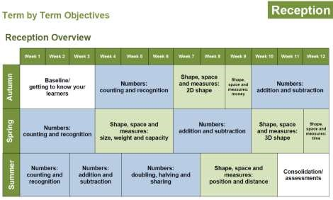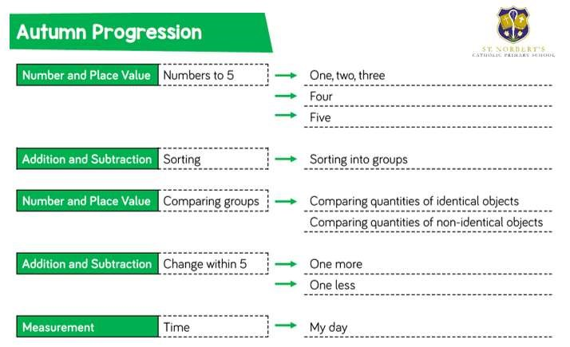

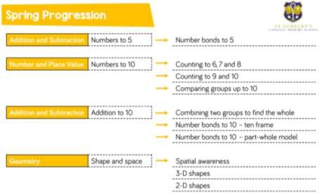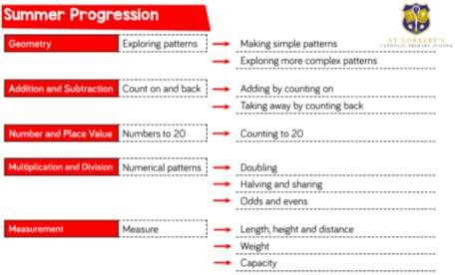

Maths Curriculum Document
Our school has adapted from the White Rose Hub’s calculation document, White Rose Scheme of Work and coupled with high quality staff training received from Jenny Cook Maths Consultancy last Autumn, the following Maths overview for each Year Group. We’ve adapted our practice within school altering our approach and provision. ‘Mastery’, as highlighted frequently within Mathematical documentation and resourcing relates to an expectation for all our children, creating a base for all high quality Maths provision throughout the school.

This document is a statement of the aims, principles and guidance for teaching and learning of Mathematics at St. Norbert’s Primary School. It is designed to help teachers and staff at St. Norbert’s Primary School ensure that Maths provision, is taught through a concrete, pictorial and abstract approach. Following the White Rose overview guidance and Scheme of Work, supplemented by our own understanding and school based resources, we aim to offer a high quality provision within the three areas leading towards pupils becoming Mathematically literate.
It is strongly advised that all staff read the school’s Maths Policy and Calculation Policy which sets out the subject headings of addition, subtraction, multiplication and division identifying within each specific area the progression of skills, knowledge and layout for more formal written methods. These documents identify calculation strategies your year group should adopt and provides breadth for moving from concrete to pictorial and then onto abstract recording, leading to more formal written methods. These methods include the use of mental methods, recalling all key number bonds, facts, times tables and similar as pupils progress through the school.

A variety of mental calculation methods will be taught enabling all children to access and succeed, alongside which, the recalling of facts will be taught and tested regularly through ‘Cold Maths’; drop-everything-and-count; Times tables tests. The progression of mental methods and expectations will comply with the New National Curriculum Statements from July 2014.

At St. Norbert’s it is important that staff always use correct mathematical language within their Year group and encourage this understanding of language from every pupil. This will take place in class discussions, Working Walls, Maths vocabulary posters and displays, as well as through oral and written feedback, next steps and target setting.

The basis of our Maths provision at St. Norbert’s primary school is enabling children to be competent across a range of problem solving strategies; able to use and apply visual representations; moving into abstract written methods which are complementary to mental methods enabling greater levels of success across all Year groups.
Mental methods should not be seen as separate from them but as an integral part in being mathematically literate. Children should use mental methods when appropriate, but for calculations that they cannot do in their heads they use an efficient written method accurately and with confidence, appropriate to their Year group.

What will ‘Good Quality Maths Teaching achieve?’
- A consistent and progressive approach to calculation, enabling a smooth transition between year groups.
- Pupils are able to understand the underlying ideas and they develop ways of recording to support their thinking and calculation methods, using particular methods that apply to special cases.
- Enabling children to learn to interpret and use signs, symbols and vocabulary.
- Children will acquire secure mental methods of calculation and one efficient written method of calculation for addition, subtraction, multiplication and division which they know they can rely on when mental methods are not appropriate.
- It will ensure that children can use these methods accurately with confidence and understanding.
- Pupils methods of calculating will be underpinned by a secure and appropriate knowledge of number facts, along with the mental skills that are needed to carry out the process and judge if it was successful.
- It will ensure that pupils are competent in fluency, reasoning and problem solving and can make informed and appropriate choices about the methods they wish to use (mental or written) to solve mathematical problems efficiently and effectively in real life contexts.

Curriculum Links
It can be an issue to gain the depth and coverage - it’s not easy to cover the full content of the curriculum in the depth necessary, however using the small-steps documents, links we have as a school to ‘Classroom Secrets’ and the range of resources available in the school the process becomes more manageable. Identifying cross-curricular links to your Maths overview will enable a far greater use of skills and application of skills throughout the curriculum thus improving pupils’ outcomes as a direct result. White Rose’s small step approach is designed to ensure that all pupils will come back to topics time and time again, both within the study of the same area of mathematics and in other areas so that they will continue to deepen their understanding through this revisiting and interleaving.

Assessment Opportunities
Utilising the end of unit or end of block assessments is a clear way of monitoring progress during and at the end of a taught block of learning. The use of such tools will enable you as the teacher to identify children, small groups for intervention purposes or for returning to later in the year. Pre-teaching of a block will also help you understand those with misconceptions, identify children for support and those needing deeper dives in their breadth of study.

Maths Annual Overview Plans For EYFS – YR6
In adapting the White Rose Scheme of Work and linking this with our understanding of Concrete, Pictorial and Abstract mathematical teaching, we are able to provide all children (Mastery) with access to a wider understanding of how their Maths learning connects together over time. The White Rose documents provided to all staff enable both an overview of their respective year group and a ‘SmallStep’ guidance document which underpins, supports and tackles misconceptions at the pre-teach stage. It is anticipated that all staff will follow the units and headings identified in the Year Group overviews, whilst also making professional judgments about their children, their learning and where certain teaching might be more beneficial.

Reception Maths Overviews

Year 1
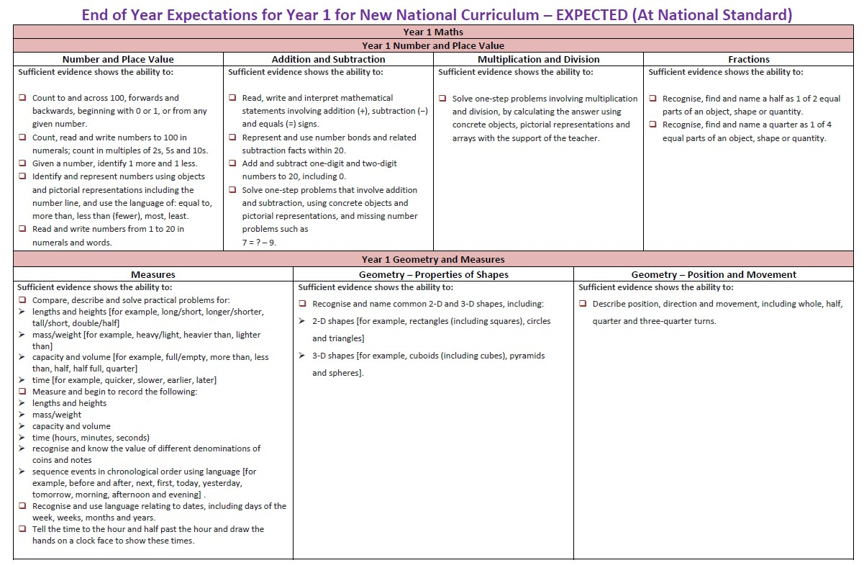
Year 2

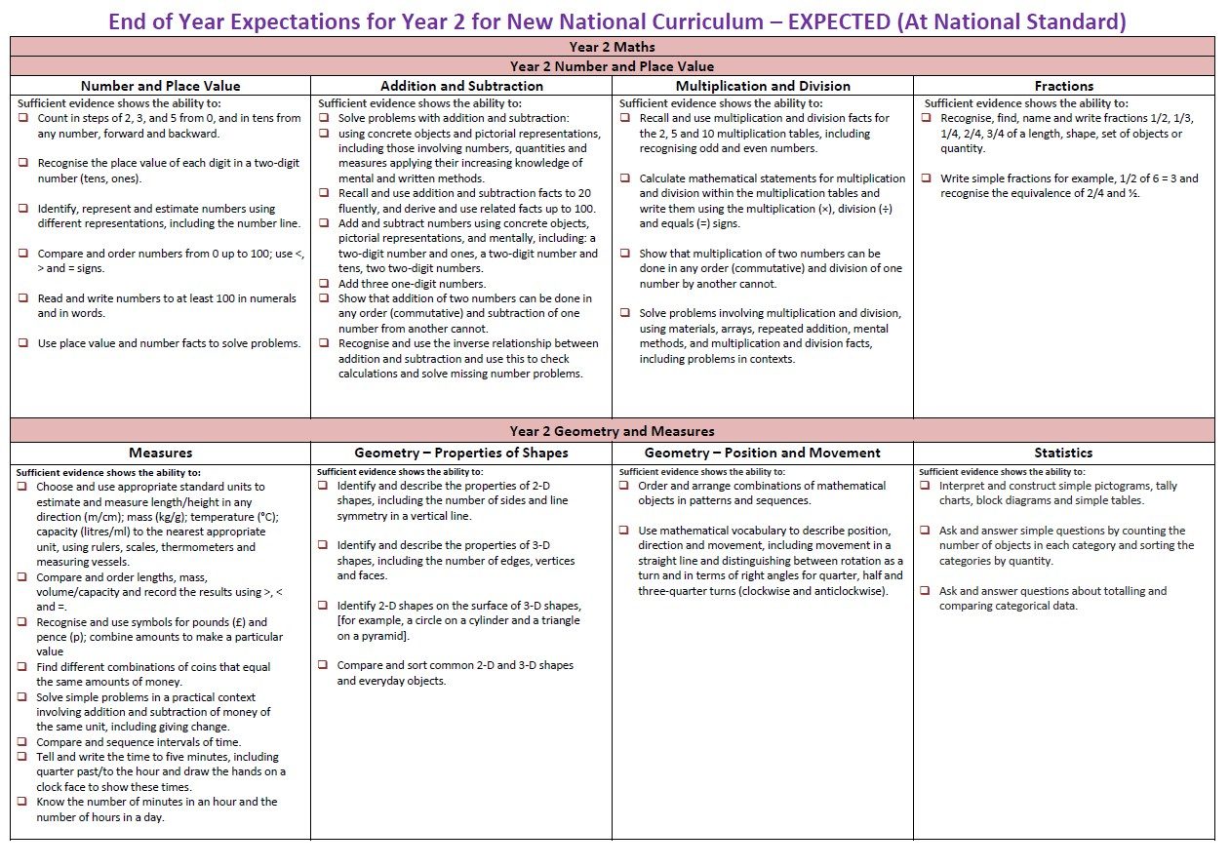
Year 3

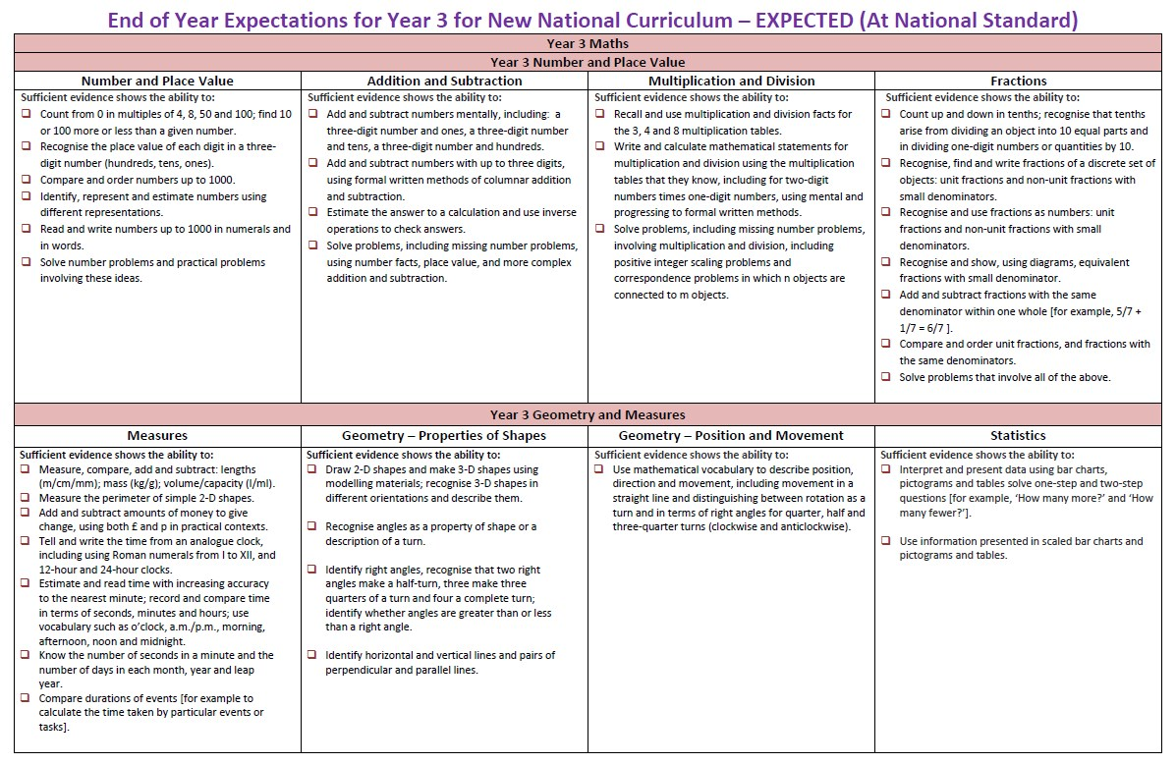
Year 4

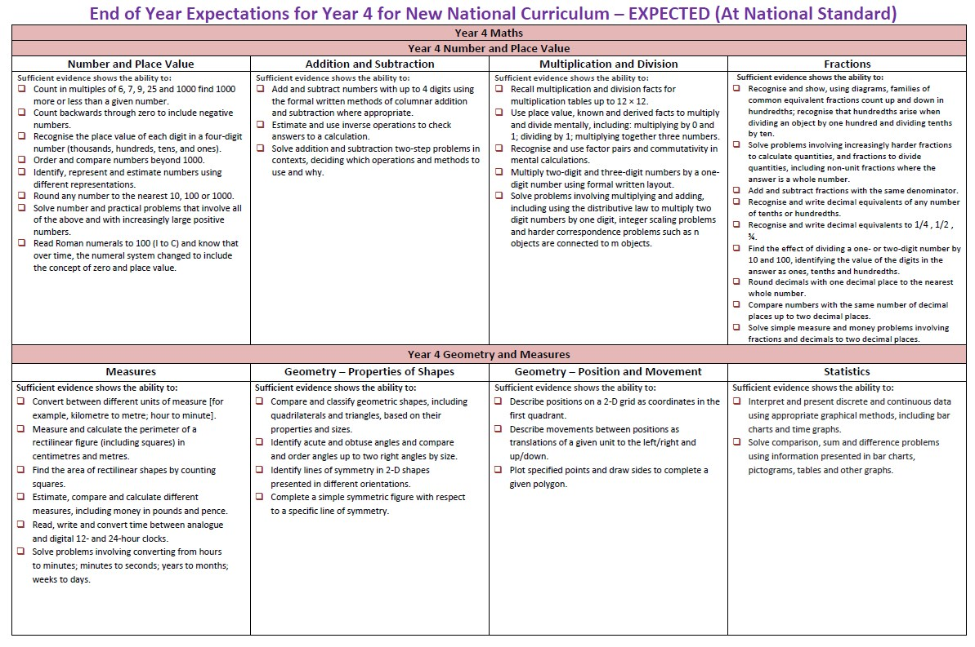
Year 5
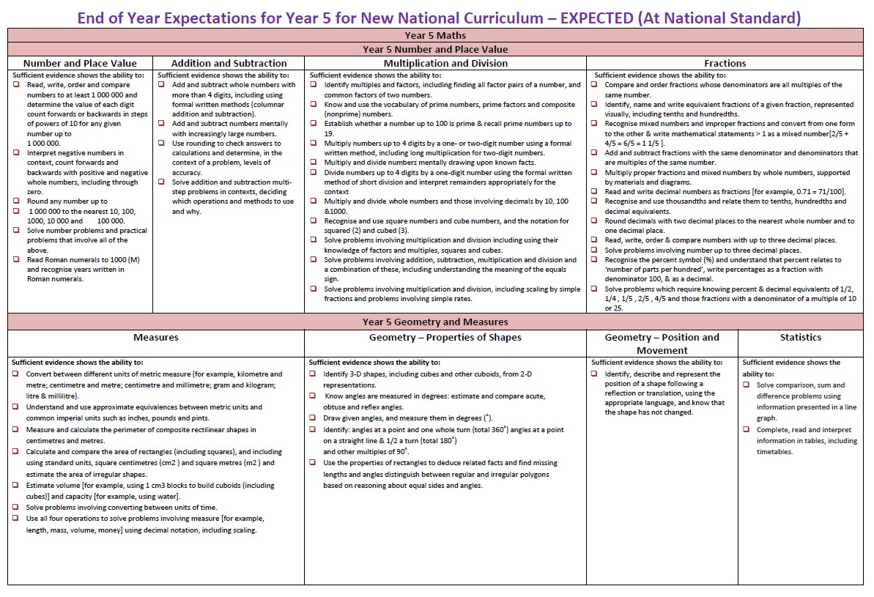
Year 6
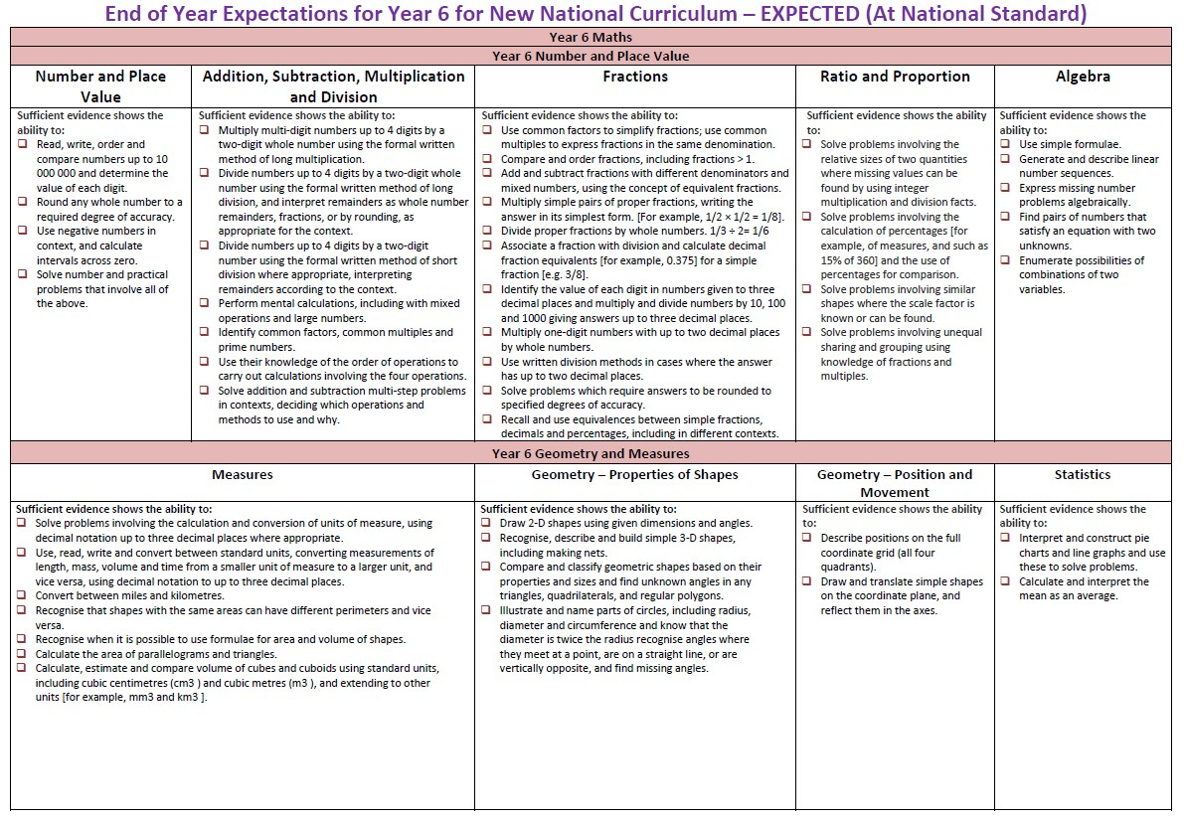

Yearly Overview EYFS

 | Advent 1 |  |  | Advent 2 |  |  | Lent 1 |  |  |  | Lent 2 |  |  | Pentecost 1 |  |  |  | Pentecost 2
Overview Topics Themes to ensure coverage but may change content due to children’s interests | All about Me |  |  | People who Help Us |  |  | Castles |  |  |  | Around the World |  |  | Farms |  |  |  | Minibeasts
Phonics | Phonics Letters and Sounds Revised  Phase 2  s a t p  i n m d  g o c k  ck e u r  h b f l  Tricky words is I the |  |  | Phonics Letters and Sounds Revised  Phase 2  Ff ll ss j  V w x y  Z zz qu  Words with s added at the end  Ch  Sh th ng nk  Words ending s /z/  Tricky words put as and has his her go no to into she push pull full he of we me be |  |  | Phonics Letters and Sounds Revised  Phase 3  Ai ee igh oa  Oo o oar or  Ur ow oi ear  Air er  Words with double letters  Longer words  Tricky words – was you they my by all are sure pure |  |  |  | Phonics Letters and Sounds Revised  Phase 3  Review  Words with two or more diagraphs  Words ending -ing  Compound words  Words with s in middle /z/ s  Words ending -s  Words with -es at the end /z/  Tricky words – secure spelling |  |  | Phonics Letters and Sounds Revised  Phase 4  Short vowel CVCC  CCVC CCCVC  Longer words CCCVC  Compound words  Root words ending in -ing -ed /t/ -ed /id/ -est  Tricky words – said so have like some come love do were here little says there when what one out today |  |  |  | Phonics Letters and Sounds Revised  Phase 4  Long vowel sound CVCC CCVC CCCVC CCV CCVCC  Words ending -s /s/ z/ -es  Root words ending -ing -ed /t/id/d/  -er -est  Tricky words – secure spelling
Literacy | Fiction  Marvelous Me by Lisa Bullard  Fiction  Squash and a squeeze Julia Donaldson |  |  | Non-Fiction – Hero’s from around the world by Lisa Gogerly  Instructions  Pizza – an interactive recipe book by Lotta Nieminen  Fiction  Jesus’ Christmas Party by Nicolas Allan |  |  | Song  There was a Princess Long Ago  Fiction  Jack and the Jelly Beanstalk by Rachel Mortimer  Fiction  Paddington at the Palace by Michael Bond |  |  |  | Non - Fiction  If Sharks disappeared by Lilly Willams  Non- Fiction  Penguins Geographical  Fiction  Handa’s Surprise by Eileen Browne |  |  | Fiction  Rosies Walk by Pat Hutchins  Fiction  Pigs might Fly by Johnathan Emmett  Instructions  Chocolate Cake by Michael Rosen |  |  |  | Fiction  Superworm by Julia Donaldson  Fiction  The Very Hungry Caterpillar by Eric Carle  Fiction  The Snail and the Whale  Julia Donaldson
Books (To be read over year- Dear time) | The longer one – Vicky the Vet by Felicity Brooks  The adventure One – Emergency by Margret Mayo  The funny One – More People to love  The poetry one – the night before Christmas by Clement Clarke Moor  The non-fiction one – you choose by Pippa Goodhart  The classic one – The Three Billy Goats Gruff |  |  |  |  |  |  | The longer one – The ups and downs of Castle Mice by Michael Bond  The adventure One – The Tournament by Heather Amery  The funny One – Oi Frog by Kes Gray  The poetry one – Poems from a Green and Blue Planet by Sabrina Mahfouz  The non-fiction one – One day on Blue Planet by Ella Bailey  The classic one - Rapunzel |  |  |  |  |  |  | The longer one -  The adventure One – Old Red by Marnie Reynolds-Bourque  The funny One – Twist and Hop the Minibeast Bop by Tony Mitton  The poetry one – Michael Rosen poems  The non-fiction one – The Amazing Life Cycle of Plants  The classic one -Little Red Riding hood
Poems /rhymes to learn over the year | The Skeleton Dance  All Families are different  Head Shoulders Knees and Toes (book)  The senses song  The Lost Dog  I’m a little hedgehog  All the leaves are falling down  Harvest time song  There are lots of people to help us song  Miss Polly Had a dolly (book)  5 little firemen standing in a row  Old Macdonald works so hard Caring for his Pets  The silly pizza song  5 little Reindeers  When Santa got stuck up the chimney  There was a princess long ago  The Grand Old Duke of York  Pussy Cat Pussy Cat (book)  Brave Knight  Old king Cole (book)  Castle on the Hill  The King in the Castle  Who will fight the Dragon?  The little Penguin  The Continents Song  The 5 Ocean Song  If you go into the bush, what do you think you’ll see?  Farmers in his den  Busy Farmer Ben  There’s a worm at the bottom of the garden  The Tiny Caterpillar song  Incey Wincey Spider
Quality Texts | We Are Family  by Patricia  Hegarty  Brush your teeth please by Leslie McGuire  Leaf Man  by Lois Ehlert  The very helpful Hedgehog by Rosie Wellesley  We are going on a pumpkin hunt by Mary Wilcox |  | When I Grow Up  by Jon Hales and Paula Monteagudo  Vet in Training  by Cath Ard  Eat Your Greens, Goldilocks by Steve Smallman |  |  |  |  | The Castle the king built by Rebecca Colby and Tom Froese National Trust  Look inside a castle by Conrad Mason |  |  |  | What a Wonderful World by Bob Thiele and George David Weiss  Little people big dreams David Attenborough by Maria Isabel Sanchez Vegara.  Were going on a egg hunt by Laura Hughes  Amazing Africa by Atinuke |  |  | What the ladybird Heard by Julie Donaldson  What the ladybird Heard Next by Julia Donaldson  Egg to chicken by Camilla de la Bedoyere  Just ducks! By Nicola Davies |  |  |  | Amazing Animal Homes by Chris Packham  Snails by Susie Williams  The Amazing Life Cylcle of a Butterly by Kay Barnham  Yucky Worms by Vivian French  My Butterfly Bouquet by Nicola Davies
Mathematics’ | Matching and Sorting  Comparing size, mass and capacity  Comparing amounts  Exploring Patterns  Representing 1, 2 and 3 |  | Composition of 1, 2, 3  Comparing 1, 2 and 3  Circles and triangles  Positional Language  Representing numbers to 5  Composition of 4 and 5  One more and less  Shapes with 4 sides |  |  |  |  | Introducing zero  Comparing numbers to 5  Composition of 4 and 5  Compare Mass  Compare Capacity  Composition of 6, 7 and 8 |  |  |  | Combining two groups  Length and Height  Time  9 and 10  Comparing numbers to 10  Number bonds to 10  3D shapes  Patterns |  |  | Building numbers beyond 10.  Counting beyond 10  Adding more  Taking way  Spatial Reasoning |  |  |  | Doubling  Sharing and grouping  Odd and even  Consolidating key skills  Patterns and relationships  Spatial awareness
Understanding of the World/PSED | Myself | Other Faiths  Judaism  Hanukkah |  |  | Welcome | Birthdays |  |  |  | Celebrating  Gathering |  |  | Gathering  Growing |  | Good news Friends |  | Other faith week – Islam Prayer |  |  | Our World
RE
RSE | Journey in love - Spiritual |  |  |  |  |  |  |  | Journey in love - Physical |  |  |  |  |  |  | Journey in love – Social and emotional
PSED | we have rules at school that we must follow.  We must work together as a team when it is necessary.  (class Charter) |  | We are all unique.  All cultures are celebrated (linked to other faiths/ key experiences)  To know right from wrong.  We recognise that we are accountable for our actions. |  |  |  |  | This is Me- see themselves as valuable individuals, recognising talents |  |  |  | Choices- understanding the actions of others, seeing someone else’s point of view |  |  | Keeping Healthy- healthy food and lifestyles, personal hygiene |  |  |  | Changing and Growing- how we change (like a butterfly), understanding how things will change be different as we grow, work together to overcome challenges
Celebrations | Harvest, Autumn |  | Bonfire night, Diwali, Hanukkah, Remembrance Sunday, Advent, Christmas |  |  |  |  | Chinese New Year  Valentines  Holi |  |  |  | Easter,  Mother’s Day, Ramadan |  |  | Father’s Day, |  |  |  | Eid
The Natural World  (Science) | Senses  The Body  Observe changes (seasons) |  | Talk about changes I have observed  Know about and understand the importance of looking after our teeth. |  |  |  |  | Use all their senses in hands-on exploration of natural materials.  Explore collections of materials with similar and/or different properties.  Look at materials that castles are made from  Look at the properties of materials  What materials would make a good castle |  |  |  | Describe what they see, hear and feel while they are outside.  Look at the 5 senses  Go on a spring walk and look at the natural environment. What do the children notice? What things have changed? How might they change again? Use this Seasons Matching Game to discuss changes as the seasons move on. |  |  | Understand the key features of the life cycle of a plant  Plant seeds and care for growing plants.  Look at different types of seeds  Grow seeds in different way  Cress heads, in jam jars and in soil  Name parts of the plant |  |  |  | Begin to understand the need to respect and care for the natural environment and all living things.  Mini beast hunt,  Grouping mini beasts, habitats,  Making habitats outdoor learning
Past and Present  (History) | Significant events in my life – birthdays, memories, |  | Similarities and differences. – Fire engines today and fire vehicles at the fire of London. |  |  |  |  | Castles, Knights and Dragons- look at different homes from the past and castles |  |  |  | Explorers- look at some explorers that travelled the world or specific regions (Earnest Shackleton- polar, Christopher Columbus) |  |  | Machines and Transport- compare different farm machinery today and in the past/how the produce is transported |  |  |  | Famous People- David Attenborough, Chris Packham, Charles Darwin (people linked to animals or discovering/caring for animals)
Geography | Know where I live. |  | Similarities and differences – Vets jobs in the UK and abroad book focus – Hero’s from around the world. |  |  |  |  | Where were castles built?  Castle maps |  |  |  | How will we get there?  What’s the weather like? |  |  | Farm map – What the ladybird heard by Julia Donaldson
Physical Development - PE | Games – Best of Balls T |  | Gym – Travelling VS |  |  |  |  | Dance - Let’s Move Knights, Castles and Dragons |  |  |  | Gym  Week 6 - Dance – Lets Move were going on an Easter Egg Hunt |  |  | Games  (Dance) |  |  |  | Butterfly Dance  (Olympic Games)
Expressive Art and Design | Leaf Printing  Leaf collage |  | Experimenting with colour |  |  |  |  | Colour in context- painting and collage Kandinsky/ Alma Thomas |  |  |  | Art around the world- African patterns (textiles), Japanese fans, Chinese writing |  |  | Sculpture- experimenting with plasticine, clay, dough. Animals |  |  |  | Printing patterns- linked to symmetry
Art
Music | Listen and respond  Explore  Perform - Different Families Song |  | Rhythmic patterns  Nativity songs |  |  |  |  | Explore changes in pitch- (BBC Bass Face Yolanda’s Band Jam) |  |  |  | Exploring tempo- animal movements, elephant walk ( BBC bring the noise) |  |  | Sound stories- using instruments |  |  |  | Sound patterns- copying, creating, performing
DT | How can we keep our prickly friends warm this winter? |  | Making dough – designing pizzas |  |  |  |  | What will your coat of arms look like? |  |  |  | Chocolate mug cake |  |  |  |  |  |  | Minibeast crafts
Cultural Capital | LMS Music |  | Take over day  Pantomime trip  Nativity |  |  |  |  |  |  |  |  |  |  |  | Chick hatching or farm visit. |  |  |  | School Trip  Butterfly hatching experience.

St. Norbert’s Voluntary Aided Catholic Academy Year One Curriculum Map
 | Advent 1 | Advent 2 | Lent 1 | Lent 2 | Pentecost 1 | Pentecost 2
Science | Animals including Humans- Ourselves  identify, name, draw and label the basic parts of the human body and say which part of the body is associated with each sense. | Seasonal Changes  observe changes across the 4 seasons; | Animals including humans  identify and name a variety of common animals including fish, amphibians, reptiles, birds and mammals;  identify and name a variety of common animals that are carnivores, herbivores and omnivores;  describe and compare the structure of a variety of common animals (fish,  amphibians, reptiles, birds and mammals including pets); | Plants  identify and name a variety of common wild and garden plants, including deciduous and evergreen trees;  identify and describe the basic structure of a variety of common flowering plants, including trees. | Seasonal Changes  observe and describe weather associated with the seasons and how day length varies. | Everyday Materials  distinguish between an object and the material from which it is made;  identify and name a variety of everyday materials, including wood, plastic, glass, metal, water, and rock;  describe the simple physical properties of a variety of everyday materials;  compare and group together a variety of everyday materials on  the basis of their simple  physical properties.
History |  | The Gunpowder Plot  - Understand national and global events beyond their living memory  - Understand the lives of significant individuals in the past who have contributed to national and international achievements – James I and Guy Fawkes |  | Travel and Transport  -Understand and identify significant historical events, people and places in their own locality. Including a case study of Raymond Mays and Longboats at Flag Fen  -Understand changes that have occurred within their live time, this can be linked to aspects of change in national life. Boats, trains and Cars |  | Significant Explorers  - Compare aspects of individual’s lives in different time periods. Ibn Battuta, Felicity Aston, Matthew Henson, Neil Armstrong
Geography | Local Area  Geography Skills and Fieldwork  -Local area walk for local study  -Create a map of the school grounds, using simple key  - Identify key human and physical features of its surrounding environment. |  | The UK  Geographical Skills and Fieldwork  -Use world maps, atlases and globes to identify the UK  -Identify UK countries and seas  Locational Knowledge  Name, locate and identify characteristics of the four countries and capital cities of the UK |  | Weather  Human and Physical Geography  -Identify seasonal and daily weather patterns in the UK (Winter/spring)  -Locate hot and cold areas of the world in relation to the Equator and the North and South Poles.  -Use basic geographical vocabulary to refer to: season and weather.
PSHE/P4C | Values: Respect, friendliness  TEAM- Together Everyone Achieves More  Children will be able to:  -identify what is kind and unkind behaviour, and how this can affect others  -know how to treat themselves and others with respect; how to be polite and courteous  -to recognise the ways in which they are the same and different to others  - know how to listen to other people and play and work cooperatively  -know how to talk about and share their opinions on things that matter to them | Values: Friendliness, Honesty, Diversity  Hygiene and Dental Care  Children will be able to:  -understand dental care and visiting the dentist; how to brush teeth correctly; food and drink that support dental health  -know about what keeping healthy means; different ways to keep healthy  -know about foods that support good health and the risks of eating too much sugar  -know about how physical activity helps us to stay healthy; and ways to be physically active everyday | Values: Self-discipline,  Trust  Digital Wellbeing and Safe Relationships  Children will be able to:  - recognise that some things are private and the importance of respecting privacy; that parts of their body covered by underwear are private  -know that sometimes people may behave differently online, including by  pretending to be someone they are not  -know how to respond safely to adults they don’t know  -know about how to respond if physical contact makes them feel uncomfortable or unsafe  -know there are situations when they should ask for permission and also when their permission should be sought  -know about the importance of not keeping adults’ secrets (only happy surprises that others will find out about eventually)  -know basic techniques for resisting pressure to do something they don’t want to  do and which may make them unsafe  -know what to do if they feel unsafe or worried for themselves or others; who to ask for help and vocabulary | Values: Cooperation, Patience  Money Matters  Children will be able to:  -know what money is; forms that money comes in; that money comes from different  sources  -understand that people make different choices about how to save and spend money  -recognise the difference between needs and wants; that sometimes people may  not always be able to have the things they want  -know that money needs to be looked after; different ways of doing this | Values: Patience, Self-belief  Diversity- local area and UK  Children will be able to:  -talk about the different groups they belong to  -understand the different roles and responsibilities people have in their community  -recognise the ways they are the same as, and different to, other people | Values: Courtesy, and Aspiration.  Thinking Positively  Children will be able to:  -recognise different feelings that humans can experience  -know how to recognise and name different feelings  -understand how feelings can affect people’s bodies and how they behave  -know ways to recognise what others might be feeling  -recognise that not everyone feels the same at the same time, or feels the  same about the same things  -know about ways of sharing feelings; a range of words to describe feelings
Music | Voices and Instruments  use their voices expressively and creatively by singing songs and speaking chants  and rhymes;  • play tuned and untuned instruments musically; | Rhythm/ Nativity  experiment with, create, select and combine sounds using the inter-related dimensions of music  use their voices expressively and creatively by singing songs and speaking chants  and rhymes; | BBC 10 Pieces Finlandia-Jean Sibelius  listen with concentration and understanding to a range of high-quality live and recorded music;  use their voices expressively and creatively by singing songs and speaking chants and rhymes; | Jack and the Beanstalk  play tuned and untuned instruments musically;  experiment with, create, select and combine sounds using the inter-related  dimensions of music | Exploring Timbre  use their voices expressively and creatively by singing songs and speaking chants and rhymes  experiment with, create, select and combine sounds using the inter-related  dimensions of music. | The Nutcracker-Tchaikovsky  -play tuned and untuned instruments musically;  - listen with concentration and understanding to a range of high-quality live and  recorded music;  -experiment with, create, select and combine sounds using the inter-related dimensions of music.
Art and Design | Picasso -Portraits  Exploring and developing ideas:  -respond positively to ideas and starting points;  - explore ideas and collect information;  Painting  -experiment with different brushes (including brushstrokes) -mix primary colours to make secondary colours;  Collage:  -sort and arrange materials;  Work of other artists  -describe the work of Picasso  -express an opinion  -use inspiration from Picasso to create their own work and compare;  -use key vocabulary to demonstrate knowledge and understanding of Picasso |  | Van Gogh  Exploring and developing ideas:  respond positively to ideas and starting points;  explore ideas and collect information;  describe differences and similarities and make links to their own work;  Drawing  draw lines of varying thickness;  use dots and lines to demonstrate pattern and texture;  use different materials to draw,  Painting  -name the primary and secondary colours;  -experiment with different brushes (and other painting tools  -mix primary colours to make secondary colours;  Work of other artists  -describe the work of Van Gogh  -express an opinion on the work of Van Gogh  -use inspiration from famous, notable artists to create their own work and compare;  -use key vocabulary to demonstrate knowledge and understanding |  | Weaving and printing  Exploring and developing ideas:  -respond positively to ideas and starting points;  - explore ideas and collect information;  -try different materials and methods to improve;  Textiles  -show pattern by weaving;  -use a dyeing technique to alter a textile’s colour and pattern;  -decorate textiles with glue or stitching, to add colour and detail;  Printing  -copy an original print;  - use a variety of materials, e.g. sponges, fruit, blocks;
Design Technology |  | Can you create a strong bridge across the moat?  Design a product that has a purpose and are aimed at an intended user;  with help, measure and mark out;  cut, shape and score materials with some accuracy;  assemble, join and combine materials  explain positives and things to improve for existing products;  identify strengths and possible changes they might make to refine their existing design;  evaluate their products and ideas against their simple design criteria; |  | Norbert Bear needs to stay dry in the rain?  Use their knowledge of existing products and their own experience to help generate their ideas;  use a range of materials and components, including textiles;  with help, measure and mark out;  demonstrate how to cut, shape and join fabric to make a simple product;  manipulate fabrics in simple ways to create the desired effect;  use a basic running stich;  explain positives and things to improve for existing products;  as they work, start to identify strengths and possible changes they might make to refine their existing design; |  | Food Eat more fruit and vegetables  Design a product that have a purpose and are aimed at an intended user;  with support, follow a simple plan or recipe;  begin to select from a range of hand tools and equipment, such as graters, zesters, safe knives, juicer;  use a range of materials and components, including food ingredients;  cut, peel and grate ingredients, including measuring and weighing ingredients using measuring cups with support;  begin to use simple finishing techniques to improve the appearance of their product, such as adding  simple decorations.  evaluate their products and ideas against their simple design criteria.
Computing | - Login to school systems and follow basic instructions  Use technology purposefully to manipulate and retrieve digital content. Children will learn how to move the cursor and click using a trackpad. | Programming and Beebots  Understand that programs execute by following precise and unambiguous instructions. Create and debug simple programs. Use technology purposefully to create digital content. | Programming and Beebots  Understand how [algorithms] are implemented as programs on digital devices, and that programs execute by following precise and unambiguous instructions | Photography  To learn to recognise that different devices can be used to capture photographs;  To gain experience capturing, editing, and improving photos.  To use digital photography skills to take images to support topic learning. | Word Processing  To open a word processing program.  To save a piece of work.  To use a keyboard to add simple text.  To insert an image to go with your text.  To highlight and select text.  To change font size.  To change Font colour.  To save your document. | ART -Paint Program  To explore the world of digital art.  To use a range of creative tools.  To create their own paintings using different brush sizes; paint effects and digital techniques;  To evaluate preferences when painting with, and without, the use of digital devices.
PE | Gym – Animals  Running and jumping  To master basic movements including running, jumping, throwing and catching, as well as developing balance, agility and co-ordination, and begin to apply these in a range of activities in the context of ‘identify and name a variety of common animals including fish, amphibians, reptiles, birds and mammals’ | Dance - Starry skies  To perform dances using simple movement patterns in the context  of ‘listening to and discussing a wide range of poems, stories’.  Gym  To develop balance, agility and co-ordination when travelling in a variety of ways. | Dance  To perform dances using simple movement patterns in the context  of ‘experience and observe phenomena looking more closely at the natural and human constructed world around them.’  Gym  To develop balance, agility and co-ordination when performing a range of contrasting movements and balances.  Swimming  Developing confidence in the water;  Splashing water over face;  Blowing bubbles in the water;  Submerging face and head in water;  Walking in water;  Floating in water;  Using buoyancy aids to support floating;  Moving across the pool;  Developing simple stroke technique;  Considering water safety and understanding signage;  Being safe in and around the water;  Swimming on back;  Swimming on front;  Propulsion stroke leg kick; Arm movements -backstroke and front crawl; | Dance  To develop balance and co-ordination.  To perform dances using simple movement patterns  by responding to a video stimulus.  Attacking and defending  To master basic movements including running, jumping,  throwing and catching, as well as developing balance, agility and  co-ordination, and begin to apply these in a range of activities in the context of travelling in different ways.  Swimming  Developing confidence in the water;  Splashing water over face;  Blowing bubbles in the water;  Submerging face and head in water;  Walking in water;  Floating in water;  Using buoyancy aids to support floating;  Moving across the pool;  Developing simple stroke technique;  Considering water safety and understanding signage;  Being safe in and around the water;  Swimming on back;  Swimming on front;  Propulsion stroke leg kick; Arm movements -backstroke and front crawl; | Gym – High and low  To develop balance, agility and co-ordination by linking movements to create a sequence.  Throwing and catching  To master basic movements including running, jumping, throwing  and catching: bouncing; aiming; accuracy in throwing; changing speed of delivery; | Dance – Seasons  To develop balance and co-ordination.  To perform dances using simple movement patterns  by improvising individually and with a partner.  Sports Day Practice  Vary their pace and speed when running. Run with a basic technique over different distances. Show good posture and balance. Jog in a straight line. Change direction when jogging. Sprint in a straight line. Change direction when sprinting. Maintain control as they change direction when jogging or sprinting.

St. Norbert’s Voluntary Aided Catholic Academy Year Two Curriculum Map

 | Advent 1 | Advent 2 | Lent 1 | Lent 2 | Pentecost 1 | Pentecost 2
Science | Animals including Humans  notice that animals, including humans, have offspring which grow into adults;  describe the importance for humans of exercise, eating the right amounts of different types of food, and hygiene. | Materials  identify and compare the suitability of a variety of everyday materials, including  wood, metal, plastic, glass, brick, rock, paper and cardboard for  particular uses;  find out how the shapes of solid objects made from some materials can be changed by squashing, bending, twisting and stretching. | Food Chains- Living Things  describe how animals obtain their food from plants and other animals, using the idea of a simple food chain, and identify and name different sources of food; | Plants  observe and describe how  seeds and bulbs grow into  mature plants; | Plants  find out and describe how plants need water, light and a suitable temperature to grow and stay healthy. | Significant Scientists  use their ideas and observations to explain how doctors use science;  test materials to find out whether they are waterproof;  describe an ocean food chain identify renewable and non-renewable sources of energy;  describe the invention of wind turbines;
History |  | The Great Fire of  London  -Understand national and global events beyond their living memory  - Identify the lives of significant individuals from the past who have contributed to national and international achievements - Samuel Pepys |  | Grace Darling RNLI  Identify the lives of significant individuals from the past who have contributed to national and international achievements Grace Darling  History of RNLI |  | Significant Nurses  -Compare aspects of these individual’s life in different time periods. Mary Seacole and/or Florence Nightingale and Edith Cavell – Local link
Geography | Mapping  Geographical skills and fieldwork  -Use aerial photographs and plan perspectives to recognise landmarks and basic human and physical features  -Local Area Study  Identifying physical and human features  -Devise a simple map; and use and construct basic symbols |  | Africa – Kenya Study  Place Knowledge  -Revise hot and cold countries, equator, North and South Pole  -Locate Kenya and describe features  -Compare Kenya to the UK  Locational Knowledge  -World’s continents and oceans (compass directions to describe location) |  | UK Seas and Coasts  Locational Knowledge  -Name, locate and identify characteristics of the UK seas and coasts  Human and Physical Geography  -Basic geographical vocabulary linked to the seaside
PSHE/P4C | Values: Respect,  Friendliness  TEAM- Together Everyone Achieves More & Medicines  Children will be able to:  -understand that bodies and feelings can be hurt by words and actions; that people can say hurtful things online  -know about how people may feel if they experience hurtful behaviour or bullying  -recognise that hurtful behaviour (offline and online) including teasing, name-calling, bullying and deliberately excluding others is not acceptable; how to report bullying; the importance of telling a trusted adult  -understand why sleep is important and different ways to rest and relax | Values: Friendliness, Honesty, Diversity  Managing Thoughts and Feelings  Children will be able to:  -understand about things that help people feel good (e.g. playing outside, doing things  they enjoy, spending time with family, getting enough sleep)  -recognise different things they can do to manage big feelings, to help calm themselves down and/or change their mood when they don’t feel good  -recognise when they need help with feelings; that it is important to ask for help with feelings; and how to ask for it  -about change and loss (including death); to identify feelings associated with this; to recognise what helps people to feel better | Values: Self-discipline, Trust  Digital Wellbeing and Safe Relationships  Children will be able to:  -know there are situations when they should ask for permission and also when their permission should be sought  -understand about the importance of not keeping adults’ secrets (only happy surprises that others will find out about eventually)  -recognise basic techniques for resisting pressure to do something they don’t want to do and which may make them unsafe  -know what to do if they feel unsafe or worried for themselves or others; who to ask for help and vocabulary to use when asking for help; importance of keeping trying until they are heard | Values: Cooperation and Patience  Money Matters  Children will be able to:  -understand what money is; forms that money comes in; that money comes from different sources  -Recognise that people make different choices about how to save and spend money  -understand about the difference between needs and wants; that sometimes people may not always be able to have the things they want  - know that money needs to be looked after; different ways of doing this | Values: Patience,  Self-belief  Global Diversity & Being Healthy  Children will be able to:  -identify the different roles and responsibilities people have in their community  -recognise the ways they are the same as, and different to, other people  - identify simple hygiene routines that can stop germs from spreading  -know that medicines (including vaccinations and immunisations and those that support allergic reactions) can help people to stay healthy  -understand how to keep safe in the sun and protect skin from sun damage  -know about different ways to learn and play; recognising the importance of knowing when to take a break from time online or TV  - know about the people who help us to stay physically healthy  -know about things that people can put into their body or on their skin; how these can affect how people feel | Value: Courtesy,  Aspiration  Keeping Safe  Children will be able to:  -know about rules and age restrictions that keep us safe  -to recognise risk in simple everyday situations and what action to take to minimise harm  -understand how to keep safe at home (including around electrical appliances) and fire safety (e.g. not playing with matches and lighters)  -recognise that household products (including medicines) can be harmful if not used correctly  -identify ways to keep safe in familiar and unfamiliar environments (e.g. beach,  shopping centre, park, swimming pool, on the street) and how to cross the road safely  -know about the people whose job it is to help keep us safe  -say basic rules to keep safe online, including what is meant by personal  information and what should be kept private; the importance of telling a trusted adult if they come across something that scares them
Music | Carnival of the Animals  -play tuned and untuned instruments musically;  - listen with concentration and understanding to a range of high-quality live and  recorded music;  -experiment with, create, select and combine sounds using the inter-related dimensions of music. | Animals (Music Express- optional)  play tuned and untuned instruments musically;  - listen with concentration and understanding to a range of high-quality live and  recorded music;  -experiment with, create, select and combine sounds using the inter-related dimensions of music.  Nativity  use their voices expressively and creatively by singing songs and speaking chants and rhymes; | Djembe Drumming  experiment with, create, select and combine sounds using the inter-related dimensions of music | Pulse and Metre  use their voices expressively and creatively by singing songs and speaking chants and rhymes  experiment with, create, select and combine sounds using the inter-related  dimensions of music | BBC 10 Pieces- Kerry Andrew- No place like  listen with concentration and understanding to a range of high-quality live and recorded music;  use their voices expressively and creatively by singing songs and speaking chants and rhymes;  play tuned and untuned instruments musically; | Water (pitch and Notation)  play tuned and untuned instruments musically  experiment with, create, select and combine sounds using the inter-related  dimensions of music
Art and Design | Monet- Landscapes  Exploring and developing ideas:  -respond positively to ideas and starting points;  - explore ideas and collect information;  Painting  -name the primary and secondary colours;  -experiment with different brushes (including brushstrokes) and other painting tools;  -mix primary colours to make secondary colours;  -add white and black to alter tints and shades;  Work of other artists  -describe the work of Monet  -express an opinion  -use inspiration from Monet to create their own work and compare;  -use key vocabulary to demonstrate knowledge and understanding of Monet |  | Lowry  Exploring and developing ideas:  respond positively to ideas and starting points;  explore ideas and collect information;  describe differences and similarities and make links to their own work;  Drawing  draw lines of varying thickness;  use dots and lines to demonstrate pattern and texture;  use different materials to draw,  Painting  -name the primary and secondary colours;  -experiment with different brushes (and other painting tools  -mix primary colours to make secondary colours;  Work of other artists  -describe the work of Lowry  -express an opinion on the work of Lowry  -use inspiration from famous, notable artists to create their own work and compare;  -use key vocabulary to demonstrate knowledge and understanding |  | Joan Miro  Exploring and developing ideas:  respond positively to ideas and starting points;  explore ideas and collect information;  describe differences and similarities and make links to their own work;  Sculpture  -use a variety of materials for sculpting,  -use a variety of shapes, including lines  -use a variety of techniques and texture  Collage  -sort and arrange materials;  -add texture by mixing materials;  Work of other artists  -describe the work of Lowry  -express an opinion on the work of Lowry  -use inspiration from famous, notable artists to create their own work and compare;  -use key vocabulary to demonstrate knowledge and understanding
Design Technology |  | Can you design and make a product which will help put out the Great Fires of London in 1666?  Design a product that has a purpose and are aimed at an intended user;  explain how their products will look and work  with help, measure and mark out;  cut, shape and score materials with some accuracy;  assemble, join and combine materials  explain positives and things to improve for existing products; |  | Can you create a recipe with ingredients grown in Kenya?  Use their knowledge of existing products and their own experience to help generate their ideas;  with support, follow a simple plan or recipe;  begin to select from a range of hand tools and equipment, such as graters, zesters, safe knives, juicer;  with help, measure and mark out;  cut, peel and grate ingredients, including measuring and weighing ingredients using measuring cups;  begin to use simple finishing techniques to improve the appearance of their product, such as adding simple decorations.  evaluate their products and ideas against their simple design criteria |  | Textiles  Delightful decorations  Use their knowledge of existing products and their own experience to help generate their ideas;  select from a range of materials, textiles and components according to their characteristics;  with help, measure and mark out;  demonstrate how to cut, shape and join fabric to make a simple product;  manipulate fabrics in simple ways to create the desired effect;  use a basic running stich;  explain positives and things to improve for existing products;
Computing | Typing Skills  Select, use and combine a variety of software (including internet services) on a range of digital devices to design and create a range of programs, systems and content that accomplish given goals, including collecting, analysing, evaluating and presenting data and information. | PowerPoint  Use technology safely and respectfully. Children will revise skills from previous unit and learn to create folders.  Use technology purposefully to create, organise, store, manipulate and retrieve digital content. | Algorithms- programmable  Robots  Understand what algorithms are and that programs execute by following precise and unambiguous instructions. Create and debug simple programs. | Algorithms- programmable  robots  Understand what algorithms are; and that programs execute by following precise and ambiguous instructions. Create and debug simple programs. Use logical reasoning to predict the behaviour of simple programs | Typing Skills  Select,  use and combine a variety of software (including internet services) on a range of digital devices to design and create a range of programs, systems and content that accomplish given goals, including collecting, analysing, evaluating and presenting data and information. | Computer and Art  To use technology purposefully to create, organise, store, manipulate and retrieve digital content in the context of using a computer program to recreate an artistic style.  I can use a range of tools in a computer program to reproduce a style of art.
PE | Dance  Copy, remember and repeat actions.  Create a short motif inspired by a stimulus. Change the speed and level of their actions. Use simple choreographic devices such as unison, canon and mirroring.  Invasion Games  Recognise and describe how the body feels during and after different physical activities.  Explain what they need to stay healthy.  Bounce and kick a ball whilst moving.  Use kicking skills in a game.  Use dribbling skills in a game.  Use different ways of travelling at different speeds and following different pathways, directions or courses. Change speed and direction whilst running.  Begin to choose and use the best space in a game.  Begin to use and understand the terms attacking and defending.  Use at least one technique to attack or defend to play a game successfully.  Understand the importance of rules in games.  Use at least one technique to attack or defend to play a game successfully.  Perform sequences of their own composition with coordination. Perform learnt skills with increasing control. Compete against self and others.  Swimming  Developing confidence in the water;  Splashing water over face;  Blowing bubbles in the water;  Submerging face and head in water;  Walking in water;  Floating in water;  Using buoyancy aids to support floating;  Moving across the pool;  Developing simple stroke technique;  Considering water safety and understanding signage;  Being safe in and around the water;  Swimming on back;  Swimming on front;  Propulsion stroke leg kick; Arm movements -backstroke and front crawl; | Dance – Toys  Use different transitions within a dance motif. Move in time to music. Improve the timing of their actions.  Gym  Copy, explore and remember actions and movements to create their own sequence. Link actions to make a sequence.  Travel in a variety of ways, including rolling. Hold a still shape whilst balancing on different points of the body.  Jump in a variety of ways and land with increasing control and balance.  Climb onto and jump off the equipment safely. Move with increasing control and care.  Log roll (controlled) Curled side roll (egg roll) (controlled) Teddy bear roll (controlled) Rocking for forward roll Crouched forward roll  Perform sequences of their own composition with coordination. Perform learnt skills with increasing control.  Swimming  Developing confidence in the water;  Splashing water over face;  Blowing bubbles in the water;  Submerging face and head in water;  Walking in water;  Floating in water;  Using buoyancy aids to support floating;  Moving across the pool;  Developing simple stroke technique;  Considering water safety and understanding signage;  Being safe in and around the water;  Swimming on back;  Swimming on front;  Propulsion stroke leg kick; Arm movements -backstroke and front crawl; | Dance – Plants  Perform sequences of their own composition with coordination. Perform learnt skills with increasing control. Compete against self and others.  Gym – Landscapes and Cities  Explore and remember actions and movements to create their own sequence. Link actions to make a sequence. Travel in a variety of ways, including rolling. Hold a still shape whilst balancing on different points of the body. Jump in a variety of ways and land with increasing control and balance. Climb onto and jump off the equipment safely. Move with increasing control and care.  Straight jump  Tuck jump  Jumping jack  Half turn jump  Cat spring  Cat spring to straddle  Standing balances Kneeling balances Large body part balances  Balances on apparatus Balances with a partner  Perform sequences of their own composition with coordination. Perform learnt skills with increasing control. | Gym – Spinning and Turning  Link actions to make a sequence.  Travel in a variety of ways.  Hold a still shape whilst balancing on different points of the body.  Jump in a variety of ways and land with increasing control and balance. Climb onto and jump off the equipment safely. Move with increasing control and care.  tuck, star, straight, straddle shapes  Front and back support  Tiptoe, step, jump and hop  Hopscotch  Skipping  Galloping  Straight jump half-turn  Games  Throwing and catching  bounce a ball with a partner.  Use throwing and catching skills in a game.  Throw a ball for distance. Use hand-eye coordination to control a ball.  Vary types of throw used.  Bounce and kick a ball whilst moving.  Use kicking skills in a game.  Use dribbling skills in a game. | Gym – Under the Sea  Travel in a variety of ways.  Hold a still shape whilst balancing on different points of the body.  Jump in a variety of ways and land with increasing control and balance. Climb onto and jump off the equipment safely. Move with increasing control and care.  tuck, star, straight, straddle shapes  Front and back support  Tiptoe, step, jump and hop  Hopscotch  Skipping  Galloping  Straight jump half-turn  Standing balances Kneeling balances Large body part balances  Balances on apparatus Balances with a partner Pike, tuck, star, straight, straddle shapes Front and back support  Perform sequences of their own composition with coordination. Perform learnt skills with increasing control  Netball and ball games  Strike or hit a ball with increasing control. Learn skills for playing striking and fielding games.  Position the body to strike a ball.  Throw different types of equipment in different ways, for accuracy and distance. Throw, catch and bounce a ball with a partner.  Use throwing and catching skills in a game.  Throw a ball for distance.  Use hand-eye coordination to control a ball.  Vary types of throw used.  Strike or hit a ball with increasing control. Learn skills for playing striking and fielding games. | Dance  Use different transitions within a dance motif. Move in time to music. Improve the timing of their actions  Copy, remember and repeat actions. Create a short motif inspired by a stimulus. Change the speed and level of their actions. Use simple choreographic devices such as unison, canon and mirroring.  Perform sequences of their own composition with coordination. Perform learnt skills with increasing control. Compete against self and others.  Watch and describe performances, and use what they see to improve their own performance. Talk about the differences between their work and that of others.  Sports Day Practice  Run at different paces, describing the different paces. Use a variety of different stride lengths. Travel at different speeds. Begin to select the most suitable pace and speed for distance. Complete an obstacle course. Vary the speed and direction in which they are travelling. Run with basic techniques following a curved line. Be able to maintain and control a run over different distances.

St. Norbert’s Voluntary Aided Catholic Academy Year Three Curriculum Map

 | Advent 1 | Advent 2 | Lent 1 | Lent 2 | Pentecost 1 | Pentecost 2
Science | Animals Including Humans/ Skeleton Structure  identify that animals, including humans, need the right types and amount of nutrition, and  that they cannot make their own food; they get nutrition from what they eat; | Animals Including Humans/ Skeleton Structure  identify that humans and some other animals have skeletons and muscles for support, protection and movement. | Rocks  compare and group together different kinds of rocks on the basis of their appearance and simple physical properties;  describe in simple terms how fossils are formed when things that have lived are trapped within rock  recognise that soils are made from rocks and organic matter. | Plants  identify and describe the  functions of different parts of flowering plants: roots, stem/trunk, leaves and flowers;  explore the requirements of plants for life and growth (air, light, water, nutrients from soil, and room to grow) and how  they vary from plant to plant;  investigate the way in which water is transported within plants;  explore the part that flowers play in the life cycle of flowering plants, including pollination, seed formation and seed dispersal. | Light  recognise that they need light in order to see things and that dark is the absence of light;  notice that light is reflected from surfaces;  recognise that light from the sun can be dangerous and that there are ways to protect their eyes; recognise that shadows are formed when the light from a light source is blocked by an opaque object;  find patterns in the way that the size of shadows change. | Magnets and forces  compare how things move on different surfaces;  notice that some forces need contact between 2 objects, but magnetic forces can act at a distance;  observe how magnets attract or repel each other and attract some materials and not others;  compare and group together a variety of everyday materials on the basis of whether they  are attracted to a magnet, and identify some magnetic materials;  describe magnets as having 2 poles; predict whether 2 magnets will  attract or repel each other, depending on which poles are facing.
History |  | Ancient Egyptians  -Understand the achievements of the earliest civilizations through an in depth study of where and when the first civilizations appeared  - Compare aspects of people’s daily lives in the past  with my own by using historical evidence or the experience  of recreating an historical setting. |  | Roman Empire  - Understand the Roman Empire and the invasion of Julius Caesar  - Understand the successful invasion by Claudius and conquest, including Hadrian’s Wall.  - Understand Roman Empire and the power of its army and British resistance  -Understand the ‘Romanisation’ of Britain and can identify sites such as Caerwent and the impact of technology, culture and beliefs including Christianity. |  | Monarchs  -Study of an aspect or theme in British history that extends pupils’ chronological knowledge beyond 1066  - Study the changing power of monarchs using case studies such as John, Anne and Victoria
Geography | UK  Locational Knowledge  -Name and locate counties, cities of the UK  Geographical regions and human and physical characteristics  -Topographical features  Human and Physical Geography  -Temperate biomes  Geographical Skills and fieldwork  -Use maps, atlases, globes and digital/computer mapping to locate countries and describe features studied. |  | Extreme Earth  Human and Physical Geography  -Volcanoes, earthquakes and climate zones.  Geographical Skills and fieldwork  -Use maps, atlases, globes and digital/computer mapping to locate countries and describe features studied. |  | Water  Human and Physical Geography  -Describe and understand The water cycle  - clouds and rain, pollution and flooding
PSHE/P4C | Values: Respect, Friendliness  TEAM- Together Everyone Achieves More  Children will:  -know that personal behaviour can affect other people; to recognise and model respectful behaviour online  -be able to recognise the importance of self-respect and how this can affect their thoughts and feelings about themselves; that everyone, including them, should expect to be treated politely and with respect by others (including when online and/or anonymous) in school and in wider society; strategies to improve or  support courteous, respectful relationships  -understand about respecting the differences and similarities between people and  recognising what they have in common with others e.g. physically, in personality or background  -know how to listen and respond respectfully to a wide range of people, including those whose traditions, beliefs and lifestyle are different to their own  -know how to discuss and debate topical issues, respect other people’s point of  view and constructively challenge those they disagree with | Values:  Friendliness, Honesty, Diversity.  Shared Responsibilities  Children will:  -be able to recognise reasons for rules and laws; consequences of not adhering to rules and laws  -be able to recognise there are human rights, that are there to protect everyone  -understand the relationship between rights and responsibilities  -know the importance of having compassion towards others; shared responsibilities we all have for caring for other people and living things; how to show care and  concern for others  -know ways of carrying out shared responsibilities for protecting the environment in school and at home; how everyday choices can affect the environment (e.g. reducing, reusing, recycling; food choices) | Values:  Self-Discipline, Trust  Digital Wellbeing  Children will:  -know about privacy and personal boundaries; what is appropriate in friendships and wider relationships (including online);  -understand why someone may behave differently online, including pretending to be someone they are not; strategies for recognising risks, harmful content and contact; how to report concerns  -know how to respond safely and appropriately to adults they may encounter (in all contexts including online) whom they do not know  -recognise different types of physical contact; what is acceptable and unacceptable; strategies to respond to unwanted physical contact | Values:  Co-operation and Patience  Positive Thinking  Children will:  -know that mental health, just like physical health, is part of daily life; the importance of taking care of mental health  -know about strategies and behaviours that support mental health — including how good quality sleep, physical exercise/time outdoors, being involved in community groups, doing things for others, clubs, and activities, hobbies and spending time with family and friends can support mental health and wellbeing  -be able to recognise that feelings can change over time and range in intensity  -understand everyday things that affect feelings and the importance of expressing feelings  -use a varied vocabulary to use when talking about feelings; about how to express feelings in different ways;  -identify strategies to respond to feelings, including intense or conflicting feelings; how to manage and respond to feelings appropriately and proportionately in different situations  -be able to recognise warning signs about mental health and wellbeing and how to  seek support for themselves and others | Values:  Patience, Self-belief  Digital Wellbeing  Children will:  -understand about seeking and giving permission (consent) in different situations  -know about keeping something confidential or secret, when this should (e.g. a birthday surprise that others will find out about) or should not be agreed to, and when it is right to break a confidence or share a secret  -be able to recognise pressure from others to do something unsafe or that  makes them feel uncomfortable and strategies for managing this  -know where to get advice and report concerns if worried about their own or  someone else’s personal safety (including online) | Values:  Courtesy & Aspiration  Aspirations  Children will:  -recognise positive things about themselves and their achievements; set goals to help achieve personal outcomes  -know that there is a broad range of different jobs/careers that people can have; that people often have more than one career/type of job during their life  -recognise stereotypes in the workplace and that a person’s career aspirations should not be limited by them  -understand what might influence people’s decisions about a job or career (e.g. personal interests and values, family connections to certain trades or businesses, strengths and qualities, ways in which stereotypical assumptions can deter people from aspiring to certain jobs)  -know that some jobs are paid more than others and money is one factor which may influence a person’s job or career choice; that people may choose to do voluntary work which is unpaid  -understand some of the skills that will help them in their future careers e.g.  teamwork, communication and negotiation  -identify the kind of job that they might like to do when they are older  -recognise a variety of routes into careers (e.g. college, apprenticeship,  university)
Music | Musical Story/Listening  play and perform in solo and ensemble contexts, using their voices and playing musical instruments with increasing accuracy, fluency, control and expression;  • improvise and compose music for a range of purposes using the inter-related dimensions of music;  • appreciate and understand a wide range of high-quality live and recorded music  drawn from different traditions and from great composers and musicians; | Ancient Egypt  play and perform in solo and ensemble contexts, using their voices and playing musical instruments with increasing accuracy, fluency, control and expression;  listen with attention to detail and recall sounds with increasing aural memory; | BBC 10 Pieces- Delia Derbyshire  use and understand staff and other musical notations;  improvise and compose music for a range of purposes using the inter-related dimensions of music;  appreciate and understand a wide range of high-quality live and recorded music  drawn from different traditions and from great composers and musicians; | Pulse and Metre/ Easter Play  play and perform in solo and ensemble contexts, using their voices and playing musical instruments with increasing accuracy, fluency, control and expression;  listen with attention to detail and recall sounds with increasing aural memory; | Body percussion  improvise and compose music for a range of purposes using the inter-related dimensions of music;  use and understand staff and other musical notations; | BBC 10 Pieces- Hans Zimmer- Earth  use and understand staff and other musical notations;  improvise and compose music for a range of purposes using the inter-related dimensions of music;  appreciate and understand a wide range of high-quality live and recorded music  drawn from different traditions and from great composers and musicians;
Art and Design | Henri Rousseau  Exploring and developing ideas:  use sketchbooks to record ideas;  explore ideas from first-hand observations;  question and make observations about starting points, and respond positively to suggestions;  adapt and refine ideas;  Drawing  -use different materials to draw, e.g. pastels, chalk, felt tips;  -show an awareness of space when drawing;  Collage  -select colours and materials to create effect, giving reasons for their choices;  -refine work as they go to ensure precision;  learn and practise a variety of techniques  Work of other artists  -use inspiration from famous artists to replicate a piece of work;  -reflect upon their work inspired by a famous notable artist and the development of their art skills;  -express an opinion on the work of famous, notable artists and refer to techniques and effect; |  | Seurat  Exploring and developing ideas:  use sketchbooks to record ideas;  explore ideas from first-hand observations;  question and make observations about starting points, and respond positively to suggestions;  adapt and refine ideas;  Painting  -use varied brush techniques to create shapes, textures, patterns and lines;  -mix colours effectively using the correct language, e.g. tint, shade, primary and secondary;  -create different textures and effects with paint;  Work of other artists  -use inspiration from famous artists to replicate a piece of work;  -reflect upon their work inspired by a famous notable artist and the development of their art skills;  -express an opinion on the work of famous, notable artists and refer to techniques and effect; |  | Mosaics  Exploring and developing ideas:  use sketchbooks to record ideas;  explore ideas from first-hand observations;  question and make observations about starting points, and respond positively to suggestions;  adapt and refine ideas;  Collage  select colours and materials to create effect, giving reasons for their choices;  refine work as they go to ensure precision;  learn and practise techniques, e.g., tessellation and mosaic  Sculpture  cut, make and combine shapes to create recognisable forms;  use clay and other malleable materials
Design Technology |  | Can you make a Shaduf lift the most amount of water?  Identify the design features  use knowledge of existing products to generate ideas;  design products with a clear purpose.  learn to use a range of tools and equipment safely,  use a wider range of materials and components,  measure and mark out to the nearest cm and millimetre;  cut, shape and score materials with some degree of accuracy;  assemble, join and combine material and components with some degree of accuracy;  evaluate their product against their original design criteria; |  | What recipes can you create from plants?  Identify the design  use their knowledge of existing products  learn to use a range of tools and equipment safely,  follow hygiene procedures;  use a heat source to cook ingredients  use a range of techniques such as mashing, whisking, crushing, grating, cutting;  prepare ingredients using appropriate cooking utensils;  measure and weigh ingredients to the nearest gram and millilitre;  start to independently follow a recipe;  evaluate their product against their original design criteria; |  | Textiles  2D shapes to 3D product  Identify the design  use their knowledge of existing products  carefully select from a range of tools.  use a range of tools and equipment safely,  measure and mark out to the nearest cm and millimetre;  demonstrate how to measure, cut, shape and join fabric with some accuracy to make a simple product;  join textiles with an appropriate sewing technique;  begin to select and use different and appropriate finishing techniques to improve the appearance of a product such as hemming, tie-dye, fabric paints and digital graphics.  evaluate their product against their original design criteria;
French | French greetings with puppets  Look carefully at the speaker and respond confidently with the appropriate gesture and phrase. Begin to recognise how some sounds (‘on’, ‘ou’, ‘et’ and ‘oi’) are represented in written form. Link actions or pictures to the new language, both in spoken and written form. Imitate the pronunciation of sounds. Take turns to speak and use appropriate intonation. | French adjectives of colour, size and shape  Listen carefully to build correct sequences of three to four blocks. Show understanding by correctly identifying a described shape, drawing it in the air or pointing on the board. Recognise cognates. Use please and thank you. Listen carefully to instructions. Describe some of the shapes in their work using language of colour, size or shape. Listen and then select the correct decoration according to its colour. Use software to produce artwork in the style of Matisse. | French playground games- numbers and age  Recall all numbers one to six, with generally accurate pronunciation, in particular vowel and combinations sounds (‘un‘, ‘eu‘, ‘oi‘ and ‘in‘). Join in with a song using actions. Respond to numbers by showing fingers or ticking on whiteboards. Ask and answer a question about their age. Change their answers and recognise number words. Listen carefully and relate sounds to a written phoneme. Recall numbers one to twelve with increasingly accurate pronunciation. | French weather and the water cycle  Recall all numbers one to six, with generally accurate pronunciation, in particular vowel and combinations sounds (‘un‘, ‘eu‘, ‘oi‘ and ‘in‘). Join in with a song using actions. Respond to numbers by showing fingers or ticking on whiteboards. Ask and answer a question about their age. Change their answers and recognise number words. Listen carefully and relate sounds to a written phoneme. Recall numbers one to twelve with increasingly accurate pronunciation. | French transport  Explain strategies for working out the meaning of words. Recognise nouns that are cognates or near cognates. Recognise transport words in written form. Join in with a song using actions to aid recall. Form simple statements about a picture, using and adapting a model. Build phrases with generally accurate pronunciation. Write a simple sentence, including forming two different accents. | A circle of life in French  Source new vocabulary from the dictionary and apply the appropriate indefinite article (un/une). Build a range of sentences from the model, selecting appropriate vocabulary. Create a sentence in the negative form. Identify some different word classes in a sentence. Recognise key vocabulary and structure clues, and use scientific understanding to solve a puzzle. Attempt to decode new sentences using their context and sentence structure. Apply understanding of the sentence structure to generate new phrases
Computing | Connecting Computers  To develop an understanding of digital devices.  To use inputs, processes, and outputs.  To compare digital and non-digital devices.  To begin to use vocabulary of computer networks; network infrastructure; devices; routers and switches. | Branching Databases  To develop an understanding of what a branching database is.  To learn how to create a branching database.  To gain an understanding of what attributes are and how to use them to sort groups of objects by using yes/no questions.  To create physical and on-screen branching databases.  To evaluate the effectiveness of branching databases.  To decide what types of data should be presented as a branching database | Sequence in music  To explore the concept of sequencing in programming through Scratch. to learn about the programming environment.  To select a range of motion, sound, and event blocks;  To use sound and motion to create their own programs.  To make a representation of a piano. | Events and actions  To recall sequencing skills from prior learning.  To move a sprite in four directions (up, down, left and right).  To explore movement within the context of a maze.  To choose an appropriately sized sprite. To program extensions, through the use of pen blocks.  To draw lines with sprites and change the size and colour of lines.  To design and code their own maze tracing program. | Desktop Publishing  To use vocabulary and terms ‘text’ and ‘images’.  To understand that text and images can be used to communicate messages.  To use desktop publishing software to make choices of font size, colour and type.  To edit and improve premade documents.  To use the terms ‘templates’, ‘orientation’, and ‘placeholders’.  To understand a template can support them in making their own magazine front cover.  To add text and images to create their own pieces of work using desktop publishing software.  To look at a range of page layouts thinking carefully about the purpose of these and evaluate how and why desktop publishing is used in the real world. | Stop Frame Animation – Literacy?  To use a range of techniques to create a stop-frame animation using tablets.  To apply Stop Motion Animation skills to create a story-based animation. To add other types of media to their animation, such as music and text.
PE | Gym – Stretching, curling and arching  Handstand Lunge into handstand Cartwheel  Tiptoe, step, jump and hop Hopscotch Skipping Chassis steps Straight jump half turn Cat leap  Large and small body part balances, including standing and kneeling balances Balances on apparatus Matching and contrasting partner balances Pike, tuck, star, straight, straddle shapes Front and back support  Invasion Games  Recognise and describe the effects of exercise on the body. Know the importance of strength and flexibility for physical activity. Explain why it is important to warmup and cool-down. | Dance  Begin to improvise with a partner to create a simple dance.  Create motifs from different stimuli.  Begin to compare and adapt movements and motifs to create a larger sequence.  Use simple dance vocabulary to compare and improve work.  Gym  Choose ideas to compose a movement sequence independently and with others. Link combinations of actions with increasing confidence, including changes of direction, speed or level. Develop the quality of their actions, shapes and balances. Move with coordination, control and care. Use turns whilst travelling in a variety of ways. Use a range of jumps in their sequences. Begin to use equipment to vault. Create interesting body shapes while holding balances with control and confidence. Begin to show flexibility in movements | Dance – Extreme Earth  Begin to improvise with a partner to create a simple dance.  Create motifs from different stimuli.  Begin to compare and adapt movements and motifs to create a larger sequence.  Use simple dance vocabulary to compare and improve work  Gym – Movement  Crouched forward roll Forward roll from standing Tucked backward roll  Straight jump Tuck jump Jumping jack Star jump Straddle jump Pike jump Straight jump half-turn Cat leap | Dance  Begin to improvise with a partner to create a simple dance.  Create motifs from different stimuli.  Begin to compare and adapt movements and motifs to create a larger sequence.  Use simple dance vocabulary to compare and improve work  Perform with some awareness of rhythm and expression.  Develop the quality of the actions in their performances.  Perform learnt skills and techniques with control and confidence.  Compete against self and others in a controlled manner.  Net and ball games  Throw and catch with greater control and accuracy.  Practise the correct technique for catching a ball and use it in a game. Perform a range of catching and gathering skills with control.  Catch with increasing control and accuracy.  Throw a ball in different ways (e.g. high, low, fast or slow). Develop a safe and effective overarm bowl. | Outdoor Adventures  Orientate with increasing confidence and accuracy around a short course/ trail.  Identify and use effective communication to begin to work as a team.  Identify symbols used on a key.  Begin to choose apparatus appropriate for the activity.  Striking and fielding  Demonstrate successful hitting and striking skills. Develop a range of skills in striking (and fielding where appropriate). Practise the correct batting technique and use it in a game. Strike the ball for distance  Move with the ball in a variety of ways with some control. Use two different ways of moving with a ball in a game.  Pass the ball in two different ways in a game situation with some success.  Know how to keep and win back possession of the ball in a team game. | Athletics  Identify and demonstrate how different techniques can affect their performance.  Focus on their arm and leg action to improve their sprinting technique.  Begin to combine running with jumping over hurdles.  Focus on trail leg and lead leg action when running over hurdles. Understand the importance of adjusting running pace to suit the distance being run.  Use one and two feet to take off and to land with.  Develop an effective take-off for the standing long jump. Develop an effective flight phase for the standing long jump. Land safely and with control  Throw with greater control and accuracy. Show increasing control in their overarm throw.  Perform a push throw. Continue to develop techniques to throw for increased distance  Sports day practice

St. Norbert’s Voluntary Aided Catholic Academy Year Four Curriculum Map
 | Advent 1 | Advent 2 | Lent 1 | Lent 2 | Pentecost 1 | Pentecost 2
Science | Living Things and their Habitats  recognise that living things can be grouped in a variety of ways;  explore and use classification keys to help group, identify and name a variety of living things in their local and wider environment  recognise that environments  can change and that this can sometimes pose dangers to living things. | Electricity  identify common appliances that run on electricity;  construct a simple series  electrical circuit, identifying and naming its basic parts, including cells, wires, bulbs, switches and buzzers;  identify whether or not a lamp will light in a simple series circuit, based on whether or not the lamp is part of a complete loop with a battery;  recognise that a switch opens and closes a circuit and associate this with whether or not a lamp lights in a simple series circuit;  recognise some common  conductors and insulators, and associate metals with being good conductors. | Digestion and teeth  describe the simple functions of the basic parts of the digestive system in humans; | Digestion and teeth  identify the different types of teeth in humans and their simple functions;  construct and interpret a  variety of food chains,  identifying producers,  predators and prey. | Sound  identify how sounds are made, associating some of them with something vibrating;  recognise that vibrations from sounds travel through a medium to the ear;  find patterns between the pitch of a sound and features of the object that produced it;  find patterns between the  volume of a sound and the strength of the vibrations that produced it;  recognise that sounds get  fainter as the distance from the sound source increases. | Materials - States of matter  compare and group materials together, according to whether  they are solids, liquids or gases;  observe that some materials change state when they are heated or cooled, and measure or research the temperature at which this happens in degrees Celsius (°C);  identify the part played by evaporation and condensation in the water cycle and associate the rate of evaporation with temperature.
History |  | Anglo-Saxons/Scots  -Understand the Scots invaded from Ireland to North Britain (now Scotland).  -Understand and identify Anglo-Saxon invasions, settlements and Kingdoms.  -Identify place names and understand what village life was like in the Anglo-Saxon period.  Develop their understanding of Anglo-Saxon Art and culture. |  | The Vikings and Anglo Saxons  -Understand the Viking and Anglo-Saxon struggle for the Kingdom of England to the time of Edward the confessor.  -Understand Viking raid and invasions, Danegeld and the resistance shown by Alfred the Great and Athelstan.  Understand Anglo- Saxon laws and justice and the events leading to and including the death of Edward the Confessor in 1066. |  | Crime and Punishment  - Develop an understanding of an aspect or theme in British history that extends pupils’ chronological knowledge beyond 1066 through a study of changes to an aspect of crime and punishment from the Anglo-Saxons to the present
Geography | Rainforests  Locational Knowledge  -Locate rainforest areas of South America  -Key physical and human characteristics, countries and major cities.  -The tropics of Cancer and Capricorn  Human and Physical geography  -Tropical biomes  -Climate zones |  | Land Use and Settlement  Human and Physical  -Types of settlement and land use  Locational Knowledge  -Land use patterns  -How aspects have changed over time  -Fieldwork Fag Fen settlement  -observe, measure and record and present human and physical features |  | Map skills  Locational knowledge  -Locate world countries using maps to focus on Europe  Geographical Skills and fieldwork  -Using symbols, grid references and compass points  -use maps atlases and globes  - use fieldwork to observe, measure, record and present  - Local study rivers in Spalding
PSHE/P4C | Values: Respect, Friendliness  Managing Our Behaviour and Building Relationships  Children will:  -recognise that there are different types of relationships (e.g. friendships, family relationships, romantic relationships, online relationships)  -understand that people may be attracted to someone emotionally, romantically and  sexually; that people may be attracted to someone of the same sex or different sex to them; that gender identity and sexual orientation are different  -know about marriage and civil partnership as a legal declaration of commitment made by two adults who love and care for each other, which is intended to be lifelong  -understand that forcing anyone to marry against their will is a crime; that help and support is available to people who are worried about this for themselves or others  -know that people who love and care for each other can be in a committed  relationship (e.g. marriage), living together, but may also live apart  -know that a feature of positive family life is caring relationships; about the different ways in which people care for one another  -recognise and respect that there are different types of family structure (including single parents, same-sex parents, step-parents, blended families, foster parents); that families of all types can give family members love, security and stability  -recognise other shared characteristics of healthy family life, including commitment, care, spending time together; being there for each other in times of difficulty  -recognise if family relationships are making them feel unhappy or unsafe, and how to seek help or advice  -know about the impact of bullying, including offline and online, and the consequences of hurtful behaviour  -know strategies to respond to hurtful behaviour experienced or witnessed, offline and online (including teasing, name-calling, bullying, trolling, harassment or the deliberate excluding of others); how to report concerns and get support | Values: Friendliness, Diversity, Honesty  Keeping Safe  Children will:  -understand reasons for following and complying with regulations and restrictions (including age restrictions); how they promote personal safety and wellbeing with  reference to social media, television programmes, films, games and online gaming  -know how to predict, assess and manage risk in different situations  -know about hazards (including fire risks) that may cause harm, injury or risk in the home and what they can do to reduce risks and keep safe  -understand the importance of taking medicines correctly and using household products safely, (e.g. following instructions carefully)  -identify strategies for keeping safe in the local environment or unfamiliar places (rail, water, road) and firework safety; safe use of digital devices when out and about  understand the importance of keeping personal information private; strategies for keeping safe online, including how to manage requests for personal information or images of themselves and others; what to do if frightened or worried by something seen or read online and how to report concerns, inappropriate content and contact  -understand what is meant by first aid; basic techniques for dealing with common injuries  -know how to respond and react in an emergency situation; how to identify situations that may require the emergency services; know how to contact them and what to say | Values: Self-discipline,  Trust  Digital Wellbeing  Children will:  -know about privacy and personal boundaries; what is appropriate in friendships and wider relationships (including online);  -understand why someone may behave differently online, including pretending to be someone they are not; strategies for recognising risks, harmful content and contact; how to report concerns  -know how to respond safely and appropriately to adults they may encounter (in all contexts including online) whom they do not know  -recognise different types of physical contact; what is acceptable and unacceptable; strategies to respond to unwanted physical contact  -know about seeking and giving permission (consent) in different situations  -know about keeping something confidential or secret, when this should (e.g. a birthday surprise that others will find out about) or should not be agreed to, and when it is right to break a confidence or share a secret  -recognise pressure from others to do something unsafe or that makes them feel uncomfortable and strategies for managing this  -know where to get advice and report concerns if worried about their own or  someone else’s personal safety (including online) | Values: Cooperation, and Patience  Healthy Bodies  Children will:  -know how to make informed decisions about health  -understand the elements of a balanced, healthy lifestyle  -know about choices that support a healthy lifestyle, and recognise what might influence these  - recognise that habits can have both positive and negative effects on a healthy lifestyle  -know what good physical health means; how to recognise early signs of physical illness  -know what constitutes a healthy diet; how to plan healthy meals; benefits to health and wellbeing of eating nutritionally rich foods; risks associated with not eating a healthy diet including obesity and tooth decay.  -understand how regular (daily/weekly) exercise benefits mental and physical health (e.g. walking or cycling to school, daily active mile); recognise opportunities to be physically active and some of the risks associated with an inactive lifestyle  -understand how sleep contributes to a healthy lifestyle; routines that support good quality sleep; the effects of lack of sleep on the body, feelings, behaviour and ability to learn | Values: Patience, Self-belief  Understanding Money  Children will:  -know about the different ways to pay for things and the choices people have about this  -recognise that people have different attitudes towards saving and  spending money; what influences people’s decisions; what makes something ‘good value for money’  -understand that people’s spending decisions can affect others and the environment (e.g. Fair trade, buying single-use plastics, or giving to charity)  -recognise that people make spending decisions based on priorities, needs and wants  -Identify different ways to keep track of money  -know about risks associated with money (e.g. money can be won, lost or stolen)  and ways of keeping money safe | Value:  Courtesy/Aspiration  Medicines  Children will:  -know that bacteria and viruses can affect health; how everyday hygiene routines can limit the spread of infection; the wider importance of personal hygiene and how to maintain it  -understand how medicines, when used responsibly, contribute to health; that some diseases can be prevented by vaccinations and immunisations; how allergies can be managed
Music | Musical story/ listening/ Notation  play and perform in solo and ensemble contexts, using their voices and playing musical instruments with increasing accuracy, fluency, control and expression;  • improvise and compose music for a range of purposes using the inter-related dimensions of music;  • appreciate and understand a wide range of high-quality live and recorded music  drawn from different traditions and from great composers and musicians; | BBC 10 Pieces: Britten- Storm Interlude  use and understand staff and other musical notations;  improvise and compose music for a range of purposes using the inter-related dimensions of music;  appreciate and understand a wide range of high-quality live and recorded music  drawn from different traditions and from great composers and musicians;  develop an understanding of the history of music | Ukulele instrument tuition  play and perform in solo and ensemble contexts, using their voices and playing musical instruments with increasing accuracy, fluency, control and expression;  use and understand staff and other musical notations; | Ukulele instrument tuition  Easter Play  play and perform in solo and ensemble contexts, using their voices and playing musical instruments with increasing accuracy, fluency, control and expression;  listen with attention to detail and recall sounds with increasing aural memory; | BBC 10 Pieces Brahms- Hungarian Dance No5 in G Minor  use and understand staff and other musical notations;  improvise and compose music for a range of purposes using the inter-related dimensions of music;  appreciate and understand a wide range of high-quality live and recorded music  drawn from different traditions and from great composers and musicians;  develop an understanding of the history of music | Dragon Scales (Music Express)  use and understand staff and other musical notations;  improvise and compose music for a range of purposes using the inter-related dimensions of music;  play and perform in solo and ensemble contexts, using their voices and playing musical instruments with increasing accuracy, fluency, control and expression;
Art and Design | Frieda Kahlo  Exploring and developing ideas:  -use sketchbooks to record ideas;  -explore ideas from first-hand observations;  -question and make observations about starting points, and respond positively to suggestions;  -adapt and refine ideas;  Painting  -use varied brush techniques to create shapes, textures, patterns and lines;  -mix colours effectively using the correct language, e.g. tint, shade, primary and secondary;  Drawing  -use different materials to draw,  -show an awareness of space when drawing;  Work of other artists  use inspiration from famous artists to replicate a piece of work;  reflect upon their work inspired by a famous notable artist and the development of their art skills;  express an opinion on the work of famous, notable artists and refer to techniques and effect; |  | Printing patterns  Exploring and developing ideas:  -use sketchbooks to record ideas;  -explore ideas from first-hand observations;  -question and make observations about starting points, and respond positively to suggestions;  -adapt and refine ideas;  Printing  -use more than one colour to layer in a print;  -replicate patterns from observations;  -make printing blocks;  -make repeated patterns with precision;  Textiles:  select appropriate materials, giving reasons;  use a variety of techniques, e.g. printing, dyeing, weaving and stitching to create different textural effects; |  | Sculpture  Exploring and developing ideas:  -use sketchbooks to record ideas;  -explore ideas from first-hand observations;  -question and make observations about starting points, and respond positively to suggestions;  -adapt and refine ideas;  Drawing  -experiment with showing line, tone and texture with different hardness of pencils;  -use shading to show light and shadow effects;  use different materials to draw, e.g. pastels, chalk, felt tips;  -show an awareness of space when drawing;  Sculpture  -cut, make and combine shapes to create recognisable forms;  -use clay and other malleable materials and practise joining techniques;  -add materials to the sculpture to create detail;
Design Technology |  | Design and make a torch that can be switched on and off.  Identify the design features  use knowledge of existing products to generate ideas;  annotated sketches and cross-sectional drawings to develop and communicate ideas;  select from a range of materials  learn to use a range of tools and equipment safely,  use a wider range of materials and components,  measure and mark out to the nearest cm and millimetre;  cut, shape and score materials with some degree of accuracy;  assemble, join and combine material and components with some degree of accuracy;  make and represent simple electrical circuits,  evaluate their product against their original design criteria; |  | Food - The Viking diet was a model of efficiency and innovation in a time when cooks had to make the most out of some very limited ingredients. Can you cook some tasty dishes with very limited ingredients?  Identify the design  use their knowledge of existing products  learn to use a range of tools and equipment safely, appropriately and accurately and learn to follow hygiene procedures;  use a heat source to cook ingredients  use a range of techniques such as mashing, whisking, crushing, grating, cutting, kneading and baking;  prepare ingredients using appropriate cooking utensils;  measure and weigh ingredients to the nearest gram and millilitre;  start to independently follow a recipe;  explore what ingredients products are made from and suggest reasons for this;  evaluate their product against their original design criteria;
French | Portraits - describing in French  Understand that adjectives change depending on whether they are describing a boy or girl, for example: sérieux and sérieuse. Correctly identify a person from a description of their hair and eye colour. Place word cards in the correct order, with the adjectives following the noun. Give a spoken sentence to describe a friend. Write four sentences accurately with the correct adjectival agreement, helped by a support sheet. | Clothes- getting dressed in French  Remember and pronounce some of the new words, recognising that some are masculine and take un, some feminine and take une and some plural and take des. Understand how to convert the indefinite article to a possessive adjective. Correctly identify items of clothing based on the written word. Say the words for items of clothing with accurate pronunciation. Put the colour adjective after the noun. Make an intelligible attempt to spell new words. Write accurately using a support and the correct form of the adjective in the correct position. Say a sentence using J’aime or Je n’aime pas. Use il/elle correctly and put the adjective in the correct position in relation to the noun. Put the right agreement on the adjective where relevant. | French numbers, calendars and birthdays  Say the numbers to 31 in French. Read and calculate Maths sums correctly in French. Say all the days of the week, working out the words for yesterday and today. Match most of the French months to their English equivalents. Ask when someone’s birthday is and give the number and month of their birthday. Say the seasons of the year. Translate the date from English to French. Say the similarities and differences between birthdays in the UK and France. Put a present wish-list into a sentence. | French weather and the water cycle  Use a physical response to show their understanding of six to eight weather phrases. Repeat new phrases with accurate pronunciation. Say at least two sentences intelligibly to convey the weather in a given place. Point or move in the correct direction during a compass points game. Understand and say several directions and weather sentences. Place weather symbols in the correct locations on a map. Match at least three numerals and words correctly. Say the correct number for their temperature. Show an understanding of the water cycle and relevant cognates in both languages. | French food- miam, miam!  Work out what new words mean by looking for cognates. Use a model text to support conversation. Complete mathematical calculations in French, writing answers in euros. Recognise shop names and label a triarama. Use a bilingual dictionary to translate given words. Spell French words accurately. Use a range of strategies to understand an unfamiliar text. Ask and respond to questions found in a café conversation. | French and the Eurovision Song Contest  Answer questions based on a video of a French-speaker, getting at least half of them correct. Match a set of instrument words to the appropriate picture, getting the majority of them correct (allowing for any that they don’t know in English). Say which instrument they play. Say what kind of music they like, using a whole sentence. Ask a question after listening to other pupils’ attempts.Read and understand music genres in written form. Recall country names with accurate pronunciation. Use a full sentence to say ‘J’habite en/au/aux …’ Write information in French about a character from a different country. Use familiar language to write several phrases or short sentences Perform a song from memory with accurate pronunciation.
Computing | The Internet  To show an understanding of networks.  To appreciate the internet as a network of networks which need to be kept secure.  To learn that the World Wide Web is part of the internet.  To explore the World Wide Web. To learn about who owns content and what they can access, add, and create.  To evaluate online content to decide how honest, accurate, or reliable it is, and understand the consequences of false information. | Data Logging  To consider how and why data is collected over time.  To consider the senses that humans use to experience the environment.  To understand how computers can use special input devices called sensors to monitor the environment. To collect data and access data captured over a long period of time. To look at data points, data sets, and logging intervals.  To use a computer to review and analyse data.  To pose questions and then use data loggers to automatically collect the data needed to answer those questions. | Presenting information  PowerPoint  To share information using a presentation software program.  To know there are a number of software programs which present information.  To select and delete slides.  To add text.  To add images.  To add sound. | Presenting information  PowerPoint  To use slide transitions and animations to develop slideshow.  To present information using a slide template.  To evaluate, review and edit slides. | Audio Editing  To identify the input device (microphone) and output devices (speaker or headphones) required to work with sound digitally.  To discuss the ownership of digital audio and the copyright implications of duplicating the work of others.  To record audio and edit.  To produce a podcast, which will include editing adding multiple tracks, and opening and saving the audio files.  To evaluate their work and give feedback to their peers. | Photo Editing - Art  To develop their understanding of how digital images can be changed and edited,  To learn how images can be resaved and reused. To consider the impact that editing images can have, and evaluate the effectiveness of their choices.
PE | Tag-Rugby  Hockey  Use a bat, racquet or stick (hockey) to hit a ball or shuttlecock with accuracy and control. Use hand-eye coordination to strike a moving and a stationary ball.  Develop different ways of throwing and catching.  Tag Rugby  Pass the ball with increasing speed, accuracy and success in a game situation. | Dance  Identify and repeat the movement patterns and actions of a chosen dance style.  Compose a dance that reflects the chosen dance style.  Confidently improvise with a partner or on their own.  Compose longer dance sequences in a small group.  Demonstrate precision and some control in response to stimuli.  Begin to vary dynamics and develop actions and motifs in response to stimuli.  Demonstrate rhythm and spatial awareness.  Change parts of a dance as a result of self-evaluation.  Use simple dance vocabulary when comparing and improving work.  Health & Fitness  Describe how the body reacts at different times and how this affects performance. Explain why exercise is good for your health. Know some reasons for warming up and cooling down.  Dance  Gym  Forward roll from standing Straddle forward roll Tucked backward roll Backward roll to straddle  Straight jump  Tuck jump  Jumping jack  Star jump  Straddle jump  Pike jump  Straight jump half-turn Straight jump full-turn Cat leap  Cat leap half-turn | Dance – Carnival of the animals  Identify and repeat the movement patterns and actions of a chosen dance style.  Compose a dance that reflects the chosen dance style.  Confidently improvise with a partner or on their own.  Compose longer dance sequences in a small group.  Demonstrate precision and some control in response to stimuli.  Begin to vary dynamics and develop actions and motifs in response to stimuli.  Demonstrate rhythm and spatial awareness.  Change parts of a dance as a result of self-evaluation.  Gym Movement  Lunge into handstand Lunge into cartwheel  Tiptoe, step, jump and hop  Hopscotch Skipping Chassis steps  Straight jump half turn Straight jump full turn Cat leap  Cat leap half turn  Pivot  1, 2, 3 and 4- point balances  Balances on apparatus Balances with and against a partner  Pike, tuck, star, straight, straddle shapes Front and back support  Perform and create sequences with fluency and expression.  Perform and apply skills and techniques with control and accuracy. | Outdoor & Adventurous  Orientate with increasing confidence and accuracy around a short course/ trail.  Identify and use effective communication to begin to work as a team.  Identify symbols used on a key.  Begin to choose apparatus appropriate for the activity.  Create a short trail for others with a physical challenge.  Start to recognize features of an orienteering course.  Start to improve trails to increase the challenge of the course.  Net and ball games  to hit a ball or shuttlecock with accuracy and control. Accurately serve underarm.  Build a rally with a partner.  Use at least two different shots in a game situation.  Move with the ball using a range of techniques showing control and fluency.  Perform and apply skills and techniques with control and accuracy.  Take part in a range of competitive games and activities. | Dance  Use dance vocabulary when comparing and improving work.  Perform and create sequences with fluency and expression.  Perform and apply skills and techniques with control and accuracy.  Invasion Games  Occasionally contribute towards helping their team to keep and win back possession of the ball in a team game. Occasionally contribute towards helping their team to keep and win back possession of the ball in a team game.  Use a range of attacking and defending skills and techniques in a game. Use fielding skills as an individual to prevent a player from scoring | Dance  Demonstrate precision and some control in response to stimuli.  Begin to vary dynamics and develop actions and motifs in response to stimuli.  Demonstrate rhythm and spatial awareness.  Change parts of a dance as a result of self-evaluation.  Use simple dance vocabulary when comparing and improving work.  Perform and create sequences with fluency and expression.  Perform and apply skills and techniques with control and accuracy.  Athletics  Confidently demonstrate an improved technique for sprinting. Carry out an effective sprint finish. Perform a relay, focusing on the baton changeover technique. Speed up and slow down smoothly.  Learn how to combine a hop, step and jump to perform the standing triple jump. Land safely and with control. Begin to measure the distance jumped.  Perform a pull throw. Measure the distance of their throws. Continue to develop techniques to throw for increased distance.  Sports Day practice

St. Norbert’s Voluntary Aided Catholic Academy Year Five Curriculum Map
 | Advent 1 | Advent 2 | Lent 1 | Lent 2 | Pentecost 1 | Pentecost 2
Science | Space  describe the movement of the Earth and other planets relative to the sun in the solar system;  describe the movement of the moon relative to the Earth;  describe the sun, Earth and moon as approximately spherical bodies;  use the idea of the Earth’s rotation to explain day and night and the apparent movement of the sun across the sky. | Forces  explain that unsupported  objects fall towards the Earth because of the force of gravity acting between the Earth and the falling object;  identify the effects of air  resistance, water resistance and friction, that act between moving surfaces; | Forces  recognise that some  mechanisms including levers, pulleys and gears allow a smaller force to have a greater effect. | Materials  compare and group together everyday materials on the basis of their properties, including  their hardness conductivity (electrical and thermal), and response to magnets;  give reasons, based on  evidence from comparative and fair tests, for the particular uses of everyday materials, including metals, wood and plastic; | Materials  know that some materials will dissolve in liquid to form a solution, and describe how to recover a substance from a solution;  use knowledge of solids, liquids and gases to decide how mixtures might be separated including through filtering, sieving and evaporating;  demonstrate that dissolving, mixing and changes of state are reversible changes;  explain that some changes result in the formation of new materials, and that this kind of change is not usually reversible, including changes associated with burning and the action of acid on bicarbonate of soda. | Living things  describe the differences in the life cycles of a mammal, an amphibian, an insect and a bird;  describe the life process of reproduction in some plants and animals.
History |  | World War II  -Develop an understanding of British History that extends their chronological knowledge beyond 1066, through a study of local forces in World War II  -Understand World War II and its place in British History |  | Mayans  -Understand and can identify the Mayan civilization as a society that contrast with British History.  - Use primary and secondary sources selectively to  research events in the past |  | Stone Age to the Iron Age  -Understand the Stone Age to the Iron Age through the study of Flag Fen  -Understand Bronze Age technology and travel for example Stonehenge.  -Identify and understand Ion Age hill forts, tribal kingdoms, farming, art and culture
Geography | Enough for Everyone  Human and physical geography  -Distribution of natural resources including energy, food, minerals and water |  | All Around the World  Locational Knowledge  -Northern and Southern hemisphere  -latitude and longitude  -time zones  -Tropics of Cancer and Capricorn  -Arctic and Antarctic  Geographical skills  -Using maps atlases and globes |  | Exploring Eastern Europe  Locational Knowledge  -Locating world countries using a map  Place Knowledge  -Understand geographical similarities and differences through the study of human and physical geography  -comparing UK region with a European region
PSHE/P4C | Values: Respect,  Friendliness  TEAM- Together Everyone Achieves More  Children will:  -understand that personal behaviour can affect other people; to recognise and model respectful behaviour online  -recognise the importance of self-respect and how this can affect their thoughts and feelings about themselves; that everyone, including them, should expect to be treated politely and with respect by others (including when online and/or anonymous) in school and in wider society; strategies to improve or  support courteous, respectful relationships  -understand about respecting the differences and similarities between people and  recognising what they have in common with others e.g. physically, in personality or background  -listen and respond respectfully to a wide range of people, including those whose traditions, beliefs and lifestyle are different to their own  -be able to discuss and debate topical issues, respect other people’s point of view and constructively challenge those they disagree with | Values: Friendliness, Diversity, Honesty  Managing Our Thoughts and Feelings  Children will:  -understand that mental health, just like physical health, is part of daily life; the importance of taking care of mental health  -identify strategies and behaviours that support mental health — including how good quality sleep, physical exercise/time outdoors, being involved in community groups, doing things for others, clubs, and activities, hobbies and spending time with family and friends can support mental health and wellbeing  -recognise that feelings can change over time and range in intensity  -understand everyday things that affect feelings and the importance of expressing feelings  -use a varied vocabulary to use when talking about feelings; about how to express feelings in different ways;  -identify strategies to respond to feelings, including intense or conflicting feelings; how to manage and respond to feelings appropriately and proportionately in different situations |  | Values: Trust, Cooperation  Communities  Children will:  -know about the different groups that make up their community; what living in a community means  - value the different contributions that people and groups make to the community  -understand about diversity: what it means; the benefits of living in a diverse community; about valuing diversity within communities  -know about stereotypes; how they can negatively influence behaviours and attitudes towards others; strategies for challenging stereotypes  -understand prejudice; how to recognise behaviours/actions which discriminate | Values: Patience,  Self- belief  Wellbeing  Children will:  -recognise warning signs about mental health and wellbeing and how to seek support for themselves and others  -recognise that anyone can experience mental ill health; that most difficulties can be resolved with help and support; and that it is important to discuss feelings with a trusted adult  -know about change and loss, including death, and how these can affect feelings; ways of expressing and managing grief and bereavement  -use problem-solving strategies for dealing with emotions, challenges and change, including the transition to new classes | Value: Courtesy,  Aspiration  Aspirations  Children will:  -recognise positive things about themselves and their achievements; set goals to help achieve personal outcomes  -know there is a broad range of different jobs/careers that people can have; that people often have more than one career/type of job during their life  -understand about stereotypes in the workplace and that a person’s career aspirations should not be limited by them  -recognise what might influence people’s decisions about a job or career (e.g. personal interests and values, family connections to certain trades or businesses,  strengths and qualities, ways in which stereotypical assumptions can deter people from aspiring to certain jobs)  -know some jobs are paid more than others and money is one factor which may influence a person’s job or career choice; that people may choose to do voluntary work which is unpaid  -identify some of the skills that will help them in their future careers e.g.  teamwork, communication and negotiation  - identify the kind of job that they might like to do when they are older  -recognise a variety of routes into careers (e.g. college, apprenticeship,  university)
Music | BBC 10 Pieces Holst- Mars  use and understand staff and other musical notations;  improvise and compose music for a range of purposes using the inter-related dimensions of music;  appreciate and understand a wide range of high-quality live and recorded music  drawn from different traditions and from great composers and musicians;  develop an understanding of the history of music | BBC 10 pieces Lark Ascending  listen and reflect on a piece of orchestral music  invent their own musical motifs and structure them into a piece  perform as an ensemble  learn musical language appropriate to the task  play and perform in ensemble contexts, using voices and playing musical instruments  improvise and compose music for a range of purposes using the interrelated dimensions of music  listen with attention to detail and recall sounds with increasing aural memory | Listening /notation work/ music story  use and understand staff and other musical notations;  improvise and compose music for a range of purposes using the inter-related dimensions of music;  play and perform in solo and ensemble contexts, using their voices and playing musical instruments with increasing accuracy, fluency, control and expression | Easter Play  play and perform in solo and ensemble contexts, using their voices and playing musical instruments with increasing accuracy, fluency, control and expression;  listen with attention to detail and recall sounds with increasing aural memo | BBC 10 Pieces- Ravi Shankar  use and understand staff and other musical notations;  improvise and compose music for a range of purposes using the inter-related dimensions of music;  appreciate and understand a wide range of high-quality live and recorded music  drawn from different traditions and from great composers and musicians;  develop an understanding of the history of music | Listening /notation work/ music story  Listening /notation work/ music story  use and understand staff and other musical notations;  improvise and compose music for a range of purposes using the inter-related dimensions of music;  play and perform in solo and ensemble contexts, using their voices and playing musical instruments with increasing accuracy, fluency, control and expression
Art and Design | Street Art- Drawing  Exploring and developing ideas:  review and revisit ideas in their sketchbooks;  offer feedback using technical vocabulary;  think critically about their art and design work;  use digital technology as sources for developing ideas |  | Hokusai- Printing and collage  Exploring and developing ideas:  review and revisit ideas in their sketchbooks;  offer feedback using technical vocabulary;  think critically about their art and design work;  use digital technology as sources for developing ideas |  | William Morris- painting  Exploring and developing ideas:  review and revisit ideas in their sketchbooks;  offer feedback using technical vocabulary;  think critically about their art and design work;  use digital technology as sources for developing ideas
Design Technology |  | Textiles  Make, do and mend  Recycle a garment  Use their knowledge of a broad range of existing products to help generate their ideas;  independently take exact measurements and mark out, to within 1 millimetre;  cut a range of materials with precision and accuracy;  demonstrate how to measure, make a seam allowance, tape, pin, cut, shape and join fabric with precision to make a more complex product;  join textiles using a greater variety of stitches, such as backstitch, whip stitch, blanket stitch;  critically evaluate the quality of design. |  | Construction  Can you create a boat that can withstand a small storm?  Use research to inform and develop detailed design criteria  use annotated sketches, cross-sectional drawings and exploded diagrams select from a wide range of tools and equipment,  select from a range of materials and components  independently take exact measurements and mark out, to within 1 millimetre;  cut a range of materials with precision and accuracy;  shape and score materials with precision and accuracy;  assemble, join and combine materials and components with accuracy;  critically evaluate the quality of design. |  | Food  Celebrating culture and seasonality  Use research to inform and develop detailed design  demonstrate how to prepare and cook a variety of predominantly savoury dishes safely and hygienically including, where appropriate, the use of a heat source;  demonstrate how to use a range of cooking techniques, such as griddling, grilling, frying and boiling;  adapt and refine recipes by adding or substituting one or more ingredients to change the appearance, taste, texture and aroma;  alter methods, cooking times and/or temperatures;  measure accurately and calculate ratios of ingredients to scale up or down from a recipe;  independently follow a recipe.  evaluate their ideas and products against the original design criteria, making changes as needed.
French | French monster pets  Notice cognates and near cognates in the text. Recognise some previously known words. Use a dictionary resource to research the meaning of relevant vocabulary. Recognise and sort nouns by gender and number, and to explain the effect this may have on an adjective. Confidently modify sentences to use the correct articles/pronouns (un/une and il/elle) according to gender. Unscramble jumbled sentences without any errors in word order. Recognise rules of agreement in longer phrases. Produce a short, structured paragraph using a range of familiar structures, with some manipulation of language and use of a word bank for support. | Space exploration - in French  Listen and identify cognates in French, noticing differences with spelling and pronunciation, e.g. for planet names. Write their own metaphors using a writing model, replacing nouns with original vocabulary. Make the correct choice of un/une for gender and add colour adjectives when writing. Form a factually and grammatically accurate phrase to compare two planets in terms of their size or temperature. Adapt a model text to create an original sentence of their own, including descriptive phrases. | Shopping in France  Recognise number words in written form. Correctly pronounce two-digit numbers that have been generated randomly. Recall vocabulary by matching the correct pictures to the appropriate words. Join in with a story, using gestures and key vocabulary. Correctly sort word-cards by gender and apply the appropriate article. Highlight a range of known and easily recognisable vocabulary in a text. | French speaking world  Recognise and respond to directions. Form directional phrases of their own. Read and understand a range of sentences including directions. Form full sentences to ask and answer questions as modelled orally. Show some understanding of national identity and stereotypes. Understand a set of true/false statements and have some idea of where to locate the information about these statements in a graph/table Use prompts to ask and answer questions that are necessary to complete information on a passport, seeking clarification if needed. | Verbs in a week  Attempt to read new verbs aloud with confidence and mostly accurate pronunciation. Create an opinion phrase using one of the new verbs. Work together to visually and orally present a verb in at least three different forms, with the appropriate pronoun. Work together to build a verb spinner and use it to generate appropriate phrases. Recognise and recall different parts of verbs ‘avoir’ and ‘être’. Create an original short text, correctly adapting a range of verbs to their appropriate form | Meet my French family  Correctly complete a gap-fill activity with French vocabulary, using pictures. Recognise words that are similar to English. Adapt a sentence to change its meaning. Apply some understanding of French pronunciation. Recognise key information within a longer text. Confidently build sentences using word cards. Respond to spoken opinions with the correct gesture. Use different opinions in sentences. Change elements of a sentence whilst retaining the meaning. Organise a text, making simple adaptations which do not affect its overall sense.
Computing | Variables in Games – Scratch  To explore the concept of variables in programming.  To explore and apply variables in a game (Scratch). To learn what variables are.  To relate variables to real-world examples of values that can be set and changed. To use variables to create a simulation of a scoreboard.  To follow the Use-Modify-Create model.  To experiment with variables in an existing project. To modify variables.  To create their own project using variables.  To design a game using variables.  To apply knowledge of variables and design to improve their game in Scratch. | WWII Movie trailer  To learn how to create short videos in groups. To use topic-based language.  To develop the skills of capturing, editing, and manipulating video.  To investigate the use of devices and software.  To take their idea from conception to completion. At the teacher’s discretion, the use of green screen can be incorporated into this unit. At the conclusion of the unit, learners have the opportunity to reflect on and assess their progress in creating a video. | Video Editing - StopMotion  To learn how to create short videos in groups.  To develop topic-based language and vocabulary.  To develop the skills of capturing, editing, and manipulating video.  To investigate the use of devices and software.  To use and apply green screen technology.  To reflect on and assess progress in creating a video. | Chatbot selection - Scratch  To develop their knowledge of selection by revisiting how conditions can be used in programs.  To learn how the If… Then… Else… structure can be used.  To select different outcomes depending on whether a condition is true or false.  To represent their understanding in algorithms and then by constructing programs using the Scratch programming environment. To use knowledge of writing programs and using selection to control outcomes.  To design a quiz in response to a given task and implement it as a program. | Vector Drawing  To create vector drawings.  To learn how to use different drawing tools to help create images. To recognise that images in vector drawings are created using shapes and lines.  To know that each individual element in the drawing is called an object.  To layer objects and begin grouping and duplicating them.  To support the creation of more complex pieces of work.  To use Google Drawings app. To recognise that there are many different drawing software apps available. | Controlling Devices – FLOWOL/ Crumble  To use physical computing to explore the concept of selection in programming. To use Crumble programming environment confidently.  To use a microcontroller (Crumble controller) and learn how to connect and program components.  To use and apply conditions as a means of controlling the flow of actions.  To make use of their knowledge of repetition and conditions when introduced to the concept of selection (through the if, then structure).
PE | Outdoor adventure  Orientate with increasing confidence and accuracy around a short course/ trail.  Identify and use effective communication to begin to work as a team.  Identify symbols used on a key.  Begin to choose apparatus appropriate for the activity.  Create a short trail for others with a physical challenge.  Start to recognize features of an orienteering course.  Start to improve trails to increase the challenge of the course.  Identify a key on a map and begin to use information in activities.  Begin to use navigation equipment to orientate around a trail.  Invasion Games: Netball/ Tag-Rugby  Consolidate different ways of throwing and catching, and know when each is appropriate in a game.  Keep and win back possession of the ball effectively in a team game.  Pass a ball with speed and accuracy using appropriate techniques in a game situation.  Use a variety of ways to dribble in a game with success. Use ball skills in various ways, and begin to link together.  Choose the best tactics for attacking and defending. Shoot in a game. Use fielding skills as a team to prevent the opposition from scoring.  Know when to pass and when to dribble in a game. Devise and adapt rules to create their own game.  Consistently perform and apply skills and techniques with accuracy and control. Take part in competitive games with a strong understanding of tactics and composition. | Health & Fitness  Know and understand the reasons for warming up and cooling down. Explain some safety principles when preparing for and during exercise.  Dance  Demonstrate imagination and creativity in the movements they devise in response to stimuli.  Use transitions to link motifs smoothly together.  Improvise with confidence, still demonstrating fluency across the sequence.  Ensure their actions fit the rhythm of the music.  Modify parts of a sequence as a result of self and peer evaluation.  Use more complex dance vocabulary to compare and improve work.  Gym  Know and understand the reasons for warming up and cooling down.  Explain some safety principles when preparing for and during exercise.  Select ideas to compose specific sequences of movements, shapes and balances.  Adapt their sequences to fit new criteria or suggestions.  Perform jumps, shapes and balances fluently and with control.  Confidently develop the placement of their body parts in balances, recognising the position of their centre of gravity and where it should be in relation to the base of the balance. Confidently use equipment to vault in a variety of ways.  Apply skills and techniques consistently. Develop strength, technique and flexibility throughout performances. Combine equipment with movement to create sequences.  Forward roll from standing Straddle forward roll Pike forward roll Tucked backward roll Backward roll to straddle | Gym – Flight  Know and understand the reasons for warming up and cooling down.  Explain some safety principles when preparing for and during exercise.  Straight jump  Tuck jump  Jumping jack  Star jump  Straddle jump  Pike jump  Stag jump  Straight jump half-turn Straight jump full-turn Cat leap  Cat leap half-turn  Split leap  Lunge into handstand Lunge into cartwheel Lunge into round-off  Games: Netball  Use ball skills in various ways, and begin to link together.  Pass a ball with speed and accuracy using appropriate techniques in a game situation.  Keep and win back possession of the ball effectively in a team game.  Choose the best tactics for attacking and defending.  Shoot in a game.  Use fielding skills as a team to prevent the opposition from scoring.  Consistently perform and apply skills and techniques with accuracy and control. Take part in competitive games with a strong understanding of tactics and composition. | Gym – Movement  Tiptoe, step, jump and hop  Hopscotch  Skipping  Chassis steps  Straight jump half turn Straight jump full turn Cat leap  Cat leap half turn  Pivot  1, 2, 3 and 4- point balances  Balances on apparatus  Part body weight partner balances  Pike, tuck, star, straight, straddle shapes  Front and back support  Perform own longer, more complex sequences in time to music.  Consistently perform and apply skills and techniques with accuracy and control.  Choose and use criteria to evaluate own and others’ performances.  Explain why they have used particular skills or techniques, and the effect they have had on their performance.  Games: Basketball/ Hockey/ Football  Use a variety of ways to dribble in a game with success. Use ball skills in various ways, and begin to link together.  Pass a ball with speed and accuracy using appropriate techniques in a game situation.  Keep and win back possession of the ball effectively in a team game.  Choose the best tactics for attacking and defending. Shoot in a game. Use fielding skills as a team to prevent the opposition from scoring.  Consistently perform and apply skills and techniques with accuracy and control. Take part in competitive games with a strong understanding of tactics and composition. | Dance  Demonstrate imagination and creativity in the movements they devise in response to stimuli.  Use transitions to link motifs smoothly together.  Improvise with confidence, still demonstrating fluency across the sequence.  Ensure their actions fit the rhythm of the music.  Modify parts of a sequence as a result of self and peer evaluation.  Use more complex dance vocabulary to compare and improve work.  Striking and Fielding  Use different techniques to hit a ball. Identify and apply techniques for hitting a tennis ball.  Explore when different shots are best used. Develop a backhand technique and use it in a game.  Practise techniques for all strokes.  Play a tennis game using an overhead serve.  Consolidate different ways of throwing and catching, and know when each is appropriate in a game.  Athletics  Improve techniques for jumping for distance. Perform an effective standing long jump. Perform the standing triple jump with increased confidence. Develop an effective technique for the standing vertical jump (jumping for height) including take-off and flight.  Land safely and with control. Measure the distance and height jumped with accuracy. Investigate different jumping techniques. | Athletics  Accelerate from a variety of starting positions and select their preferred position.  Identify their reaction times when performing a sprint start.  Continue to practise and refine their technique for sprinting, focusing on an effective sprint start. Select the most suitable pace for the distance and their fitness level in order to maintain a sustained run.  Identify and demonstrate stamina, explaining its importance for runners.  Perform a fling throw. Throw a variety of implements using a range of throwing techniques.  Measure and record the distance of their throws.  Continue to develop techniques to throw for increased distance.  Striking and Fielding  Use different techniques to hit a ball. Identify and apply techniques for hitting a tennis ball.  Explore when different shots are best used. Develop a backhand technique and use it in a game.  Practise techniques for all strokes.  Play a tennis game using an overhead serve.  Consolidate different ways of throwing and catching, and know when each is appropriate in a game.  Sports Day Practice

St. Norbert’s Voluntary Aided Catholic Academy Year Six Curriculum Map
 | Advent 1 | Advent 2 | Lent 1 | Lent 2 | Pentecost 1 | Pentecost 2
Science | Light  recognise that light appears to travel in straight lines;  use the idea that light travels in straight lines to explain that objects are seen because they give out or reflect light into  the eye;  explain that we see things  because light travels from light sources to our eyes or from light sources to objects and then to our eyes;  use the idea that light travels in straight lines to explain why shadows have the same shape as the objects that cast them | Electricity  associate the brightness of a lamp or the volume of a buzzer with the number and voltage of cells used in the circuit;  compare and give reasons for variations in how components  function, including the  brightness of bulbs, the  loudness of buzzers and the on/off position of switches;  use recognised symbols when representing a simple circuit in a diagram | Living things  describe how living things are classified into broad groups according to common observable characteristics and based on similarities and  differences, including micro-organisms, plants and animals;  give reasons for classifying plants and animals based on specific characteristics. | Animals including humans  identify and name the main parts of the human circulatory system, and describe the functions of the heart, blood vessels and blood;  recognise the impact of diet, exercise, drugs and lifestyle on the way their  bodies function;  describe the ways in which nutrients and water are transported within animals, including humans. | Inventors  give reasons for classifying plants and animals based on  specific characteristics;  identify and name the main parts of the human circulatory system, and describe the functions of the heart, blood vessels and blood;  recognise the impact of diet, exercise, drugs and lifestyle on the way their bodies function;  recognise that living things have changed over time and that fossils provide information about living things that  inhabited the Earth millions of years ago;  use recognised symbols when representing a simple circuit in a diagram. | Evolution and Inheritance  recognise that living things have changed over time and that fossils provide information about living things that inhabited the Earth  millions of years ago;  recognise that living things produce offspring of the same kind, but normally offspring  vary and are not identical to their parents;  identify how animals and  plants are adapted to suit their environment in different ways and that adaptation may lead to evolution.
History |  | Ancient Greece  -Understand and can identify Ancient Greece, what Greek life was like, their achievements and their influence on the Western world  -Use primary and secondary source to gather  information about the ancient Greek period. |  | Leisure and Entertainment  -Understand British History that extends their chronological knowledge beyond 1066, through a study of Leisure and Entertainment in the 20th Century  -Compare how young people’s lives in different eras to today.  Describe changes in 20th century technology, cinema, television and holidays and the effects on our lives today. |  | The Shang Dynasty of Ancient China  -Understand the achievements of the earliest civilisations through an in depth study of The Shang Dynasty of Ancient China.  - Develop a chronologically secure knowledge  and understanding of world history  -Understand how our knowledge about the past is  constructed from a range of sources and that different  versions of past events may exist, giving some evidence  for this
Geography | Mountains  Locational knowledge  -Topographical features  Human and Physical  -Describe and understand key aspects of mountains  and climates  Geographical skills and fieldwork  -grid references, compass points symbols and keys |  | Trade and Economics  Human and physical Geography  -Economic activity including trade links  Locational knowledge  -Locating the world’s countries, using maps to focus on South America |  | Amazing Americas  Human and physical Geography  -Identifying biomes  Locational knowledge  Geographical skills and fieldwork  -Study of a UK region fieldwork compared to areas of North America
PSHE/P4C | Values: Respect, Friendliness  Managing Behaviour and Relationships  Children will:  -recognise that there are different types of relationships (e.g. friendships, family relationships, romantic relationships, online relationships)  -know that people may be attracted to someone emotionally, romantically and sexually; that people may be attracted to someone of the same sex or different sex to them; that gender identity and sexual orientation are different  -know about marriage and civil partnership as a legal declaration of commitment made by two adults who love and care for each other, which is intended to be lifelong  -understand that forcing anyone to marry against their will is a crime; that help and support is available to people who are worried about this for themselves or others  -understand that people who love and care for each other can be in a committed relationship (e.g. marriage), living together, but may also live apart  -know that a feature of positive family life is caring relationships; about the different ways in which people care for one another  -recognise and respect that there are different types of family structure (including single parents, same-sex parents, step-parents, blended families, foster  parents); that families of all types can give family members love, security and stability  -recognise other shared characteristics of healthy family life, including commitment, care, spending time together; being there for each other in times of difficulty  -recognise if family relationships are making them feel unhappy or unsafe, and how to seek help or advice  -understand the impact of bullying, including offline and online, and the  consequences of hurtful behaviour  -identify strategies to respond to hurtful behaviour experienced or witnessed, offline and online (including teasing, name-calling, bullying, trolling, harassment or the deliberate excluding of others); how to report concerns and get support  -understand about discrimination: what it means and how to challenge it | Values: Friendliness,  Diversity, Honesty  Keeping Safe  Children will:  -know reasons for following and complying with regulations and restrictions (including age restrictions); how they promote personal safety and wellbeing with reference to social media, television programmes, films, games and online gaming  -know how to predict, assess and manage risk in different situations  -understand about hazards (including fire risks) that may cause harm, injury or risk in the home and what they can do to reduce risks and keep safe  -know the importance of taking medicines correctly and using household products safely, (e.g. following instructions carefully)  -recognise strategies for keeping safe in the local environment or unfamiliar places (rail, water, road) and firework safety; safe use of digital devices when out and about  -understand the importance of keeping personal information private; strategies for keeping safe online, including how to manage requests for personal information or images of themselves and others; what to do if frightened or worried by  something seen or read online and how to report concerns, inappropriate content and contact  -know what is meant by first aid; basic techniques for dealing with common injuries  -know how to respond and react in an emergency situation; how to identify  situations that may require the emergency services; know how to contact them and what to say | Values: Self-discipline, Trust  Digital Wellbeing  Children will:  -recognise ways in which the internet and social media can be used both positively and negatively  -understand how to assess the reliability of sources of information online; and how to make safe, reliable choices from search results  -know some of the different ways information and data is shared and used online, including for commercial purposes  -understand how information on the internet is ranked, selected and targeted at specific individuals and groups; that connected devices can share information  -recognise things appropriate to share and things that should not be shared on social media; rules surrounding distribution of images  -understand how text and images in the media and on social media can be manipulated or invented; strategies to evaluate the reliability of sources and  identify misinformation | Values: Trust, Cooperation  Healthy Bodies  Children will:  -know how to make informed decisions about health  -understand the elements of a balanced, healthy lifestyle  -understand about choices that support a healthy lifestyle, and recognise what might influence these  -recognise that habits can have both positive and negative effects on a healthy lifestyle  -know what good physical health means; how to recognise early signs of  physical illness  -understand what constitutes a healthy diet; how to plan healthy meals; benefits to health and wellbeing of eating nutritionally rich foods; risks associated with not eating a healthy diet including obesity and tooth decay.  -know how regular (daily/weekly) exercise benefits mental and physical health (e.g. walking or cycling to school, daily active mile); recognise opportunities to be physically active and some of the risks associated with an inactive lifestyle  -identify how sleep contributes to a healthy lifestyle; routines that support good quality sleep; the effects of lack of sleep on the body, feelings, behaviour and ability to learn | Values: Patience, Self-belief  Medicines  Children will:  -know that bacteria and viruses can affect health; how everyday hygiene routines can limit the spread of infection; the wider importance of personal hygiene and how to maintain it  -understand how medicines, when used responsibly, contribute to health; that some diseases can be prevented by vaccinations and immunisations; how allergies can be managed  -know how to maintain good oral hygiene (including correct brushing and flossing); why regular visits to the dentist are essential; the impact of lifestyle choices on dental care (e.g. sugar consumption/acidic drinks such as fruit juices, smoothies and fruit teas; the effects of smoking)  -know about the benefits of sun exposure and risks of overexposure; how to keep safe from sun damage and sun/heat stroke and reduce the risk of skin cancer  -know about the benefits of the internet; the importance of balancing time online with other activities; strategies for managing time online  -understand how and when to seek support, including which adults to speak to in and outside school, if they are worried about their health | Value: Courtesy,  Aspiration  Managing Money  Children will:  -know about the different ways to pay for things and the choices people have about this  -recognise that people have different attitudes towards saving and spending money; what influences people’s decisions; what makes something ‘good value for money’  -understand that people’s spending decisions can affect others and the environment (e.g. Fair trade, buying single-use plastics, or giving to charity)  -recognise that people make spending decisions based on priorities, needs and wants  -Identify different ways to keep track of money  -know about risks associated with money (e.g. money can be won, lost or stolen) and ways of keeping money safe  -understand the risks involved in gambling; different ways money can be won or lost through gambling-related activities and their impact on health, wellbeing and future aspirations  -identify the ways that money can impact on people’s feelings and  emotions
Music | Listening /notation work/ music story  appreciate and understand a wide range of high-quality live and recorded music  drawn from different traditions and from great composers and musicians;  develop an understanding of the history of music | BBC 10 Pieces: Vivaldi-Winter  use and understand staff and other musical notations;  improvise and compose music for a range of purposes using the inter-related dimensions of music;  appreciate and understand a wide range of high-quality live and recorded music  drawn from different traditions and from great composers and musicians;  develop an understanding of the history of music | Tonality-  improvise and compose music for a range of purposes using the inter-related dimensions of music;  appreciate and understand a wide range of high-quality live and recorded music  drawn from different traditions and from great composers and musicians; | BBC 10 Pieces- Grieg- Hall of the Mountain King  use and understand staff and other musical notations;  improvise and compose music for a range of purposes using the inter-related dimensions of music;  appreciate and understand a wide range of high-quality live and recorded music  drawn from different traditions and from great composers and musicians;  develop an understanding of the history of music | Listening /notation work/ music story  use and understand staff and other musical notations;  improvise and compose music for a range of purposes using the inter-related dimensions of music;  appreciate and understand a wide range of high-quality live and recorded music  drawn from different traditions and from great composers and musicians; | Leavers Play  play and perform in solo and ensemble contexts, using their voices and playing musical instruments with increasing accuracy, fluency, control and expression;  listen with attention to detail and recall sounds with increasing aural memory;
Art and Design | Collage- Robin Brooks  Exploring and developing ideas:  review and revisit ideas in their sketchbooks;  offer feedback using technical vocabulary;  think critically about their art and design work;  use digital technology as sources for developing ideas  Painting  create a colour palette, demonstrating mixing techniques;  use a range of paint to create visually interesting pieces;  Collage  -add collage to a painted or printed background;  -create and arrange accurate patterns;  -use a range of mixed media;  -plan and design a collage;  Work of other artists  -give detailed observations about notable artists’, artisans’ and designers’ work;  -offer facts about notable artists’, artisans’ and designers’ lives; |  | Still Life- Objects and meanings  Exploring and developing ideas:  review and revisit ideas in their sketchbooks;  offer feedback using technical vocabulary;  think critically about their art and design work;  use digital technology as sources for developing ideas  Drawing  use a variety of techniques to add effects, e.g. shadows, reflection, hatching and cross-hatching;  depict perspective in drawings;  use a variety of tools and select the most appropriate;  Painting  create a colour palette, demonstrating mixing techniques;  use a range of paint to create visually interesting pieces;  Work of other artists  -give detailed observations about notable artists’, artisans’ and designers’ work; |  | Sculpture- Vases  Exploring and developing ideas:  review and revisit ideas in their sketchbooks;  offer feedback using technical vocabulary;  think critically about their art and design work;  use digital technology as sources for developing ideas  Sculpture  -plan and design a sculpture;  -use tools and materials to carve, add shape, add texture and pattern;  -develop cutting and joining skills, e.g. using wire, coils, slabs and slips;  Work of other artists  give detailed observations about notable artists’, artisans’ and designers’ work;
Design Technology |  | To make a phone case that can hold …  Use their knowledge of a broad range of existing products to help generate their ideas;  independently take exact measurements and mark out, to within 1 millimetre;  cut a range of materials with precision and accuracy;  demonstrate how to measure, make a seam allowance, tape, pin, cut, shape and join fabric with precision to make a more complex product;  join textiles using a greater variety of stitches, such as backstitch, whip stitch, blanket stitch;  critically evaluate the quality of design |  | Can you put on a shoe box Show?  Use research to inform and develop detailed design criteria  use annotated sketches, cross-sectional drawings and exploded diagrams select from a wide range of tools and equipment,  select from a range of materials and components  independently take exact measurements and mark out, to within 1 millimetre;  cut a range of materials with precision and accuracy;  shape and score materials with precision and accuracy;  assemble, join and combine materials and components with accuracy;  critically evaluate the quality of design. |  | Food  Come dine with me  Use research to inform and develop detailed design  demonstrate how to prepare and cook a variety of predominantly savoury dishes safely and hygienically including, where appropriate, the use of a heat source;  demonstrate how to use a range of cooking techniques, such as griddling, grilling, frying and boiling;  adapt and refine recipes by adding or substituting one or more ingredients to change the appearance, taste, texture and aroma;  alter methods, cooking times and/or temperatures;  measure accurately and calculate ratios of ingredients to scale up or down from a recipe;  independently follow a recipe.
French | French sport and the Olympics  Accurately pronounce the name of a sport. Construct simple sentences to say whether they like a sport or not. Know where some of the countries are located in the world. Identify some of the French country words using cognates and near cognates. Use the correct form of ‘aller’ and the correct preposition in most cases in written exercises. Understand and accurately pronounce most words and phrases about sports. Follow the basic rules of pétanque. Write an interview article in French about their Olympic sport and visit to the Olympic Games using a writing frame. | French football champions  Try two methods of memorising and learn at least four of the new words. Learn and pronounce most of the new words, remembering the vocabulary from the previous lesson. Translate some player profiles. Construct the sentence, I come from [a place] in French. Understand comprehension questions based on the topic of football and show some competence in answering them. Complete part of a player profile. Deliver an oral presentation with a reasonable standard of pronunciation. | In my French house  Understand the different types of houses and their rooms in French. Ask and answer questions using vocabulary about houses. Remember and understand the elements of a house and family. Use a writing frame to create a written description of their house. Label a bedroom and use the related vocabulary in simple sentences. Accurately use prepositions verbally as well as in written sentences. Describe all the rooms in their house. Describe where they live and with whom. Write a letter including questions. | Planning a French holiday  Remember the countries in the world in French. Use a writing model to create a complex sentence. Begin to understand the present and future tense of ‘aller’ in French. Identify the present and future tenses in reading and listening. Label images of clothing correctly. Speak in sentences and write a paragraph. Recognise familiar words and cognates. Begin to understand the gist of the text to be able to answer some questions. Find out information from a range of websites and use this information to plan a holiday. | Visiting a town in France  Describe routes to school using pictures and word cards. Follow simple directions accurately. Describe the relationship between places using a preposition. Put modes of transport into a simple sentence. Role-play buying tickets. Use modes of transport to build sentences about going to places. Begin to use negative sentences correctly. Learn to say and read places in a town. Use a writing frame to give a reasoned opinion on a visit. Identify the grammatical elements of a text. Understand the gist of a text. To understand that existing written sentences in French can be  adapted  To know that when standalone adjectives are used, such as when  saying c'est amusant, we always use the singular masculineUse a text to write their own description.
Computing | Combining software  to present, analyse and evaluate software;  To learn about the World Wide Web as a communication tool.  To learn how we find information on the World Wide Web, through learning how search engines work. (including how they select and rank results). | Combining software  to present, analyse and evaluate  To learn what influences searching.  To compare different search engines.  To investigate different methods of communication.  To evaluate which methods of internet communication to use for particular purposes. | Designing, programming and debugging  To explore the concept of variables in programming through games in Scratch.  To learn what variables are, and relate them to real-world examples of values that can be set and changed.  To use variables to create a simulation of a scoreboard. | Designing, programming and debugging  To follow the Use-Modify-Create model.  To experiment with variables in an existing project.  To modify variables.  To create their own variables in a project. To design their own project.  To apply their knowledge of variables and design to improve their game in Scratch. | Spreadsheet Modelling- Part 1  To organise data into columns and rows to create their own data set.  To learn the importance of formatting data to support calculations.  To learn simple formulas. To use simple formulas to to produce calculated data. To apply formulas that include a range of cells, and apply formulas to multiple cells by duplicating them. | Spreadsheet Modelling- Part 2 – School Play  To use spreadsheets to plan an event and answer questions.  To create graphs and charts, and evaluate their results in comparison to questions asked.
PE | Dance  Understand the importance of warming up and cooling down. Carry out warm-ups and cool-downs safely and effectively. Understand why exercise is good for health, fitness and wellbeing.  Know ways they can become healthier.  Invasion games  Football/ Netball  Show confidence in using ball skills in various ways in a game situation, and link these together effectively.  Choose and make the best pass in a game situation and link a range of skills together with fluency, e.g. passing and receiving the ball on the move. Keep and win back possession of the ball effectively and in a variety of ways in a team game. Demonstrate a good awareness of space. Think ahead and create a plan of attack or defense.  Apply knowledge of skills for attacking and defending. Work as a team to develop fielding strategies to prevent the opposition from scoring. | Dance – Electricity  Demonstrate strong and controlled movements throughout a dance sequence.  Combine flexibility, techniques and movements to create a fluent sequence.  Move appropriately and with the required style in relation to the stimulus, e.g. using various levels, ways of travelling and motifs.  Show a change of pace and timing in their movements.  Move rhythmically and accurately in dance sequences.  Improvise with confidence, still demonstrating fluency across their sequence.  Dance with fluency and control, linking all movements and ensuring that transitions flow.  Demonstrate consistent precision when performing dance sequences.  Modify some elements of a sequence as a result of self and peer evaluation.  Use complex dance vocabulary to compare and improve work.  Gym  Understand the importance of warming up and cooling down. Carry out warm-ups and cool-downs safely and effectively. Understand why exercise is good for health, fitness and wellbeing. Know ways they can become healthier.  Create their own complex sequences involving the full range of actions and movements: travelling, balancing, holding shapes, jumping, leaping, swinging, vaulting and stretching. Demonstrate precise and controlled placement of body parts in their actions, shapes and balances. Confidently use equipment to vault and incorporate this into sequences. Apply skills and techniques consistently, showing precision and control. Develop strength, technique and flexibility throughout performances.  Forward roll from standing Straddle forward roll Pike forward roll Dive forward roll Tucked backward roll Backward roll to straddle Backward roll to standing pike Pike backward roll | Gym – Movement  Straight jump  Tuck jump  Jumping jack  Star jump  Straddle jump  Pike jump  Stag jump  Straight jump half-turn Straight jump full-turn Cat leap  Cat leap half-turn  Cat leap full-turn  Split leap  Stag leap  Hurdle step onto springboard  Squat on vault Straddle on vault  Star jump off  Tuck jump off  Straddle jump off  Pike jump off  Squat through vault Straddle over vault  Gym – Counter balance/tension  Lunge into cartwheel Lunge into round-off Hurdle step Hurdle step into cartwheel Hurdle step into round-off  Tiptoe, step, jump and hop Hopscotch Skipping Chassis steps Straight jump half turn Straight jump full turn Cat leap Cat leap half turn Cat leap full turn Pivot  1, 2, 3 and 4- point balances Balances on apparatus Develop technique, control and complexity of part-weight partner balances Group formations Pike, tuck, star, straight, straddle shapes Front and back support  Link actions to create a complex sequence using a full range of movement that showcases different agilities, performed in time to music. Perform and apply a variety of skills and techniques confidently, consistently and with precision. Begin to record their peers’ performances, and evaluate these. | Net and ball Games  Understand the importance of warming up and cooling down. Carry out warm-ups and cool-downs safely and effectively. Understand why exercise is good for health, fitness and wellbeing.  Know ways they can become healthier.  Throw and catch accurately and successfully under pressure in a game.  Follow and create complicated rules to play a game successfully. Communicate plans to others during a game. Lead others during a game.  Perform and apply a variety of skills and techniques confidently, consistently and with precision.  Take part in competitive games with a strong understanding of tactics and composition. | Athletics  Understand the importance of warming up and cooling down. Carry out warm-ups and cool-downs safely and effectively. Understand why exercise is good for health, fitness and wellbeing.  Know ways they can become healthier.  Recap, practise and refine an effective sprinting technique, including reaction time. Build up speed quickly for a sprint finish. Run over hurdles with fluency, focusing on the lead leg technique and a consistent stride pattern. Accelerate to pass other competitors. Work as a team to competitively perform a relay. Confidently and independently select the most appropriate pace for different distances and different parts of the run. Demonstrate endurance and stamina over longer distances in order to maintain a sustained run.  Develop the technique for the standing vertical jump. Maintain control at each of the different stages of the triple jump. Land safely and with control. Develop and improve their techniques for jumping for height and distance and support others in improving their performance. Perform and apply different types of jumps in other contexts. Set up and lead jumping activities including measuring the jumps with confidence and accuracy.  Perform a heave throw. Measure and record the distance of their throws. Continue to develop techniques to throw for increased distance and support others in improving their personal best. Develop and refine techniques to throw for accuracy. | Striking and Fielding  Hit a bowled ball over longer distances.  Use good hand-eye coordination to be able to direct a ball when striking or hitting. Understand how to serve in order to start a game.  Throw and catch accurately and successfully under pressure in a game.  Outdoor adventure  Identify and use effective communication to work as a team.  Identify symbols used on a key.  Begin to choose apparatus appropriate for the activity.  to improve trails to increase the challenge of the course.  Identify a key on a map and begin to use information in activities.  Begin to use navigation equipment to orientate around a trail.  Sports Day practice

